
Permit Application Identification Number

OWRB USE ONLY

Floodplain Development
Permit Application

For Proposed Development on State Owned or Operated Property
Submit Application to: Oklahoma Water Resources Board
Engineering & Planning Division
3800 N. Classen Boulevard
Oklahoma City, OK 73118
(405) 530-8800 Fax: (405) 530-8900
Cheyanne.Reynolds@owrb.ok.gov

The Oklahoma Floodplain Management Act is located in the Oklahoma Statutes under 82 O.S., 2001, §1601-1620, as amended. The Oklahoma Water Resources Board (OWRB) serves as the coordinating state agency for the National Flood Insurance Program (NFIP). State Owned and/or Operated Property must comply with state requirement(s) prior to development in the floodplain. For further information please contact OWRB.

Applicant:
_____________________________________________________________________________________

Address:
_____________________________________________________________________________________

_____________________________________________________________________________________

Contact Person: ______________________________________________________________________

Phone & Email: ______________________________________________________________________

Project Number and Let Date (if applicable): ________________________________________________

- General Description of Proposed Development (legal description): ____________________________________________________________________________________________________________________________________________________________________________________________________________________________________________________________________________________________________________________________________________________________________________________________________________________________________________________________________________________
(i.e. any man-made change, including bridges, roads, placement of structures, dredging, filling, raising/lowering of grade, channelization project, drilling, mining or excavating, paving, substantial improvement, utilities, material storage, other)
- Location of Proposed Development (please attach map(s) with this application – FEMA FIRMette or applicant supplied map) (circle location on map)

  - Community Name _______________________________________________________

  - FIRM Panel Number and Effective Date_____________________________________

  - Flood Zone(s) _______________________

  - Latitude _________________________ Longitude _____________________________

  - Name of tributary, creek, lake, or water body (attach floodplain map): ________________________________________________________________________________________________________________________________________________

  - Name of highway(s) and or road(s)
________________________________________________________________________________________________________________________________________________

- Provide relevant elevation(s) of proposed structure(s) (if applicable): ________________________________________________________________________________________________________________________________________________________________________________________________________________________________________________________________________________________________________________________

Provide BFEs at site before/after development: ______________________________________

- Attach preliminary engineering/project report(s) for the proposed development. (provide summary)

- Attach hydrologic/hydraulic study(s) that address potential impacts to the floodplain from the proposed development. (required in Zone A, upon request in other SFHAs)

- Provide copies of any coordination notices with local community officials on the proposed development.

- Were alternative development locations outside the floodplain area considered?

□ YES □ NO

If YES, please detail locations and reasons why they were not pursued: ____________________________________________________________________________________________________________________________________________________________________________________________________________________________________________________________________________________________________________________________________________________________________________________________________________________________________________________________________________________

All applicants are responsible for obtaining federal, state, and local permits for proposed development. The OWRB is not responsible for permits not obtained by applicants.

I verify that the above information is true and accurate to the best of my knowledge and that the proposed development (if permitted) will be constructed in accordance with the Oklahoma Water Resources Board’s rules and regulations.

Applicant Signature _______________________________Date________________________

Applicant Name (print) and Title

______________________________________________________________________________

Attested by: _______________________________________Date________________________

Name (print) and Title __________________________________________________________

Certified by: ___________________________________________________________________
Registered Professional Engineer required to certify application for development permit for bridges and roads. See OAC 785:55-1-4(e).

Name (print), Title, and Oklahoma P.E. Certification Number

______________________________________________________________________________

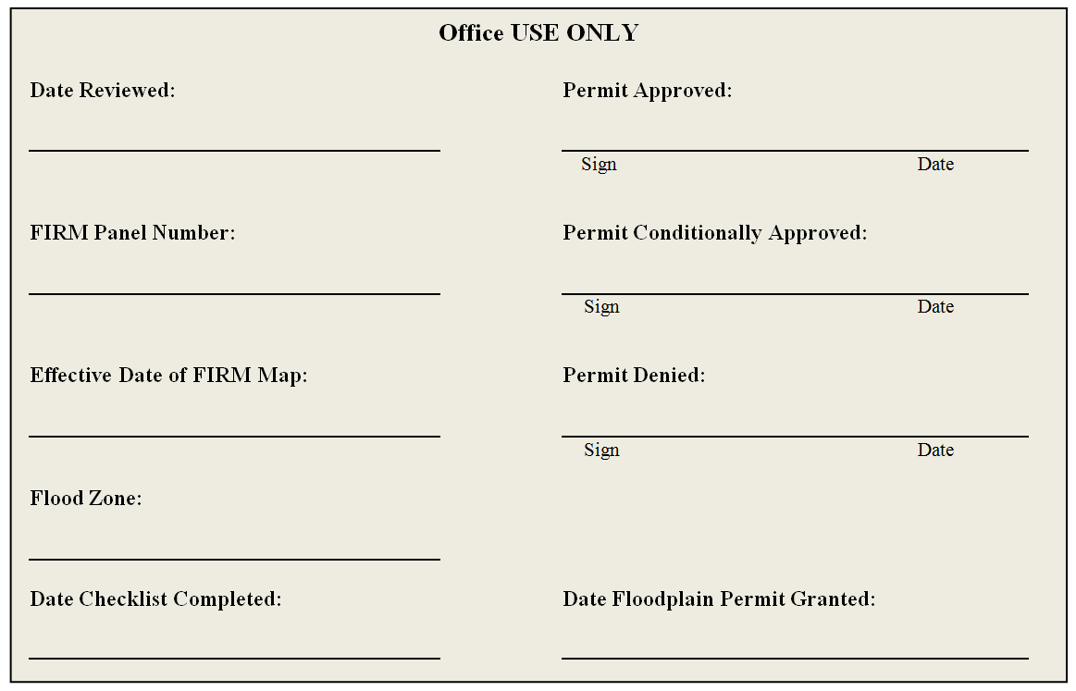
(SEAL)

