The purpose of the ESEA Resource Toolkit is to provide sample documentation that local education agencies (LEAs) may use to ensure compliance with the requirements that govern federal grants under the ESEA. Most of the documents are intended to be modified by the LEAs to meet the requirements.

Plans
ESEA Professional Development Requirements
Tuition Reimbursement Information
Notifications
Parents Right-to-Know Notification Information
Parents Right-to Know Notification – English
Parents Right-to Know Notification – Spanish
Parents Right-to-Know Notification for English Learners – English
Parents Right-to-Know Notification for English Learners – Spanish
Four Week Notification to Parents (non-certified teacher)
Four Week Notification to Parents (non-certified teacher) - Charter School
Four Week Notification to Parents (non-certified teacher) - Adjunct Teacher
Parent Notification of Student Achievement on Assessments
Sample Letter Explaining EL Identification
Sample Letter Explaining EL Identification (Spanish)
Notification of Student Experiencing Homelessness Placement Decision – English
Student Experiencing Homelessness Placement Decision Dispute – English
Notification of Student Experiencing Homelessness Placement Decision – Spanish
Student Experiencing Homelessness Placement Decision Dispute – Spanish
Notification of Student Independent Status for Free Application for Student Aid (FAFSA)
Notification from Public School to Nonpublic School Regarding ESEA Equitable Services
Forms
Title I Methodology Information and Examples
Title I School-Parent Compact Information and Template
Paraprofessional Credential Requirement Information and Hiring Checklist
Time Distribution Records Information and Templates
Inventory Information and Template
Neglected and/or Delinquent Program Evaluation
Neglected and/or Delinquent Program Transition Plan
Home Language Survey
Home Language Survey (Spanish)
Home Language Survey Supplement - “Less Often” Non-EL Bilingual Qualification Form
English Language Academic Plan (ELAP)
Sample EL Monitoring Form
WIDA ACCESS and Alt-ACCESS Security Checklists
Student Residency Questionnaire – Exact Form Required
Best Interest Determination (BID) for School Placement (McKinney-Vento)
Best Interest Determination (BID) for School Placement (Foster Care)
ESSA Tribal Consultation Agreement
Regulations Regarding Evidence-Based Research and Interventions
Sample Intervention/Program Evaluation From
Other Requirements
List of Required Policies and Procedures
Single Audit Information

ESEA Professional Development Requirements

Local educational agencies (LEAs) may use the following information to determine if a proposed professional development activity meets the definition found in the Elementary and Secondary and Education Act (ESEA) Section 8101(42).

In accordance with ESEA Sections 2301, 4110, and 5232 - ESEA funds may NOT be used to fund any part of professional development that is mandated by the state of Oklahoma (see additional information on the final page of this document). Oklahoma Statue (O.S) §70-6-194

The LEA must review expenditures for professional development in consideration of the following information.

- Allocable
A cost is allocable to a particular federal award if the goods or services involved are assignable to that federal award in accordance with relative benefits received. 2 C.F.R. §200.405(a) The LEA must be able to answer “Yes” to the following question.
- Does the proposed professional development activity (included related expenditures) for a particular grant program (Title I, Title II, Title III, Title IV, and Title V) benefit the intent of the program?

- Necessary and Reasonable
All expenditures for goods or services using federal funds must be reasonable and necessary and adhere to 2 C.F.R. §200.404 The LEA must be able to answer “Yes” to questions a-c. If the LEA answers no to question d then a justification must be provided in the ESEA Consolidated Application.

- Is necessary for proper performance of the grant?
- Is the market price for comparable services in the geographic area?
- Is the request prudent considering the responsibilities to the employees, students, and the public at large?
- Is the request a significant deviation from established practices and policies?

- Professional Development Requirements ESEA 8101(42) and (44)
To qualify as an ESEA approved professional development activity under ESEA Section 8101(42) the LEA must answer “Yes” to questions a-c.
- Is the proposed professional development activity an integral part of the school and local educational agency (LEA) strategies for providing educators with the knowledge and skills necessary to enable students to succeed in a well-rounded education and to meet the challenging state academic standards?
- Is the proposed professional development for one of the following – teachers, principals, other school leaders, specialized instructional support personnel, or paraprofessionals?
The definition for "other school leaders" may be found in ESEA Section 8101(44).
  - Is the school leader an employee of the elementary, secondary, district, or other entity operating an elementary or secondary school?
AND
  - Is the school leader responsible for the daily leadership and managerial operations in the elementary or secondary school building?
- Is the proposed professional development for sustained (not stand-alone, 1-day, or short term workshops), intensive, collaborative, job-embedded, data-driven, and classroom-focused activity?
To qualify as an ESEA approved professional development activity under ESEA Section 8101(42) the LEA must answer “Yes” to at least ONE of the questions d-u.
- Will the proposed professional development activity improve and increase teachers’ knowledge of the academic subjects the teachers teach; understanding of how students learn; and ability to analyze student work and achievement from multiple sources, including how to adjust instructional strategies, assessments, and materials based on such analysis?
- Will the proposed professional development activity be an integral part of broad schoolwide and district-wide educational improvement plans?
- Will the proposed professional development activity allow for personalized plans for each educator to address the educator’s specific needs identified in observation or other feedback?
- Will the proposed professional development activity improve classroom management skills?
- Will the proposed professional development activity support the recruitment, hiring, and training of effective teachers, including teachers who became certified through alternative routes to certification?
- Will the proposed professional development activity advance teacher understanding of effective instructional strategies that are evidence-based; and strategies for improving student academic achievement or substantially increasing the knowledge and teaching skills of teachers?
- Will the proposed professional development activity be aligned with, and directly related to, academic goals of the school or local educational agency?
- Will the proposed professional development activity be developed with extensive participation of teachers, principals, other school leaders, parents, representatives of Indian tribes (as applicable), and administrators of schools to be served under ESEA?
- Will the proposed professional development activity be designed to give teachers of English learners, and other teachers and instructional staff, the knowledge and skills to provide instruction and appropriate language and academic support services to those children, including the appropriate use of curricula and assessments?
- Will the proposed professional development activity (to the extent appropriate) provide training for teachers, principals, and other school leaders in the use of technology (including education about the harms of copyright piracy), so that technology and technology applications are effectively used in the classroom to improve teaching and learning in the curricula and academic subjects in which the teachers teach?
- Will the proposed professional development activity, be regularly evaluated for the impact on increased teacher effectiveness and improved student academic achievement, with the findings of the evaluations used to improve the quality of professional development?
- Will the proposed professional development activity be designed to give teachers of children with disabilities or children with developmental delays, and other teachers and instructional staff, the knowledge and skills to provide instruction and academic support services, to those children, including positive behavioral interventions and supports, multi-tier system of supports, and use of accommodations?
- Will the proposed professional development activity include instruction in the use of data and assessments to inform and instruct classroom practice?
- Will the proposed professional development activity include instruction in ways that teachers, principals, other school leaders, specialized instructional support personnel, and school administrators may work more effectively with parents and families?
- Will the proposed professional development activity involve the forming of partnerships with institutions of higher education, including, as applicable, Tribal Colleges and Universities as defined in section 316(b) of the Higher Education Act of 1965 (20 U.S.C. 1059c(b)), to establish school-based teacher, principal, and other school leader training programs that provide prospective teachers, novice teachers, principals, and other school leaders with an opportunity to work under the guidance of experienced teachers, principals, other school leaders, and faculty of such institutions?
- Will the proposed professional development activity create programs to enable paraprofessionals (assisting teachers employed by a local educational agency receiving assistance under part A of title I) to obtain the education necessary for those paraprofessionals to become certified and licensed teachers?
- Will the proposed professional development activity provide follow-up training to teachers who have participated in activities described in section 8101(42) that are designed to ensure that the knowledge and skills learned by the teachers are implemented in the classroom?
- Will the proposed professional development activity (where practicable) provide jointly for school staff and other early childhood education program providers, to address the transition to elementary school, including issues related to school readiness?

- Evidence-Based Requirement ESEA 8101(21)
To qualify as an ESEA approved professional development activity the professional development must also be evidence-based according to ESEA Section 8101(21). To qualify as an ESEA approved professional development activity under ESEA Section 8101(21) the LEA must answer “Yes” to at least ONE of the questions a-c and must answer “Yes” to question d.
- Does the professional development activity have strong evidence from at least 1 well-designed and well-implemented experimental study?
- Does the professional development activity have moderate evidence from at least 1 well-designed and well-implemented quasi-experimental study?
- Does the professional development activity have promising evidence from at least 1 well-designed and well-implemented correlational study with statistical controls for selection bias?
- REQUIRED The professional development activity must demonstrate a rationale based on high-quality research findings or positive evaluation that such activity, strategy, or intervention is likely to improve student outcomes or other relevant outcomes and includes ongoing efforts to examine the effects of such activity, strategy, or intervention.

- Presidential Executive Actions
The use of federal funds must also consider any applicable Presidential Executive Actions. In the case of professional development, please ensure that federal funds used to support professional development activities consider the requirements in the Presidential Executive Action released on January 20, 2025 Ending Radical And Wasteful Government DEI Programs And Preferencing

Oklahoma State Required Professional Development
The following is a list of the professional development requirements that must first be met using state and/or local funds before using federal funds to supplement. O.S. §70-6-194
- Bloodborne Pathogens
- Family Educational Rights and Privacy Act (FERPA)
- Alcohol, Drug, and Tobacco Awareness
- Student Communications
- Autism PD for certified employees & support staff who work with students in early childhood to third grade (once every 3 years)
- Bullying Prevention PD for certified employees and support staff
- Child Abuse and Neglect; Child Sexual Abuse Awareness & Reporting PD for certified employees and support staff (once every 5 years)
- Digital Teaching and Learning PD for certified teachers
- Dyslexia Awareness PD for certified teachers and administrators (once every school year)
- English Learner PD for certified employees and staff who work with EL students
- Family & Community Engagement PD for school personnel
- Human Trafficking PD for certified employees and support staff
- Mental Health Needs of Students PD certified employees and support staff
- Racial & Ethnic Education for certified employees and support staff
- Suicide Awareness training for all school district staff
- Any state required professional development

Tuition Reimbursement Information

Tuition reimbursement is an allowable use of federal funds. Reimbursement may be used as a strategy to improve teacher and principal quality and promote professional growth. Depending on the amount an employer provides to its employees, the Internal Revenue Service (IRS) requires the employer (district) to report employee’s income on the W-2 Form. For more information visit the IRS Website. Whether tuition reimbursement is taxable or not is between the employee and the employer and depends on the amount received.
Tuition reimbursement should be addressed either in the district’s compensation policy or in a separate policy document. The policy and accompanying procedures should include the following information –
- Establish the eligibility requirements in accordance with the federal grant requirements.
- Not be discriminatory in its eligibility requirements.
- Not favor highly compensated employees.
- Indicate the amount that employees may receive during a school year.
- Be publicized to all employees who are eligible to participate.

The tuition reimbursement policy and accompanying procedures may be requested as a component of the monitoring process.

Parents-Right-To-Know Notification Information

Overview
Parents Right-to-Know is a requirement under the Elementary and Secondary Education Act (ESEA). ESEA Section 1112(e) has two significant components -
- The first component requires the district to inform parents/guardians each year that they have a right to request and review their child’s teacher credentials. This notification can be shared in the handbook, on the district’s website etc.
- The second component of this section requires the district to inform parents/guardians if their child is being instructed by a teacher that is not appropriately certified to teach in their state for four or more weeks. When this situation occurs, the district must notify the impacted students’ parents/guardians with a letter.

Parents Right-To-Know - Parent/Guardian Request
The first component of PRTK in ESEA Section1112 (e)(1)(a) is that parents/guardians have a right to request the qualifications of their child’s teacher or paraprofessional. The district may provide information they deem appropriate to demonstrate the teacher or paraprofessionals qualifications. Examples of qualifications could be a resume, curriculum vitae, copy of teaching certificate, and/or other documents that specify the qualifications. Parent/guardians do not have a right to access confidential information or the teacher’s personnel documentation. Districts should identify what information will be provided if requested; how the district will provide annual notice to parents/guardians about this right; and how the district will provide the selected documentation upon request. These are local decisions, but OSDE recommends the district be consistent in how the annual notice is published; what information is disbursed; and the method of disbursement.

Four-Week Letter Requirement
The second component of PRTK is that a letter is required to be sent to a student’s parents/guardians when a teacher, who does not meet the state teacher certification requirements for the assigned grade level and/or subject area, has instructed their child for four or more consecutive weeks. If a school has a teacher instructing that is not appropriately certified in the subject matter and grade level, and the school receives Title I, Part A funding, the district must issue the four-week letter. This requirement must be adhered to by all schools (including charter schools) that receive Title I, Part A funding. This requirement is also applicable to adjunct teachers. The district may utilize the four-week letter template provided by the Oklahoma Department of Education (OSDE), or they may develop their own four-week letter. If the district develops their own letter, it must provide the following information:
- The school receives federal funds under Title I, Part A and the notice is a requirement of ESEA Section 1112(e)(1)(A);
- Their child is receiving instruction by a teacher that is not deemed appropriately certified in the State of Oklahoma;
- The name of the teacher, grade level(s), and specific subject areas the teacher provides instruction.

How to Send Out a Four-Week Letter
The district may choose to disseminate the four-week letter in a manner that meets the needs of their community. Examples of effective methods include electronic mail, traditional mail, or via the district contact management system. It is recommended that the district provide consistent modes of delivery to ensure equitable access to all impacted parents/guardians.

Parents Right-to-Know Notification - English

LEA LETTERHEAD

Date

Dear Parent(s)/Guardian(s):

The Every Student Succeeds Act (ESSA) requires that all schools receiving Title I funds must inform parents of their right to ask schools about the qualifications of their child’s teachers and qualifications of any paraprofessional serving their child - ESSA Section 1112 (e).

Your child attends a school that receives federal Title I funds. You have the right to request the following
information which will be provided to you in a timely manner, if you request it:
- Whether the teacher has met Oklahoma's qualification and licensing criteria for the
grade level(s) and subject matter being taught;
- Whether Oklahoma has decided that the teacher can teach in a classroom without being licensed or qualified under state regulations because of special circumstances;
- The teacher's college major; whether the teacher has any advanced degrees and, if so, the subject of the degrees;
- Whether any paraprofessional educators provide services to your child and, if they do, their qualifications.

If you would like to receive any of the above-mentioned information, please make the request in writing
to your school’s principal.

Our teachers are committed to helping your child develop the academic knowledge and critical thinking
your child needs to succeed in school and beyond. I encourage you to support your child’s education and communicate with their teacher on a regular basis. By partnering, families and educators can provide your child with the best education possible.

Sincerely,

School Principal

Parents Right-to-Know Notification - Spanish

LEA LETTERHEAD

Fecha

Estimados padres/tutores:

La Lay Cada Estudiante Triunfa Every Student Succeeds Act - ESSA requiere que todas las escuelas que reciben fondos del programa Título I deben informar a los padres de su derecho de solicitar información de las escuelas sobre las cualificaciones de los maestros de sus hijos y de cualquier profesional que presta servicios a sus hijos.

Su niño asiste a una escuela que recibe fondos federales de Título I. Por lo tanto, tienen el derecho a solicitar la siguiente información, la cual se le proporcionará de manera oportuna, si se solicita:

- si el maestro ha cumplido o no con las cualificaciones y criterios de licenciatura de Oklahoma para el nivel de grado(s) y materias que él o ella enseña
- si Oklahoma ha decido o no que el maestro puede enseñar en un salón de clases sin tener licencia o estar cualificado bajo los reglamentos debido a circunstancias especiales;
- la especialización universitaria del maestro; si el maestro tiene o no algún título de estudios avanzados y, si es así, cuál es la especialización del título obtenido;
- si algún educador para profesional presta o no servicios a su niño y, si es así, cuáles son sus cualificaciones;

Si desean recibir cualquiera de la información antes mencionada, por favor solicítenla por escrito al director de la escuela de su niño.

Nuestros maestros se han comprometido a ayudar a su niño a adquirir el conocimiento académico y el razonamiento crítico que él/ella necesita para tener éxito en la escuela y más allá. Les animo a que apoyen la educación de sus hijos y que se comuniquen con sus maestros de forma regular. Mediante la colaboración, las familias y los educadores pueden darles a sus hijos la mejor educación posible.

Atentamente,

Director de la escuela

Parents Right-to-Know Notification for English Learners - English

LEA LETTERHEAD

Date

Dear Parents and Guardians,

In accordance with Parents Right-to-Know requirement under the Every Student Succeeds Act (ESSA) Section 1112(e)(1)(A) this is a notification from __________ Public Schools to every parent/guardian of a student in a Title I school that you have the right to request and receive in a timely manner:
- information regarding the professional qualifications of your student’s classroom teachers. The information regarding the professional qualifications of your student’s classroom teachers shall include the following:
- If the teacher has met state qualification and licensing criteria for the grade level and subject areas taught;
- If the teacher is teaching under emergency or temporary status in which the state qualifications and licensing criteria are waived;
- The teacher’s baccalaureate degree major, graduate certification, and field of discipline; and
- Whether the student is provided services by paraprofessionals, and if so, their qualifications
- information regarding any State or local educational agency policy regarding student participation in any assessments mandated by section 1111(b)(2) and by the State or local educational agency, which shall include a policy, procedure, or parental right to opt the child out of such assessment, where applicable.
- upon request, parents of an English learner may:
  - have the child immediately removed from an English Learner (EL) program;
  - decline the child’s enrollment in an EL program, or choose another program or method of instruction, if available;
  - receive assistance in selecting among various programs and methods of instruction, if more than one program or method is offered by the eligible entity.
- notification if your student has been taught for four or more consecutive weeks by a teacher who does not meet the applicable state certification for licensure requirements at the grade level and subject area in which the teacher has been assigned.

If you have questions or concerns, please feel free to contact the school principal at __________

Sincerely,

School Principal

Parents Right-to-Know Notification for English Learners - Spanish

LEA LETTERHEAD

Fecha

Queridos Padres y Guardianes:

De acuerdo con Sobre El Derecho A La Información Para Los Padres y el requisito de Cada Estudiante Tiene Éxito Every Student Succeeds Act (ESSA) Sección 1112 (e)(1)(A) esta notificación de ________ Escuelas Públicas a cada padre/tutor de un estudiante en una escuela de Título I que usted tiene el derecho de solicitar y recibir de manera oportuna:
- Información sobre las cualificaciones profesionales de los maestros de su estudiante.
La información sobre las cualificaciones profesionales de los maestros de su estudiante incluirá lo siguiente:
- Si el maestro ha cumplido con los criterios estatales de calificación y licencia para el nivel de grado y las áreas de enseñó;
- Si el maestro está enseñando bajo estado de emergencia o temporal en el que se renuncian las cualificaciones estatales y los criterios de licencia;
- El grado de bachillerato del maestro, la certificación de posgrado y la disciplina; y
- Si el estudiante es proporcionado servicios por para profesionales, y si es así, sus calificaciones
- Información sobre cualquier póliza de agencias educativas estatales o locales con respecto a la participación de los estudiantes en cualquier evaluación ordenada por la sección 1111(b)(2) y por la agencia educativa estatal o local, que incluirá una póliza, procedimiento, o el derecho de los padres a excluir al niño de dicha evaluación, cuando proceda.
- a petición, los padres de un estudiante de inglés pueden:
- Hacer que el estudiante sea inmediatamente removido de un programa de Estudiantes de Inglés (EL);
- Rechazar la inscripción del niño en un programa EL, o elegir otro programa o método de instrucción, si está disponible;
- Recibir asistencia en la selección entre varios programas y métodos de instrucción, si más de un programa o método es ofrecido por la entidad elegible.
- Notificación si su estudiante ha sido enseñado durante cuatro o más semanas consecutivas por un maestro que no cumple con la certificación estatal aplicable para los requisitos de licencia a nivel de grado y área de asignatura en la que el maestro ha

Si tiene preguntas o inquietudes, no dude en ponerse en contacto con el director de la escuela en __________

Sinceramente,

Director de la escuela

Four Week Notification to Parents (non-certified teacher)

This notification should be sent to parents/guardians for each teacher that does not meet Oklahoma teacher certification requirements after four weeks of instruction.

LEA LETTERHEAD

Date

Dear Parent(s)/Guardian(s):

The Every Student Succeeds Act (ESSA) Section 1112(e)(1)(B)(ii) requires all Title I schools to notify parents or guardians of a child that has been taught for four consecutive weeks by a teacher who has not met state certification and licensing requirements for the grade level and subject areas in which the teacher has been assigned.

The purpose of this letter is to notify you, as required by federal law, that Mr./Ms. NAME OF TEACHER does not currently meet Oklahoma teacher certification requirements for the grade level and subject areas being taught to your child.

Nevertheless, given their professional experience, we believe that your child is receiving a high-quality education.

(Any additional information or explanation may be inserted here regarding emergency certification, adjunct status etc.)

If you have any concerns regarding this information, you have the right, as a parent/guardian, to review the qualifications of your child’s teacher. Please contact NAME AND TITLE at PHONE NUMBER if you have any questions.

Sincerely,

FIRST AND LAST NAME
School Principal

Four Week Notification to Parents (non-certified teacher) – Charter School

This notification should be sent to parents/guardians for each teacher that does not meet Oklahoma teacher certification requirements after four weeks of instruction.

LEA LETTERHEAD

Date

Dear Parent(s)/Guardian(s):
The Every Student Succeeds Act (ESSA) requires all Title I schools to notify parents or guardians of a child that has been taught for four consecutive weeks by a teacher who has not met state certification and licensing requirements for the grade level and subject areas in which the teacher has been assigned ESSA Section 1112(e)(1)(B)(ii).

In the Oklahoma Charter School Act, §42.18-5 a charter school shall be exempt from all statutes and rules relating to schools, boards of education, and school districts. A charter school is not required to employ an individual who holds a valid Oklahoma teaching certificate as defined in 70 O.S. §1-116. Tribally operated charter schools and other charter schools may choose to operate their own certification process unique to the qualifications appropriate for a teacher at their school; provided, except as provided in 70 O.S. §5-142(E), all individuals must satisfactorily undergo and clear a national criminal history record check prior to employment in a public school (charter or non-charter).

The purpose of this letter is to notify you, as required by federal law, that Mr./Ms. NAME OF TEACHER does not currently meet Oklahoma teacher certification requirements for the grade level and subject areas being taught to your child.

Nevertheless, given their professional experience, we believe that your child is receiving a high-quality education.

(Any additional information or explanation may be inserted here regarding the teacher’s experience and related credentials etc.)

If you have any concerns regarding this information, you have the right, as a parent/guardian, to review the qualifications of your child’s teacher. Please contact NAME AND TITLE at PHONE NUMBER if you have any questions.

Sincerely,

FIRST AND LAST NAME
School Principal

Four Week Notification to Parents (non-certified teacher) – Adjunct Teacher

This notification should be sent to parents/guardians for each teacher that does not meet Oklahoma teacher certification requirements after four weeks of instruction.

LEA LETTERHEAD

Date

Dear Parent(s)/Guardian(s):
The Every Student Succeeds Act (ESSA) requires all Title I schools to notify parents or guardians of a child that has been taught for four consecutive weeks by a teacher who has not met state certification and licensing requirements for the grade level and subject areas in which the teacher has been assigned ESSA Section 1112(e)(1)(B)(ii).

As permitted in 70 O.S. §6-122.3(G), a public school in Oklahoma may use adjunct teachers that are not required to meet Oklahoma teacher certification requirements as defined in 70 O.S. §1-116. As required by 70 O.S. §5-142(E) all individuals must satisfactorily undergo and clear a national criminal history record check prior to employment in a public school.

The purpose of this letter is to notify you, as required by federal law, that Mr./Ms. NAME OF TEACHER does not currently meet Oklahoma teacher certification requirements for the grade level and subject areas being taught to your child.

Nevertheless, given their professional experience, we believe that your child is receiving a high-quality education.

(Any additional information or explanation may be inserted here regarding the teacher’s experience and related credentials etc.)

If you have any concerns regarding this information, you have the right, as a parent/guardian, to review the qualifications of your child’s teacher. Please contact NAME AND TITLE at PHONE NUMBER if you have any questions.

Sincerely,

FIRST AND LAST NAME
School Principal

Parent Notification of Student Achievement on Assessments

Any school that receives Title I, Part A funds shall provide to each individual parent of a child who is a student in the school a notification to the parents related to the individual academic growth of the student on each of the state academic assessments required. ESEA Section 1112 (e)(1)(B)(i)

The following is an example of a notification.

LEA LETTERHEAD

Date

To the parent/guardian of INSERT STUDENT NAME,

Each year students at several grade levels participate in the Oklahoma State Testing Program (OSTP). If your student has participated in the OSTP - scores will be available on the OSTP Parent/Student Portal using the link below.
Information in the OSTP portal showcases your student's performance on the Oklahoma School Testing Program (OSTP) Tests in key academic areas. State test results, when combined with other information (i.e. homework, classwork, report card grades, and local assessments), can help you and the teacher work together to support your student's growth. Your student's state testing identification number (STN) is required to access their scores. If you do not have this number, please contact the school.
OSTP Parent/Student Portal

Parents Right-To-Know Letter – English Learners

This letter should be sent to parents/guardians of identified English Learners not later than 30 days after the beginning of the school year, or during the first 2 weeks of the child’s placement in a language instruction educational program.

LEA LETTERHEAD

Date
Dear Mrs./Mr. INSERT NAME,

DISTRICT Public Schools wishes to inform the parent(s)/guardian(s) of STUDENT NAME that your student has been identified for participation in our district’s English Learner (EL) program.
Your student participated in EL placement testing after review of their Home Language Survey and/or after teacher recommendation indicated they should be assessed for EL status. Upon review of their EL placement testing scores, your student was awarded EL status and will receive special services to help them in learning the English language.
The attached English Learner Academic Plan (ELAP) outlines the following information:
- Your student’s current level of English proficiency
- The services your student will receive as an identified EL
- The language learning targets your student will be working toward over the coming year
- The expected amount of time it will take for your student to exit EL status based on their current level of English proficiency
To exit EL status, your student must score as English proficient on the state English Language Proficiency Assessment. Your student will continue to receive EL services until this score has been reached.
As parent or guardian, you have the right to have your student immediately removed from our EL program, but please understand that removing your student from the program will not remove their EL status. Students identified as EL will remain so until they score English proficient on the yearly English Language Proficiency Assessment.
Information regarding expected rates of graduation for English Learners is available at www.oklaschools.com.
DISTRICT Schools welcomes any questions or concerns you may have about this letter. Please feel free to contact DISTRICT/SITE STAFF at PHONE NUMBER at your convenience.
Sincerely,

School Principal

Carta Sobre El Derecho A La Información Para Los Padres - Estudiantes De Ingles

Esta carta debe ser enviada a los padres/tutores de los estudiantes de inglés identificados a más tardar 30 días después del comienzo del año escolar, o durante las primeras 2 semanas de la colocación del niño en un programa educativo de enseñanza de idiomas.

LEA LETTERHEAD

Fecha

Estimada Sra./Sr.NOMBRE,

DISTRITO Las Escuelas Públicas desean informar al padre(s)/guardián(es) de NOMBRE DEL ESTUDIANTE que su estudiante ha sido identificado para participar en el programa de Estudiantes de Inglés (EL) de nuestro distrito.
Su estudiante participó en el examen de colocación de EL después de revisar la Encuesta de Idioma en el Hogar y/o después de la recomendación del maestro indicó que deben ser evaluados para EL. Después de revisar sus resultados del examen de EL, su estudiante recibió el estatus de EL y recibirá servicios especializados para apoyarles con su inglés.
El Plan Académico de Estudiantes de Inglés (ELAP) adjunto describe la siguiente información:
- Nivel actual de inglés de su estudiante
- Los servicios que su estudiante recibirá como EL
- Los objetivos de aprendizaje que su estudiante estará trabajando hacia el año que viene
- La cantidad de tiempo que tomará para que su estudiante salga del estado de EL basado en su nivel actual de dominio del inglés
Para salir del programa de EL, su estudiante debe calificar competente en Inglés en la Evaluación de Dominio del Idioma Inglés del estado. Su estudiante continuará recibiendo servicios de EL hasta que este resultado haya sido alcanzado.
Como padre o tutor, usted tiene el derecho de que su estudiante sea inmediatamente removido de nuestro programa EL, pero por favor entienda que remover a su estudiante del programa no eliminará su estatus de EL. Los estudiantes identificados como EL permanecerán así hasta que obtengan una calificación de dominio del inglés en la evaluación anual.
Información sobre el índice de graduación para estudiantes de inglés está disponible en www.oklaschools.com.
DISTRITO Las escuelas aceptan cualquier pregunta o preocupación que usted pueda tener acerca de esta carta. Por favor, no dude en ponerse en contacto con DISTRITO/ PERSONAL DEL SITIO en NÚMERO DE TELÉFONO a su conveniencia.
Sinceramente,
Director de la escuela
Student Experiencing Homelessness Placement Decision Notification - English
LEA LETTERHEAD

Written Enrollment Decision Notice

This form is to be completed by the local homeless education liaison when an enrollment request is denied.

Date: _________________________________________________________________________
Name of person completing form: __________________________________________________
Title of person completing form: ___________________________________________________

In compliance with the McKinney-Vento Homeless Assistance Act, the following written notification is provided to:

Name of Parent(s)/Guardian(s): ___________________________________________________
Name of Student(s): ____________________________________________________________
After reviewing your request to enroll the student(s) listed above, the enrollment request is denied. This determination is based upon:

You have the right to appeal this decision by contacting the school district’s site homeless education liaison.
Name of local liaison: ___________________________________________________________
Title: ________________________________________________________________________
Phone Number: ________________________________________________________________
In addition:
- The student listed above has the right to enroll immediately in the requested school pending the resolution of dispute.
- You may provide written or verbal communication(s) to support your position regarding the student’s enrollment in the requested school. You may use the form attached to this notification.
- You may contact the State Coordinator for Homeless Education if further help is needed or desired. The State Coordinator can be reached at the Oklahoma State Department of Education’s Office of Title Services: (405) 521-2846.
Student Experiencing Homelessness Placement Decision Dispute – English

LEA LETTERHEAD

Written Enrollment Decision Notice
To be completed by the parent, guardian, caretaker, or unaccompanied youth when a dispute arises.
Date: _________________________________________________________________________
Student(s): ____________________________________________________________________
Person completing the form: ______________________________________________________
Relation to student(s): ___________________________________________________________
I may be contacted at (phone or email): ______________________________________________
I wish to appeal the enrollment decision made by: _____________________________________
Name of School: _______________________________________________________________

I have been provided with (please check all that apply):
☐ A written explanation of the school’s decision.
☐ The contact information of the school district’s local homeless education liaison.
☐ A copy of the state’s dispute resolution process for students experiencing homelessness.

Optional: You may include a written explanation in the space below to support your appeal or you may provide your explanation verbally.

The local homeless education liaison provided me with a copy of this form when I submitted it. _______ (Please initial)

Student Experiencing Homelessness Placement Decision Notification - Spanish

LEA LETTERHEAD

Aviso por escrito de decisión de inscripción

Este formulario debe ser llenado por el enlace local de educación para personas sin hogar cuando una solicitud de inscripción sea denegada.
Fecha: ________________________________________________________________________
Nombre de la persona que llena el formulario: ________________________________________
Título de la persona que llena el formulario: _________________________________________

En cumplimiento con la Ley de Asistencia para personas sin Hogar de McKinney-Vento, se envía la siguiente notificación por escrito a:
Nombre de los padres/tutores: _____________________________________________________
Nombre de los alumnos: _________________________________________________________
Después de revisar su solicitud para inscribir a los alumnos mencionados anteriormente, la solicitud de inscripción es denegada. Esta determinación se basa en:

Usted tiene el derecho de apelar esta decisión poniéndose en contacto con el enlace de educación para personas sin hogar del distrito escolar.

Nombre del enlace local: _________________________________________________________
Título: _______________________________________________________________________
Número de teléfono: ____________________________________________________________
Además:
- El alumno arriba mencionado tiene el derecho de inscribirse inmediatamente en la escuela solicitada hasta que se resuelva la disputa.
- Usted puede proporcionar comunicaciones escritas o verbales que apoyen su posición con respecto a la inscripción del estudiante en la escuela solicitada. Puede usar el formulario anexo a esta notificación.
- Si necesita o desea ayuda adicional, puede comunicarse con el coordinador estatal de educación para personas sin hogar en la Oficina de Programas Federales del Departamento de Educación del Estado de Oklahoma: (405) 521-2846.

Student Experiencing Homelessness Placement Decision Dispute (Spanish)

LEA LETTERHEAD

Aviso por escrito de decisión de inscripción

Para ser llenado por el padre, tutor, cuidador, o joven sin compañía cuando surja una disputa.

Fecha: ________________________________________________________________________
Nombre de la persona que llena el formulario: ________________________________________
Relación con los alumnos: ________________________________________________________
Se me puede localizar en (teléfono o correo-e): _______________________________________
Deseo apelar la decisión de inscripción hecha por: _____________________________________
Nombre de la escuela: ___________________________________________________________

Se me proporcionó (seleccione todas las opciones pertinentes):
☐ Explicación por escrito de la decisión de la escuela.
☐ La información de contacte del enlace local de educación para personas sin hogar del distrito escolar.
☐ Una copia del proceso de resolución de la disputa del estado para alumnos sin hogar.

Opcional: Puede incluir una explicación por escrito en el siguiente espacio que apoye su apelación, o puede proporcionar su explicación oralmente.

El enlace de educación para personas sin hogar me proporcionó una copia de este formulario cuando lo presentó.
_________ (Escribe sus iniciales)
Notification of Student Independent Status for Free Application for Student Aid (FAFSA)
LEA LETTERHEAD

Independent Student Status of Unaccompanied Homeless Youth
Determination for the 20XX-20XX FAFSA.

To Whom It May Concern:

I am providing this letter to convey my determination that after July 1, 20XX, [INSERT NAME OF STUDENT] was:

☐ an unaccompanied homeless youth, as defined by the FAFSA Simplification Act (Public Law No: 1116-260.
☐ an unaccompanied, self-supporting youth at risk of homelessness.

Student’s Social Security Number (SSN): |  | Student’s Date of Birth (DOB):
Student’s Mailing Address: [if the student does not have a stable address, you may list the name, phone number and mailing address of a friend or relative, or the school]

Under the FAFSA Simplification Act (Public Law No:116-260), I am authorized to document this student’s living situation and determine his/her independent student status as an unaccompanied homeless youth or unaccompanied, self-supporting youth at risk of homelessness. Financial aid administrators must accept this documentation unless there is specific documented conflicting information. Please address any questions to me at the number or e-mail address listed below.

Signature: |  |  |  |  | Date:
Print Name: |  |  |  |  | Phone:
Email:
Title:
Agency:
Role (Check One):
☐ School district homeless liaison, or designee of the liaison.
☐ Director or a designee of a director of an emergency or transitional shelter, street outreach program, homeless youth drop-in center, or other program serving individuals who are experiencing homelessness.
☐ Director or a designee of a director of a program funded under TRIO or GEAR UP.
☐ A financial aid administrator at the same or another institution who previously made a determination.

Pertinent Definitions
From the FAFSA Simplification Act (Public Law No: 116-260) and
The 20XX-XX Application and Verification Guide

Homeless
A student is considered homeless if the student lacks fixed, regular, and adequate housing. This is broader than just living “on the street.” It includes temporarily living with other people because the student had nowhere else to go; living in substandard housing (if it doesn’t meet local building codes or the utilities are turned off, it is generally not adequate); living in emergency or transitional shelters, for example, trailers provided by the Federal Emergency Management Agency (FEMA) after disasters; or living in motels, camping grounds, cars, parks, abandoned buildings, bus or train stations, or any public or private place not designed for humans to live in. It also includes living in the school dormitory if the student would otherwise be homeless. A student living in any of these situations and fleeing an abusive parent may be considered homeless even if the parent would provide support and a place to live. For more information on the definition of homelessness, see “Does My Living Situation Meet the Definition of Homelessness?”

Unaccompanied
When a student is not living in the physical custody of a parent or guardian.

Youth
Any student who is not yet 24 may qualify for a homeless youth determination.

Self-Supporting
When a student pays for his own living expenses, including a fixed, regular, and adequate housing.

At risk of being homeless
When a student’s housing may cease to be fixed, regular, and adequate, for example, a student
who is being evicted and has been unable to find fixed, regular, and adequate housing.

Notification from Public School to Nonpublic School Regarding ESEA Equitable Services

LEA LETTERHEAD
Date
Dear INSERT NAME OF NONPUBLIC SCHOOL ADMINISTRATOR:
Each year, the Elementary and Secondary Education Act (ESEA) requires INSERT LEA NAME to inform area nonpublic schools of the option to participate in all federally funded grant available to the LEA for the upcoming school year of 20XX-20XX, including DELETE PROGRAMS FOR WHICH THE DISTRICT HAS NO ALLOCATION
- Title I, Part A (Educational Assistance to At-Risk Students)
- Title I, Part C (Education of Migratory Children)
- Title II, Part A (Professional Development/Supporting Effective Instruction)
- Title III, Part A (Language Instruction for English Learners and Immigrant Students)
- Title IV, Part A (Student Support and Academic Enrichment Grants)
- Title IV, Part B (21st Century Community Learning Centers)
It is INSERT LEA NAME’S responsibility to verify whether your school wishes to participate in one or more of these federally funded programs; furthermore, accredited and non-accredited are both eligible, but only nonprofit schools may participate.
According to the Elementary and Secondary Education Act (ESEA), every local educational agency (LEA) receiving federal funding is required to consult with nonpublic school representatives each year (ESEA Section 1117 and ESEA Section 8015). Please select a convenient time for consultation:
1. INSERT OPTION
2. INSERT OPTION
3. INSERT OPTION
We look forward to discussing the possibility of your school’s participation.
Sincerely,
INSERT NAME OF FEDERAL PROGRAM DIRECTOR /LEA REPRESENTATIVE
INSERT NAME OF LEA
INSERT MAILING ADDRESS
INSERT EMAIL ADDRESS AND PHONE NUMBER

Title I Supplement, not Supplant Methodology Information

Under the Every Student Succeeds Act (ESSA), local education agencies (LEAs) are required to submit the methodology (way/logic) used to ensure that Title I, Part A federal funds are supplemental. The district must describe how the distribution of state and local funds to each school is neutrally determined. ESEA Section 1118(b)(1)

The Oklahoma State Department of Education (OSDE) does not require the use of a mandated template or format for submission of the methodology. OSDE offers the example forms on the subsequent pages for districts to reference. The provided examples are not exhaustive. Additional information may be found in the Supplement Not Supplant Under Title I, Part A of the Elementary and Secondary Education Act of 1965, As Amended by the Every Student Succeeds Act Non-Regulatory Guidance June 2019.

District Exemptions
The following districts are not required to have a methodology:

- single-school districts
- districts with only one school per grade span (example one school for PK-3, one school for 4-6, one school for 7-9, one school for 10-12)
- districts that serve ALL their schools with Title I funds

Districts may select one of the following methods or may use another method to demonstrate compliance with the supplement, not supplant requirement.

- Methodology example based on enrollment and grade level
Example Public Schools determines its basic education allocation on total enrollment counts for each school as if the state and local funds are the only funds each school is receiving. Each school is given additional allocations for other needs such as technology, supplies, and additional necessary costs.
Example Public Schools groups schools by grade span (example we have two sites for each grade span PK-3, 3-5, 6-8, 9-12). Each grade span receives a different per pupil amount, but all schools are treated the same whether or not these schools are Title I-A served.

Example Public School’s state and local funds are allocated in a per pupil calculation. For full-time equivalency (FTE) staff, including salaries and benefits, for administrators, educators, instructional staff, and school counselors; $2,300 is allocated per elementary and middle school student (grades PK-8), and $2,300 is allocated per secondary student (grades 9-12).
Professional development (PD) and technology/supplies are funded with state and local dollars and are allocated on a per pupil and per building allocation. Schools are each awarded $20 per student plus an additional $500 per building for PD. Schools are each awarded $50 per student and an additional $400 per building for technology/supplies.

Additional necessary costs, such as lunch, library supplies, athletic supplies, utility costs, transportation etc. are allocated at $1,400 per student districtwide.

County Name: |  |  | County Code:
District Name: |  |  | District Code:
Fiscal Year:

School Name | School Enrollment | Grade Span | Title I
Grant Elementary | 208 | PK-3 | ☐
Harding Elementary | 251 | PK-3 | ☐
Cleveland Elementary | 303 | 3-5 | ☐
Taft Middle School | 296 | 3-5 | ☐
Hoover Middle School | 276 | 6-8 | ☐
Washington Middle School | 460 | 6-8 | ☐
Adams Middle School | 202 | 6-8 | ☐
Hamilton High School | 895 | 9-12 | ☐
Lincoln High School | 700 | 9-12 | ☐

Data Source:

Assurance: Example Public Schools attests that to the best of my knowledge the funding methodology for the distribution of state and local funds is neutrally distributed and consistently applied across all schools in the district.
Superintendent Name (printed):
Superintendent Name (signature): |  |  | Date:

- Methodology example based on staffing and supplies
The Example Public Schools based the school site allocation on type of personnel, resources, or supplies that each school will need and awards the funds based on student enrollment. Funds for personnel are calculated based on the average salary for that position within the district.

The Example Public Schools has determined that each school will be allocated:
Quantity | School Site or Student Enrollment Number | Category | Allocation Amount | Total Amount
1 | per school | principal | $72,000.00 | $72,000.00
1 | per school | librarian | $49,000.00 | $49,000.00
2 | per school | counselors | $50,000.00 | $100,000.00
20 | per school | teachers | $41,000.00 | $820,000.00
$250 per student | x 232 | technology | $58,000.00 | $58,000.00
$5500 per site | per school | professional development | $5,500.00 | $5,500.00
$250 per student | x 232 | supplies | $58,000.00 | $58,000.00

Teachers based on grade level and class size requirements indicated below:
Grade Level | Funding Level | Maximum Class Size
K-3 | 20:1 | 20
4-6 | 25:1 | 25
7-9 | 30:1 | 30
10-12 | 26:1 | 30

The district will allocate state and local funds to each school per the information above without regard for whether a school receives Title I, Part A funds.

Assurance: Example Public Schools attests that to the best of my knowledge the funding methodology for the distribution of state and local funds is neutrally distributed and consistently applied across all schools in the district.
Superintendent Name (printed):
Superintendent Name (signature): |  |  | Date:

- Methodology example based on student enrollment and student designations
All schools in Example Public Schools follow a model based on total student enrollment, with schools earning additional funds to support historically underserved student groups. These supplemental funds are intended to provide the additional supports and resources to ensure all student groups meet state achievement goals.

Example Public Schools allocates its state and local funds based on the following calculations:
Category | Enrollment Number |  | Allocation Amount Per Student |  | Total Allocation Amount
All students | 450 | X | $5,500.00 | = | $2,475,000.00

If applicable, any additional state and local funding for student subgroups.
Category | Enrollment Number |  | Allocation Amount Per Student |  | Total Allocation Amount by Category
Allocation per English Learner | 13 | X | $500.00 | = | $6,500.00
Allocation per students with disabilities | 25 | X | $1,500.00 | = | $37,500.00
Allocation per preschool students | 57 | X | $5,300.00 | = | $302,100.00
 |  |  |  |  | $346,100.00

Add the totals from each of the tables above.
Table 1 |  | Table 2
$2,475,000.00 | + | $346,100.00 | = | $2,821,100.00

The district will allocate state and local funds to each school per the information above without regard for whether a school receives Title I, Part A funds.

Assurance: Example Public Schools attests that to the best of my knowledge the funding methodology for the distribution of state and local funds is neutrally distributed and consistently applied across all schools in the district.
Superintendent Name (printed):
Superintendent Name (signature): |  |  | Date:

Title I School-Family Compact

Each Title I, Part A school must jointly develop, with the parents of children served under Title I, Part A, a school-parent compact as a component of its written parental involvement policy. A school-parent compact is a written agreement between the school and the parents of children participating in Title I, Part A programs that identifies the activities that the parents, the entire school staff, and the students will undertake to share the responsibility for improved student academic achievement. In addition, the school-parent compact outlines the activities that the parents, school staff, and students will undertake to build and develop a partnership to help the children achieve the State’s high academic standards. ESEA Section 1116(d)

Shared Responsibilities for High Student Achievement
  - Provide high-quality curriculum and instruction in a supportive and effective learning environment that enables the participating children to meet the state's challenging academic standards.
  - Hold parent-teacher conferences (at least annually in elementary schools) during which the compact will be discussed as it relates to the individual child's achievement.
  - Provide parents with frequent reports on their children's progress.
  - Provide parents with reasonable access to staff.
  - Provide parents opportunities to volunteer and participate in their child's class and to observe classroom activities.
  - Ensure regular two-way, meaningful communication between family members and school staff, and to the extent practicable, in a language that family members can understand. ESEA Section 1116(d)(1)
Compact Development & Implementation Checklist |  | Yes | No
1. | Parents participated in designing the compact.
2. | Teachers and principals participated in designing the compact.
3. | The purpose of the compact is clearly articulated so that teachers and parents both understand its intent.
4. | Students understand the meaning of the compact.
5. | The compact reflects administrative responsibility for creating a climate conducive to learning including a high-quality curriculum and balanced assessment system.
6. | The compact reflects teacher responsibility for creating a climate conducive to learning.
7. | The compact reflects teacher responsibility for establishing meaningful two-way communication with parents.
8. | The compact reflects parent responsibility for creating a home environment conducive to learning
9. | The compact reflects parent responsibility for being involved in their child’s learning
10. | The compact reflects student responsibility for learning.
11. | The responsibilities outlined in the compact are developmentally and individually appropriate for both the child and parent.
12. | The compact is reviewed with students and parents periodically throughout the year.
13. | The effectiveness of the compact is evaluated on an annual basis and data is used to make revisions.

Title I School-Family Compact Example

The NAME OF SCHOOL and the families of the students participating in activities, services, and programs funded by Title I, Part A of the Elementary and Secondary Education Act, agree that this compact outlines how families, the entire school staff, and students will share the responsibility for improving student academic achievement and the means by which the school and families will build and develop a partnership that will help students achieve the State’s high standards.

This compact is in effect during school year 2XXX – 2XXX.

School Responsibilities
The NAME OF SCHOOL will provide:
- high-quality curriculum and instruction in a supportive and effective learning environment that enables the participating students to meet the State’s student academic achievement standards as follows:

(Describe how the school will provide high-quality curriculum and instruction, and do so in a supportive and effective learning environment)

- opportunities for family/guardian-teacher conferences (at least annually in elementary schools) during which this compact will be discussed as it relates to the individual student’s achievement. Specifically, those conferences will be held:

(Describe when the family/guardian-teacher conferences will be held)

- reports to families/guardians on their students’ progress. Specifically, the school will provide reports as follows:
(Describe when and how the school will provide reports to families)

- accessible forms of communication with staff for families/guardians. Specifically, staff will be available for consultation with families/guardians as follows:
(Describe when, where, and how staff will be available for consultation with families)

- opportunities for families/guardians to volunteer and participate in their student’s classes, and to observe classroom activities, as follows:
(Describe when and how families/guardians may volunteer, participate, and observe classroom activities)
  - organized, ongoing, and timely systems for families/guardians to be actively involved in the planning, implementation, and review of programs including but not limited to family engagement policies and the development of any schoolwide program plans.
  - at least one meeting of families/guardians of participating students annually at a convenient time and location, offering multiple meetings and opportunities for multiple languages, if necessary, at which the school will inform families/guardians of the school’s participation in Title I and the requirements of Title I, including family engagement requirements.
  - information to families/guardians of participating students in an understandable and uniform format, including alternative formats, upon the request of families/guardians with disabilities, and, to the extent practicable, in a language families/guardians can understand.
  - information to families/guardians of participating students about Title I, Part A programs that include a description and explanation of the school’s curriculum, the forms of academic assessment used to measure student's progress, and the proficiency levels students are expected to meet.
  - opportunities for regular meetings for families/guardians to formulate suggestions and to participate, as appropriate, in decisions about the education of their students. The school will respond to any such suggestions as soon as feasible.
  - an individual student report to each family/guardian about the performance of their student on the State assessment in at least mathematics and English language arts/reading.
  - timely notice to each family/guardian when their student has been assigned or has been taught for four (4) or more consecutive weeks by a teacher who has not met state licensure requirements.

Family Responsibilities
We, as a family/guardian, will support our student’s learning in the following ways:
(Describe the ways in which families/guardians will support their student’s learning, such as:
      - Ensuring attendance.
      - Tracking and supporting the completion of assignments.
      - Volunteering to support my student’s school and/or classroom.
      - Participating in decisions related to my student’s education.
      - Staying informed about my student’s education by promptly addressing all notices from the school or the school district and responding, as appropriate.

Student Responsibilities (Optional)
We, as students, will share the responsibility to improve our academic achievement and achieve the State’s high standards. Specifically, we will:
(Describe the ways in which students will support their academic achievement, such as:
1. Complete my assignments and ask for help when I need to.
2. Participate in out-of-school enrichment (i.e., sports, clubs, community service, part-time job or internship).
3. Share all notices and information that I receive from my school with my family/guardian every day.

OPTIONAL
Signature of School Representative |  | Date
Signature of Family Member/Guardian |  | Date
Signature of Student |  | Date

Paraprofessional Credential Requirements Information

In the 2019-2020 school year, there were several changes to Oklahoma State Department of Education (OSDE) administrative rules that were completed through the legislative approval process that included the necessary steps of publication in the Oklahoma Register.

The paraprofessional rule (OAC 210:20-9-102) has been amended to clarify the requirements that apply to paraprofessionals in two federally defined roles, Title I schools and special education services, and it stipulates that: “Under Oklahoma law at 70 O.S. § 6-127A, a public school paraprofessional is an employee of a school district whose position is instructional in nature, or who delivers other direct services to students and/or their parents, and for which a certified teacher or other professional has the ultimate responsibility for the design, implementation, and evaluation of the individual educational programs or related services and student performance. Individuals must meet requirements established by federal and state law to be authorized to serve as public school paraprofessionals.”

The required qualifications (Tier 1) for a general education paraprofessional are:
- Has completed at least two (2) years of study at an institution of higher education, defined as completion of at least forty-eight (48) credit hours of college coursework; OR
- Has obtained an associate's degree or higher; OR
- Has either passed the Oklahoma General Education Test (OGET), obtained a National Career Readiness Certificate through successful completion of the ACT WorkKeys assessment, or passed the ParaPro Assessment offered through the Educational Testing Service.
The required qualifications (Tier 2) for a special education paraprofessional are:
- meet one of the Tier 1 qualifications AND
- Has completed the Oklahoma Special Education Paraprofessional Training available at Career Technology centers, equivalent training provided by the State Department of Education through an in-person or online program, or other state-approved training provided by a school district. AND
- Has completed training in cardiovascular pulmonary resuscitation (CPR) and First Aid.
The Office of Title Services (OTS) ensures that ALL paraprofessionals who work in a Title I, Part A School (Targeted Assistance and Schoolwide), in general education or special education settings have proper qualifications. To obtain a credential/certificate from OSDE is not mandatory, but meeting one of the approved qualifications is mandatory in a Title I school.

Paraprofessional Hiring Checklist (optional)
Purpose: This form is intended to provide a local educational agency (LEA) with guidance to ensure compliance with the Elementary and Secondary Education Act (ESEA) 1111 (g)(2)(J), State of Oklahoma’s rules OAC 210:20-9-102, and 70 O.S. § 6-127A. This form is not required and does not need to be submitted to the Oklahoma State Department of Education (OSDE).
The paraprofessional rule OAC 210:20-9-102 has been amended to clarify the requirements that apply to paraprofessionals in two federally defined roles, Title I schools and special education services, and it stipulates that: “Under Oklahoma law at 70 O.S. § 6-127A, a public school paraprofessional is an employee of a school district whose position is instructional in nature, or who delivers other direct services to students and/or their parents, and for which a certified teacher or other professional has the ultimate responsibility for the design, implementation, and evaluation of the individual educational programs or related services and student performance. Individuals must meet requirements established by federal and state law to be authorized to serve as public school paraprofessionals.”

- 1. Does the paraprofessional candidate have a high school diploma or other recognized equivalent (GED)? | Yes | ☐
 | No | ☐

Tier I Requirements - An instructional support individual (regardless of salary funding source) in any school that receives a Title I, Part A allocation must meet the Tier I requirements.

- Does the paraprofessional candidate have at least ONE of the following credentials? | Select Option | Supporting Documentation
- Completed 48 semester hours at an institute of higher education |  | Transcript
- Possesses an Associate (or higher) degree |  | Transcript
- ParaPro Assessment (455+) |  | Score Report
- ACT WorkKeys Assessment (Bronze Level) |  | Score Report
- Oklahoma General Education Test (OGET) |  | Score Report
Does the paraprofessional candidate have an Oklahoma Paraprofessional Certificate* issued by the OSDE’s Office of Teacher Certification? | Yes | ☐
 | No | ☐
*If the paraprofessional candidate has an Oklahoma Paraprofessional Certificate, OSDE would recommend keeping a copy of the certificate along with the supporting documentation for one of the options listed above.

Tier II Requirements - In addition to Tier I, a special education paraprofessional must complete two additional Tier II requirements.

- Does the paraprofessional candidate have at least ONE of the following credentials? | Select Option | Supporting Documentation
- Pepper |  | Certificate
- Career Technology Center Training |  | Certificate
- Other state-approved training |  | Certificate
- Cardiovascular Pulmonary Resuscitation (CPR)/First Aid training, while maintaining a current certification? | Yes | ☐
 | No | ☐

Time Distribution Records

Districts with employees that are paid, in whole or in part, with federal funds are required to document employee time and effort by maintaining time distribution records in accordance with federal requirements. The federal requirements for time and effort are outlined below -

- Total compensation must be reasonable for the services rendered and conforms to the established written policy of the non-Federal entity consistently applied to both Federal and non-Federal activities; 2 C.F.R. § 200.430(a)(1)
- Personnel expenses must be based on records that accurately reflect the work performed and be supported with verifiable documentation. 2 C.F.R. §200.430 (i)(1)
- Standards for Documentation of Personnel Expenses:
  - Be supported by a system of internal control which provides reasonable assurance that the charges are accurate, allowable, and properly allocated;
  - Be incorporated into the official records of the non-Federal entity;
  - Reasonably reflect the total activity for which the employee is compensated by the non-Federal entity, not exceeding 100% of compensated activities;
  - Include both federally funded and all other activities paid by the LEA on an integrated basis, but may also comprise of supplemental records as defined in the LEA’s written policy.
  - Comply with the established accounting policies and practices of the LEA.
  - Support the distribution of the employee's salary or wages among specific activities or cost objectives if the employee works on more than one Federal award; a Federal award and non-Federal award; an indirect cost activity and a direct cost activity; two or more indirect activities which are allocated using different allocation bases; or an unallowable activity and a direct or indirect cost activity.
  - Recognize that while budget estimates may be used for accounting purposes, they do not qualify as support for reimbursements of federal funds.
  - Budget estimates (i.e., estimates determined before the services are performed) alone do not qualify as support for charges to Federal awards. 2 C.F.R. § 200.430(i)(1)

To prevent audit exposure regarding time and effort documentation, the Office Title Services and Competitive Grants recommends the following -

      - In LEAs that consolidate administrative costs in project 786, an employee paid with federal funds AND working exclusively on project 786 should complete time and effort documentation twice a year (semi-annually).

      - In a school that receives Title I funds AND uses the schoolwide consolidation of funds, employees paid with federal funds working on the schoolwide program should complete time and effort documentation twice a year (semi-annually).

      - In a school that receives Title I funds and operates under a schoolwide plan that does not use the schoolwide consolidation of funds, employees paid with a single federal funding source and working on a single cost objective (a single project code) should complete time and effort documentation twice a year (semi-annually).

      - In a school that receives Title I funds and operates under a schoolwide plan that does NOT use the schoolwide consolidation of funds or a school that operates under a targeted assistance plan, employees paid with federal funds and working on multiple cost objectives are required to complete time and effort documentation at least monthly 2 C.F.R. Compliance Supplement 4-84.000 (page 1050 – April 2022).

In the first, second, and third scenarios the school should maintain semi-annual time and effort records while in the fourth scenario the school is required to maintain monthly time and effort records.

Types of Time and Effort Records

Cost objective means a program, function, activity, award, organizational subdivision, contract, or work unit for which cost data are desired and for which provision is made to accumulate and measure the cost of processes, products, jobs, capital projects, etc. For example, Title I might have several cost objectives Title I Admin, Title I Program, Title I Parental Involvement, Title I Non-Public School Admin, Title I, Non-Public School program etc. 2 C.F.R. § 200.28

Semi-Annual Time and Effort Record
  - completed for employees who work solely on a single Federal award or cost objective
  - certifies that the employee worked solely on that program for the period covered by the certification
  - meets the standards for documentation outlined in 2 C.F.R. § 200.430(i)(1) unless a substitute system has been approved by the cognizant Federal agency
  - will be prepared at least semi-annually (once per semester)
  - will be signed by the supervisory official having first-hand knowledge of the work performed by the employee

Monthly Time and Effort Record and Personnel Activity Report (PAR)
- Completed for employees who work on multiple activities or cost objectives such as:
  - more than one Federal award
  - a Federal award and a non-Federal award
  - an indirect cost activity and a direct cost activity
  - two or more indirect activities which are allocated using different allocation bases, or
  - an unallowable activity and a direct or indirect cost activity. 2 C.F.R. § 200.430(i)(1)(vii)
- Personnel Activity Reports:
  - meet the standards for documentation outlined in 2 C.F.R. § 200.430(i)(1) unless a substitute system has been approved by the cognizant Federal agency
  - must reflect an after-the-fact distribution of the actual activity of each employee
  - must account for the total activity for which each employee is compensated
  - must be prepared at least monthly and must coincide with one or more pay periods and
  - must be signed by the employee and the supervisory official having first-hand knowledge of the work performed by the employee

Note: budget estimates or other distribution percentages determined before the services are performed do not qualify as support for charges to Federal awards but may be used for interim accounting purposes

Funding Source | Documentation Required | Frequency | Approval
Salary is 100% from a single federal funding source. | The LEA should keep a Semi-Annual Time and Effort Record. | Semi-Annually  - July - December  - January - June  Completed and signed the last working day of December (but not later than January 31st) and last working day of May or June (but no later than July 31st. | Supervisor with firsthand knowledge of the work performed by the employee.
Salary is a combination of federal/state/local funds that is an approved single cost objective.  This is applicable to schools that have consolidated funds and/or have an approved schoolwide plan. | The LEA should keep a Semi-Annual Time and Effort Record. | Semi-Annually  - July - December  - January - June  Completed and signed the last working day of December (but not later than January 31st) and last working day of May or June (but no later than July 31st. | Supervisor with firsthand knowledge of the work performed by the employee.
Salary is a combination of federal/state/local funds and is NOT working under a single cost objective. | Monthly Time Distribution Record and a Personnel Activity Report (PAR) | Monthly  Recorded daily on a Personnel Activity Report (PAR) and signed at the end of each month. | Employee and supervisor with firsthand knowledge of the work performed by the employee.

Semi-Annual Time and Effort (Single Employee)

Federal requirements require employees that work solely (100%) on a single Federal award or cost objective, charges for their salaries and wages will be supported by periodic certifications that the employees worked solely on that program for the period covered by the certification. These certifications will be prepared at least semiannually (at least every six months) and will be signed by the employee and/or a supervisory official having first-hand knowledge of the work performed by the employee. 2 C.F.R. §200.430 (i)(1)

County Code: |  | Click or tap here to enter text.
District Code: |  | Click or tap to enter a date.
District Name: |  | Click or tap here to enter text.
School Name: |  | Click or tap here to enter text.
Fiscal Year: |  | Click or tap here to enter text.
Start Date: | Click or tap to enter a date. |  |  | End Date: | Click or tap to enter a date.
Federal Funding Program Name: |  |  | Click or tap here to enter text.
Federal Funding Project Code: |  |  | Click or tap here to enter text.

Employee Name (Print): | Click or tap here to enter text.

By signing below, I certify that I have first-hand knowledge of the employee performing duties and responsibilities during the time period indicated.
Supervisor Name (Print): |  | Click or tap here to enter text.
Supervisor Signature: |  |  | Date:

LEA’s must keep the semi-annual certification document on file in their administrative offices for at least three fiscal years. Employees working on multiple activities or cost objectives must document their work according to the distribution of their salaries or wages through personnel activity reports (monthly Time and Effort Logs) instead of semi-annual certifications.

Semi-Annual Time and Effort Record (Multiple Employees)

Federal requirements require employees that work solely (100%) on a single Federal award or cost objective, charges for their salaries and wages will be supported by periodic certifications that the employees worked solely on that program for the period covered by the certification. These certifications will be prepared at least semiannually (at least every six months) and will be signed by the employee and/or a supervisory official having first-hand knowledge of the work performed by the employee. 2 C.F.R. §200.430 (i)(1)

County Code: |  | Click or tap here to enter text.
District Code: |  | Click or tap to enter a date.
District Name: |  | Click or tap here to enter text.
School Name: |  | Click or tap here to enter text.
Fiscal Year: |  | Click or tap here to enter text.
Start Date: | Click or tap to enter a date. |  |  | End Date: | Click or tap to enter a date.
Federal Funding Program Name: |  |  | Click or tap here to enter text.
Federal Funding Project Code: |  |  | Click or tap here to enter text.

Employee Name | Employee Position

By signing below, I certify that I have first-hand knowledge of the employee(s) performing duties and responsibilities during the time period indicated.
Supervisor Name (Print): | Click or tap here to enter text.
Supervisor Signature: |  |  | Date:

LEA’s must keep the semi-annual certification document on file in their administrative offices for at least three fiscal years. Employees working on multiple activities or cost objectives, must document their work according to the distribution of their salaries or wages through personnel activity reports (monthly Time and Effort Logs) instead of semi-annual certifications.

Monthly Time and Effort Record

For an employee who works on multiple activities or cost objectives (e.g., in part on a federal program whose funds have not been consolidated in a consolidated schoolwide pool and in part on federal programs supported with funds consolidated in a schoolwide pool or on activities that are not part of the same cost objective), an LEA must maintain time and effort distribution records in accordance with 2 C.F.R. §200.430(i)(1)(vii) that support the portion of time and effort dedicated to: (i) The federal program or cost objective; and (ii) Each other program or cost objective supported by consolidated federal funds or other revenue sources. This form is to be used along with the Personnel Activity Report (PAR).

County Code: | Click or tap here to enter text.
District Code: | Click or tap to enter a date.
District Name: | Click or tap here to enter text.
School Name: | Click or tap here to enter text.
Fiscal Year: | Click or tap here to enter text.
Start Date: | Click or tap to enter a date. | End Date: | Click or tap to enter a date.

Federal Program | Activity Description | Percent of Time

By signing below, I certify this report is an after-the-fact determination of total activities and actual percent of time expended for the time period indicated.

Employee Name (Print): |  | Click or tap here to enter text.
Employee Signature: |  |  | Date:

By signing below, I certify that I have first-hand knowledge of the employee performing duties and responsibilities during the time period indicated.
Supervisor Name (Print): | Click or tap here to enter text.
Supervisor Signature: |  |  | Date:

LEA’s must keep the monthly time distribution records on file in their administrative offices for at least three fiscal years. Employees working on a single cost objective, may document their work through semi-annual certifications.
Personnel Activity Report
County Code: |  | Click or tap here to enter text.
District Code: |  | Click or tap to enter a date.
District Name: |  | Click or tap here to enter text.
School Name: |  | Click or tap here to enter text.
Fiscal Year: |  | Click or tap here to enter text.
Start Date: | Click or tap to enter a date. |  | End Date: | Click or tap to enter a date.

In the table below document the program name and the number of hours each day spent on program activities.
Program Name/Code:
Date
 | M | Tu | W | Th | F |  | M | Tu | W | Th | F | M | Tu | W | Th | F | M | Tu | W | Th | F | M | Tu | W | Th | F
# of hours

Program Name/Code:
Date
 | M | Tu | W | Th | F |  | M | Tu | W | Th | F | M | Tu | W | Th | F | M | Tu | W | Th | F | M | Tu | W | Th | F
# of hours

Program Name/Code | Number of Hours | % of time spent on each program (may be recorded on the monthly time distribution record)

By signing below, I certify that the information recorded above is true and correct.
Employee Name (Print): |  | Click or tap here to enter text.
Employee Signature: |  |  | Date:
By signing below, I certify that I have first-hand knowledge of the employee performing duties and responsibilities during the time period indicated.
Supervisor Name (Print): |  | Click or tap here to enter text.
Supervisor Signature: |  |  | Date:
LEA’s must keep the report on file in their administrative offices for at least three fiscal years. Employees working on multiple activities with multiple salary funding sources must document their work according to the distribution of their salaries or wages through personnel activity reports (also known as monthly time and effort logs) instead of semi-annual certifications.

Inventory Information

All materials, supplies, equipment and computing devices must be inventoried. Consumable items (lasting no longer than one year) may not be included on the inventory.

All materials, supplies, and equipment purchased with federal funds, no matter what the value of the item, must be labeled.

Store all materials, supplies, and equipment securely and appropriately.

In a Title I, Part A Targeted Assistance program all materials, supplies, and equipment are reserved only for identified students.

Equipment
A physical inventory of property must be reviewed and the results reconciled with the property records at least once every two years.

Property records for equipment must be maintained that include:
- a description of the property
- a serial number or other identification number
- the source of funding for the property (including the FAIN)
- who holds title
- the acquisition date
- cost of the property
- percentage of Federal participation in the project costs for the Federal award under which the property was acquired
- the location
- use and condition of the property
- any ultimate disposition data including the date of disposal and sale price of the property. 2 C.F.R. 200.313(d)(1)

All items must be kept on the federal program inventory for at least three years from the date of the final expenditure report or, for Federal awards that are renewed quarterly or annually, from the date of the submission of the quarterly or annual financial report. After three years districts must use their policy for records retention and disposition. 2 C.F.R. 200.334

OSDE Recommendation - OSDE may not impose any other record retention requirements; however, the OSDE recommends that records are kept for five years based on the fact that the statute of limitations for any misspent funds applies for five years after the grant performance period ends.
If the inventoried item is still in use, keep the item on inventory until disposition. After disposition, keep the item on the inventory for a minimum of three years from the disposition date OR five years beyond when the performance period of the funding source has ended.

Inventory

Item Description | Serial Number | Funding Source (Federal Award Identification Number FAIN) Items over $10000 | Title Holder | Acquisition Date | Initial Cost | Percent Paid with Federal Funds | Location | Condition | Disposal or Sale of Item

Neglected and/or Delinquent Evaluation Plan

This form is available for download on the Office of Title Services webpage.

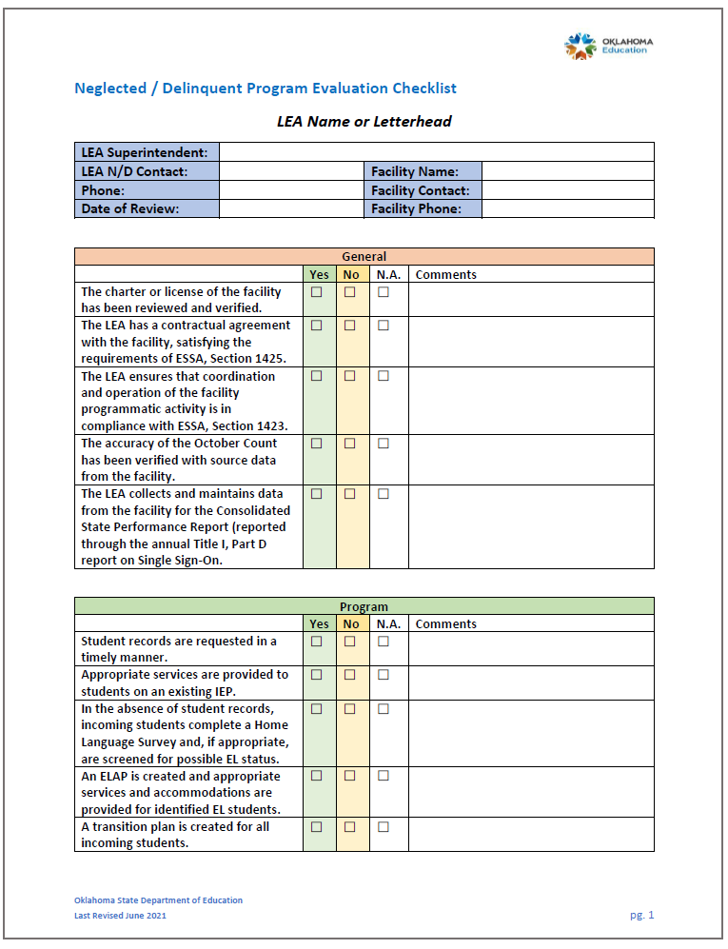
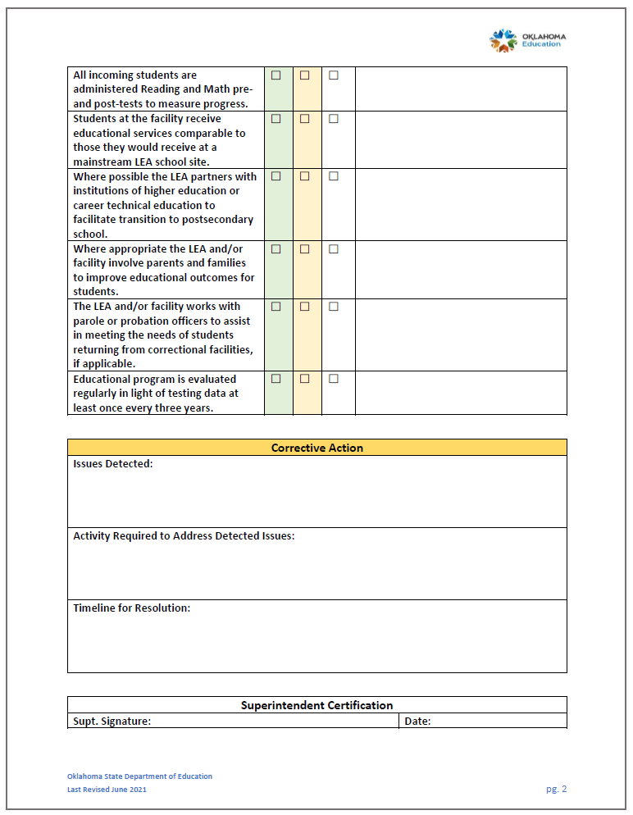

Neglected and/or Delinquent Transition Plan

This form is available on the Office of Title Services webpage.

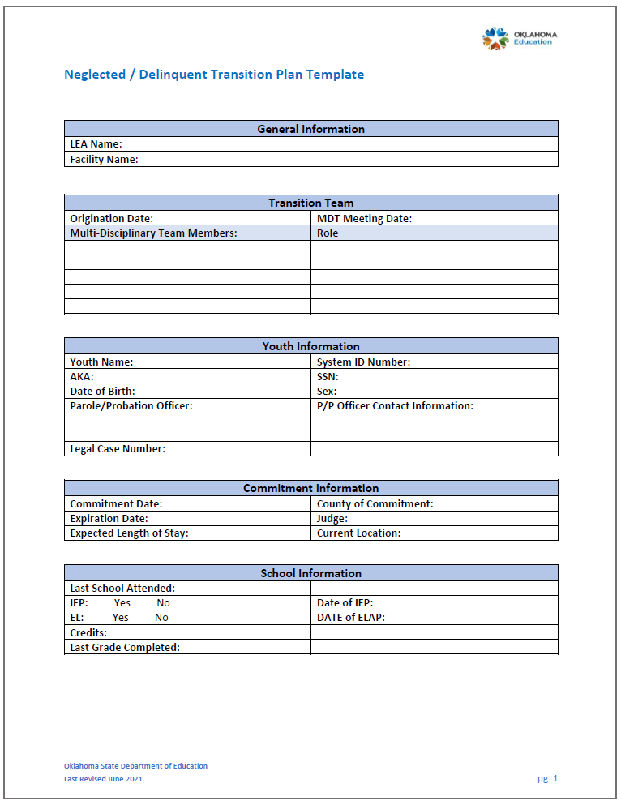
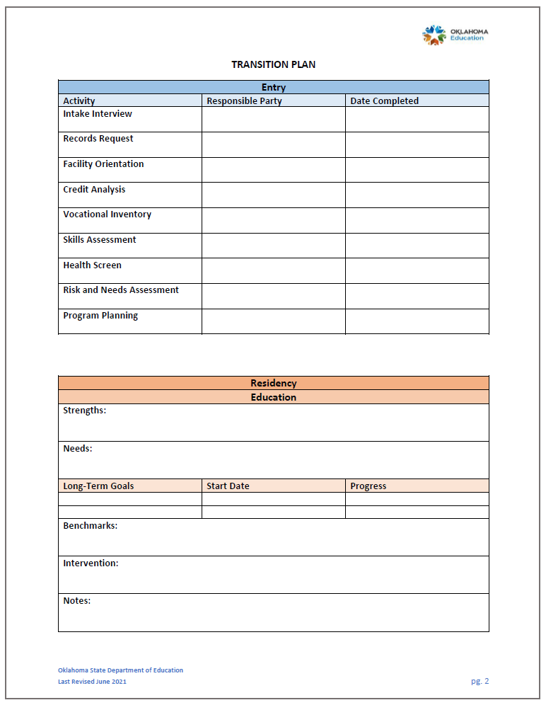

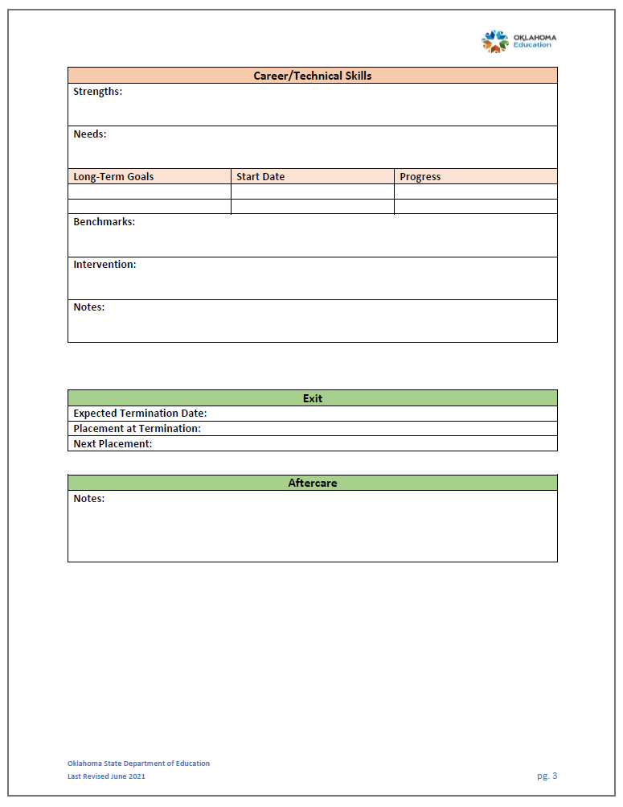

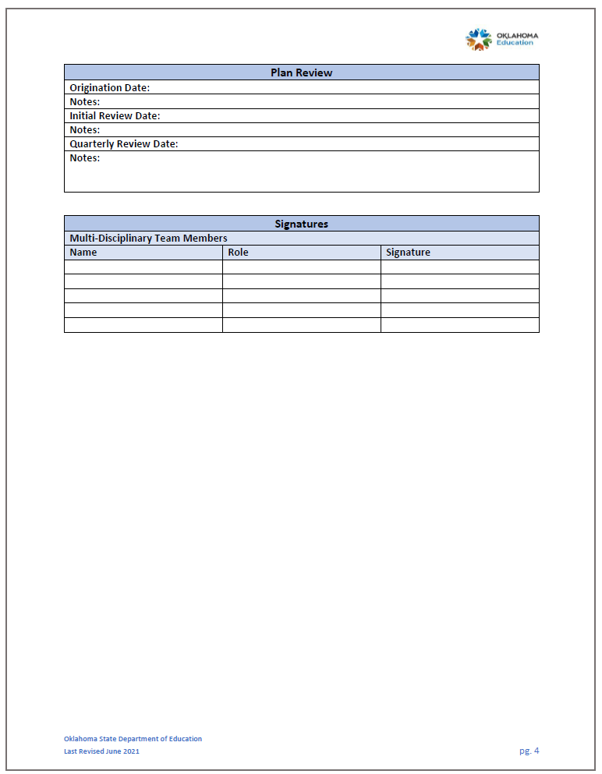

Home Language Survey - English
This form is available with prepopulated drop-down fields.

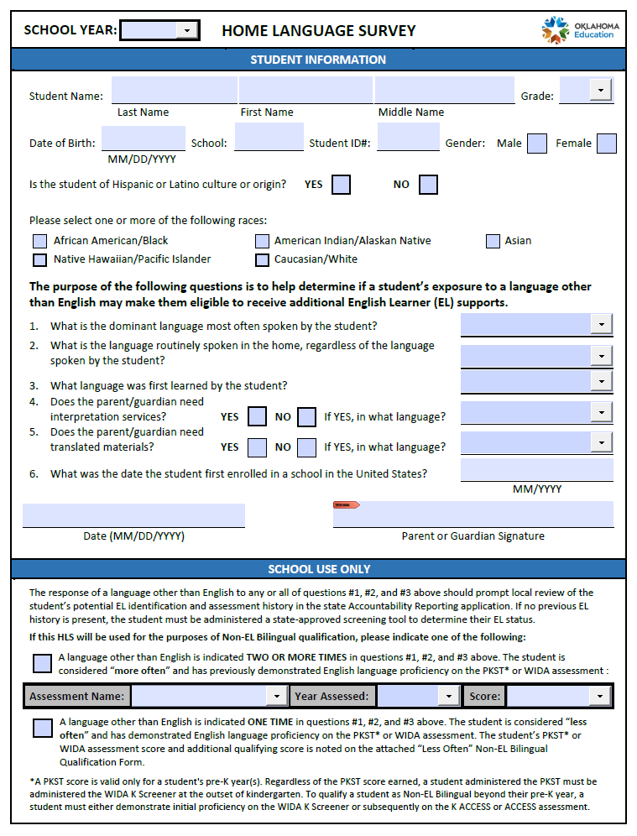

Home Language Survey – Spanish
This form is available with prepopulated drop-down fields.

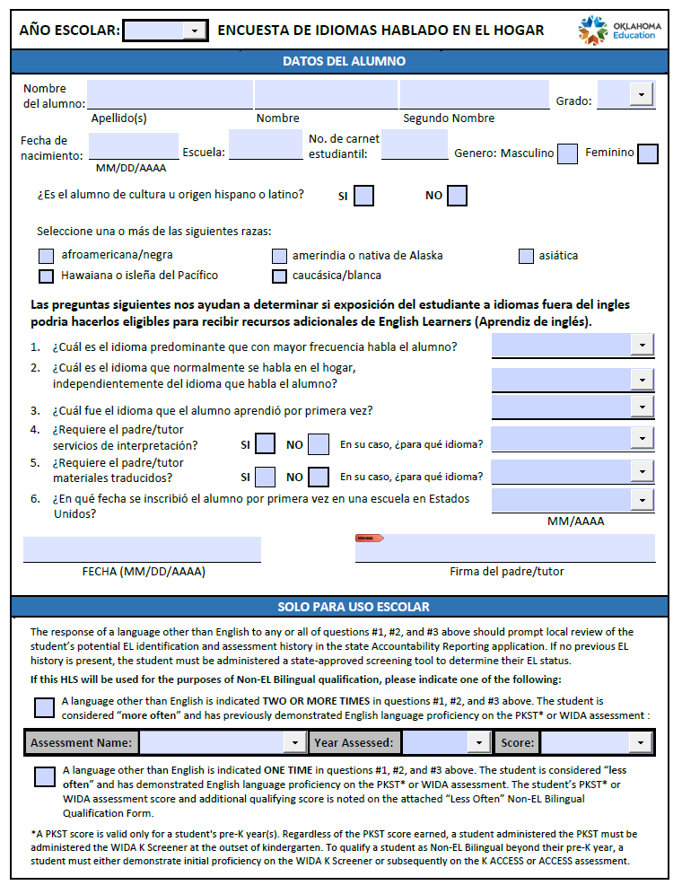

Home Language Survey Supplement – “Less Often” Non-EL Bilingual Qualification Form
This form is available with prepopulated drop-down fields.

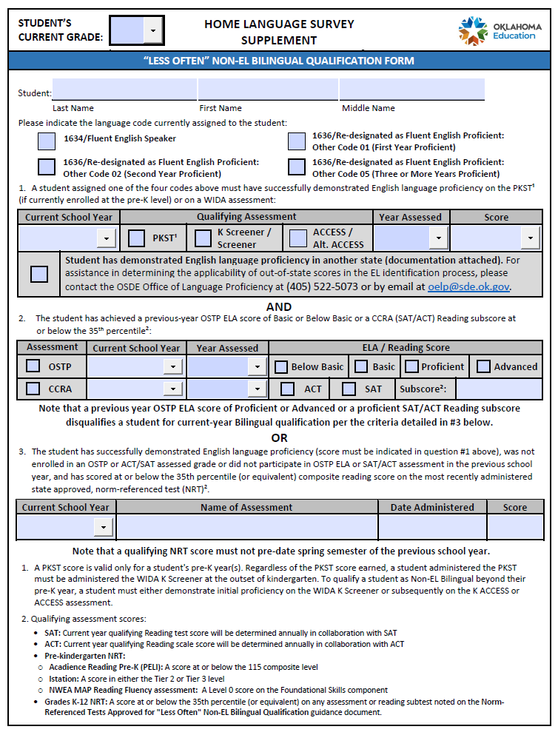

English Language Academic Plan (ELAP)

Any student identified as English Learner (EL) through the state English Learner Proficiency Assessments (ELPA), currently the WIDA spectrum of exams, must have a completed English Language Academic Plan (ELAP) on file and accessible to appropriate instructional personnel. The form is available for download.

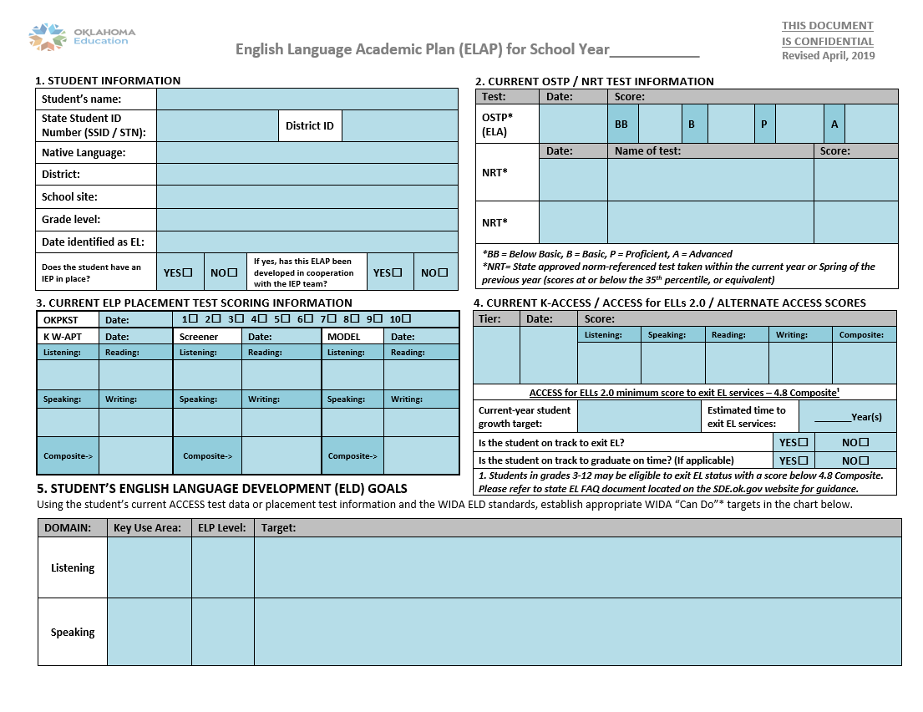
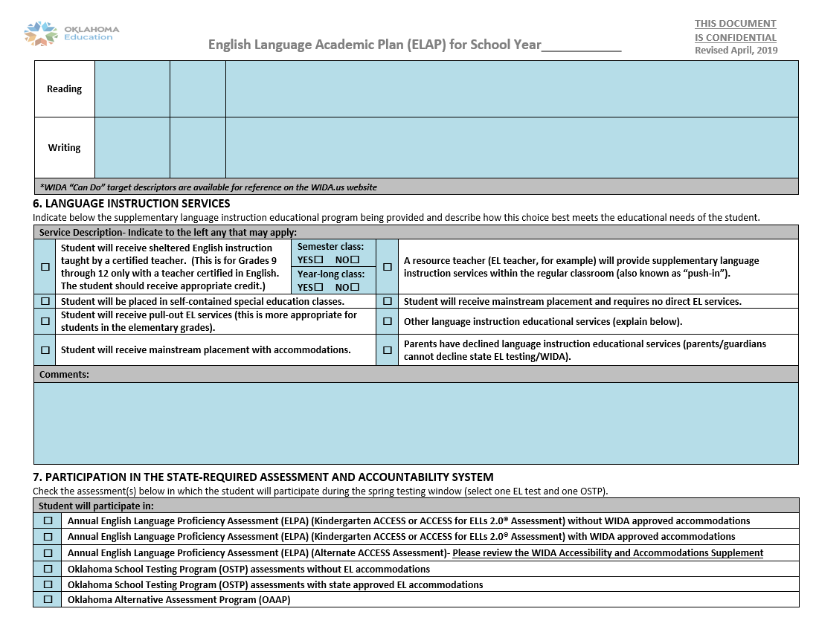

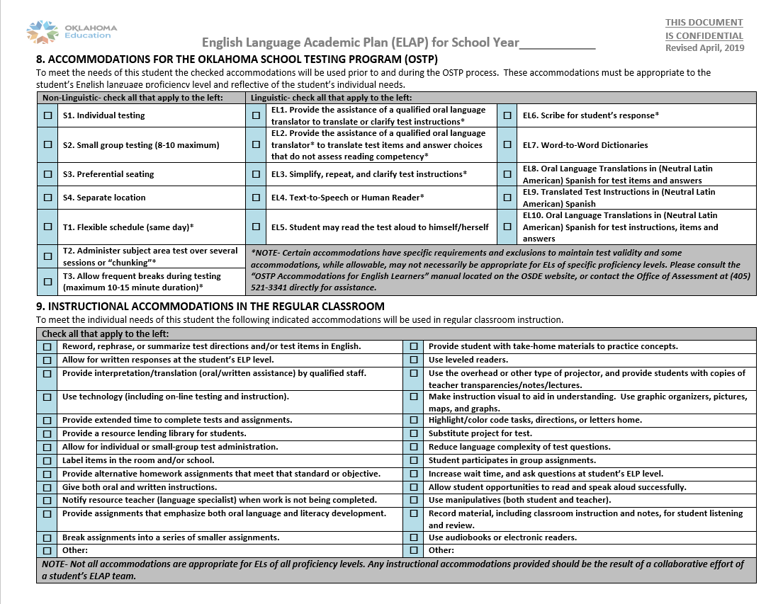

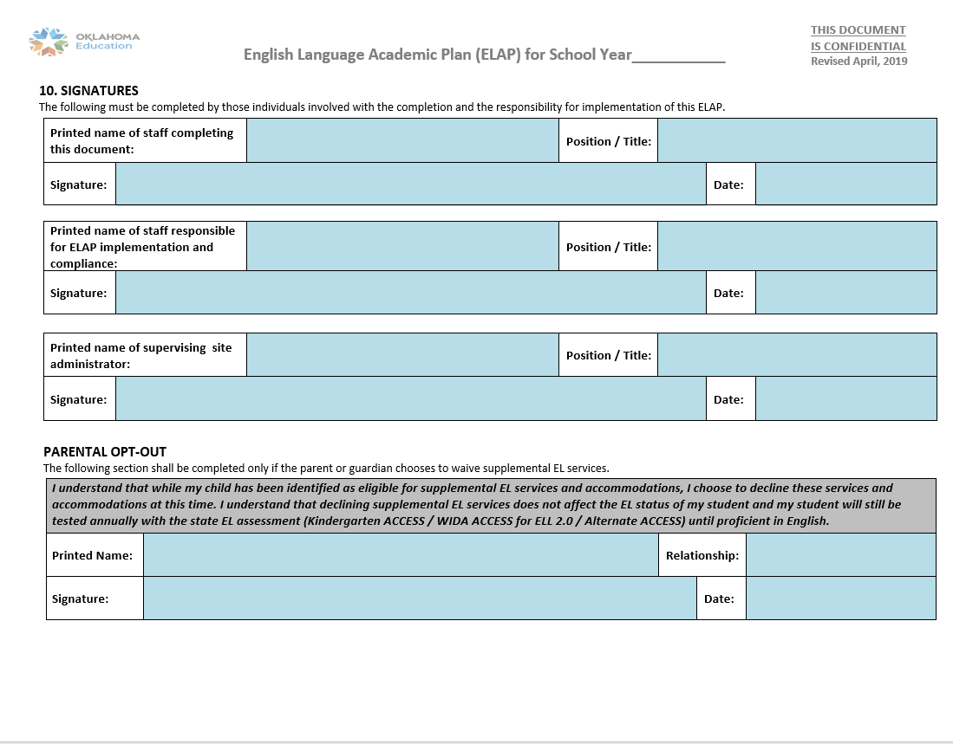

English Learner Monitoring Form

This form is available for download.

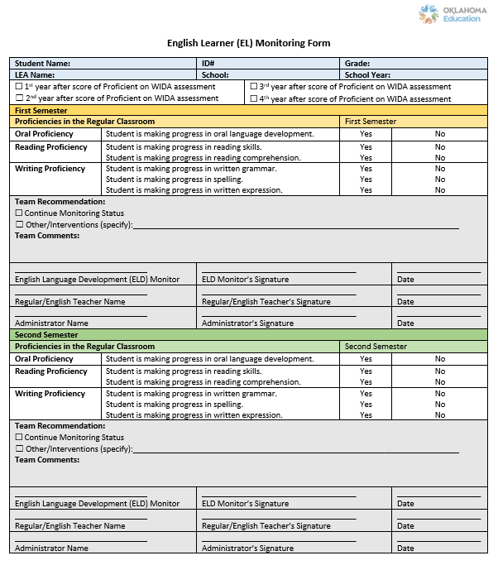

WIDA ACCESS and ALT-ACCESS Security Checklists

These forms are available for download.

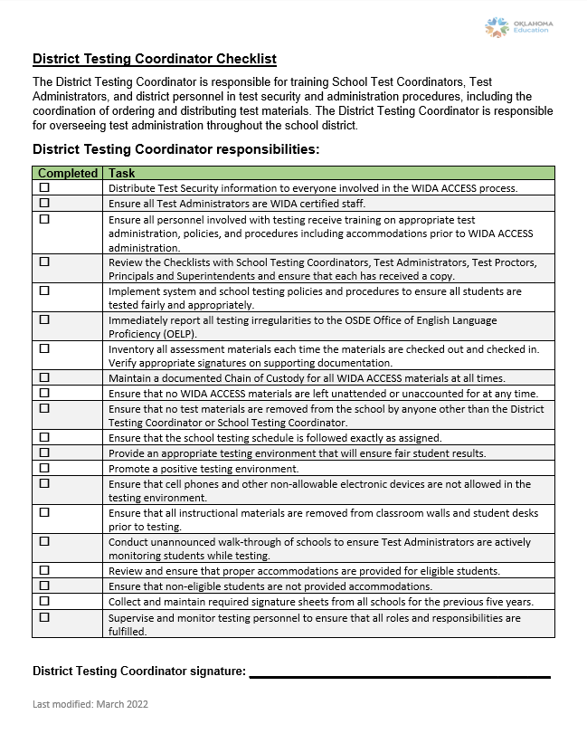

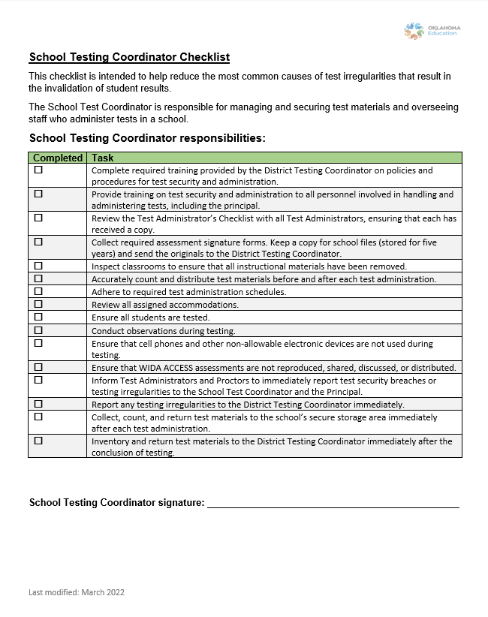

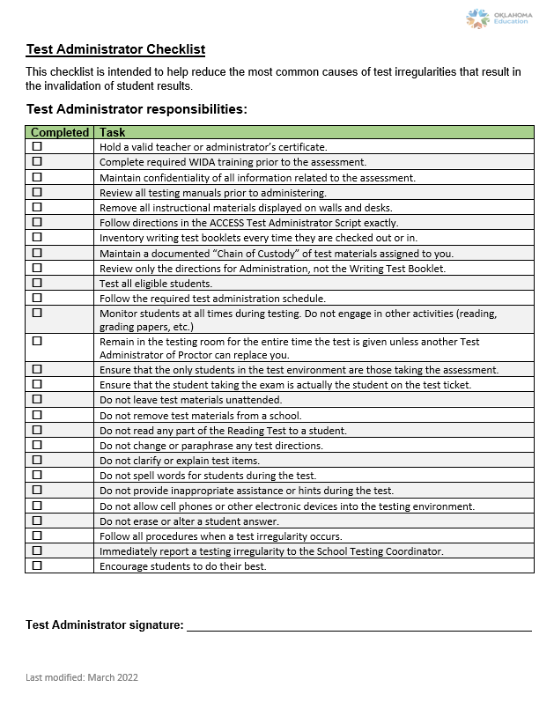

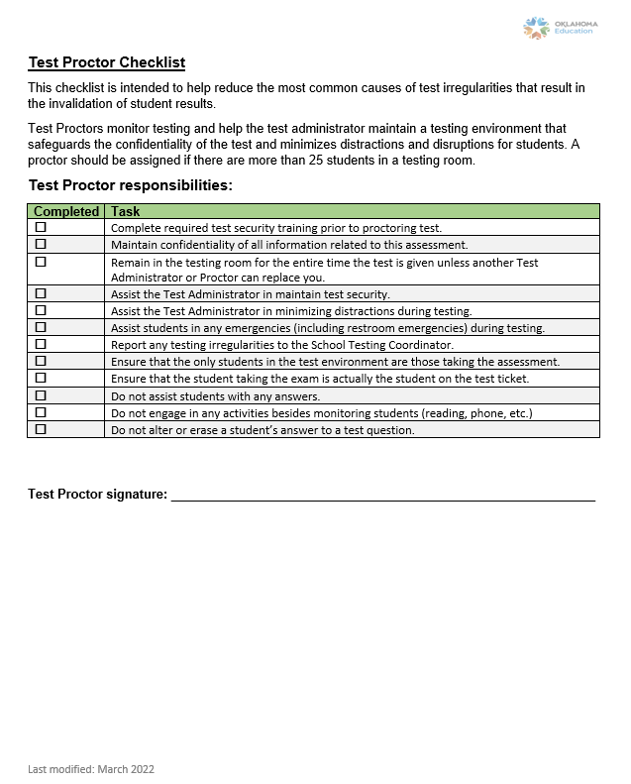

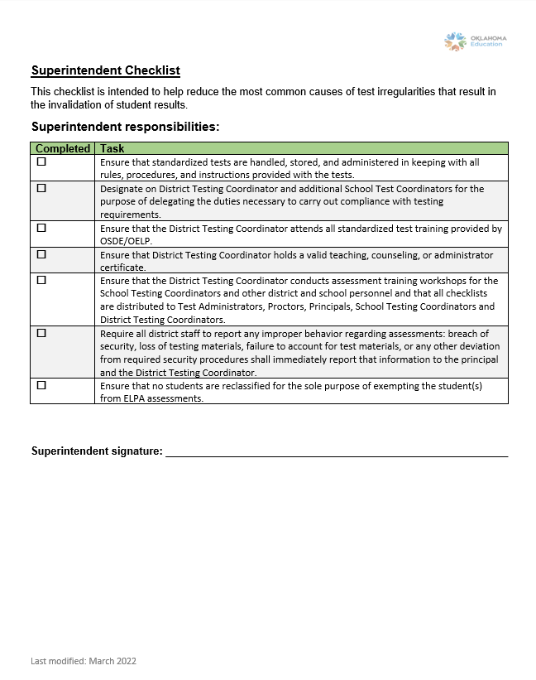

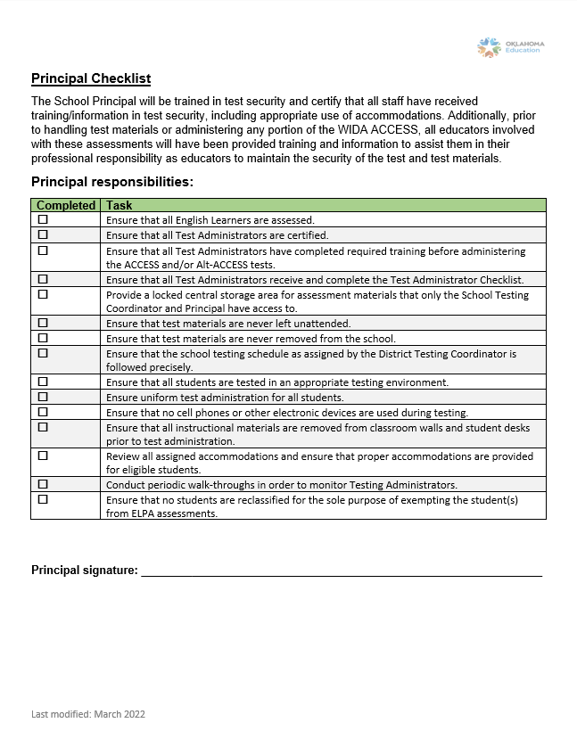

Student Residency Questionnaire

This form is available for download on the Office of Title Services webpage. The district is required to collect all information in this form. 70 O.S. § 1210.210
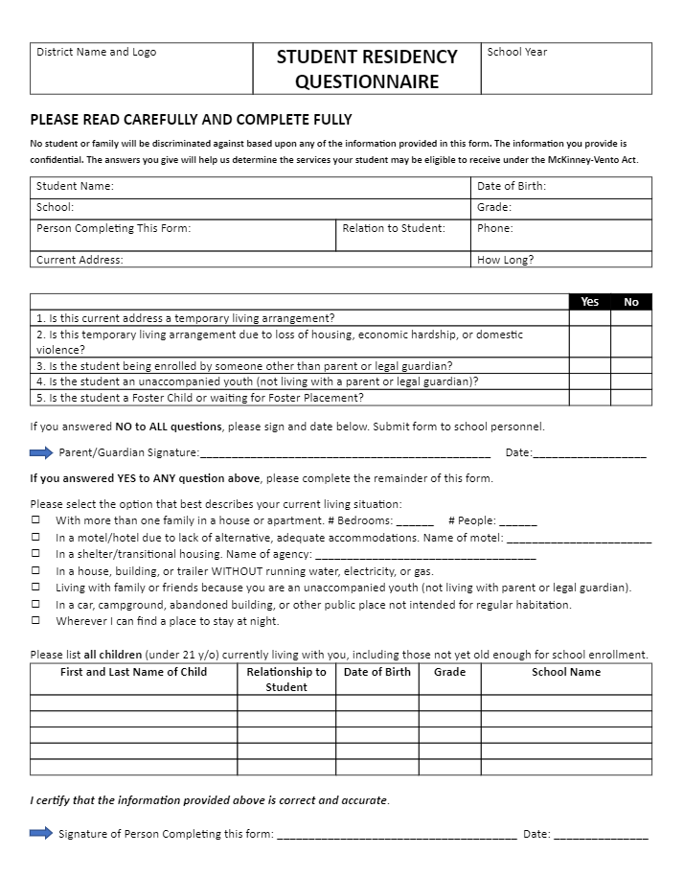
Best Interest Determination (BID) for School Placement (McKinney-Vento)

This form is available for download on the Office of Title Services webpage.

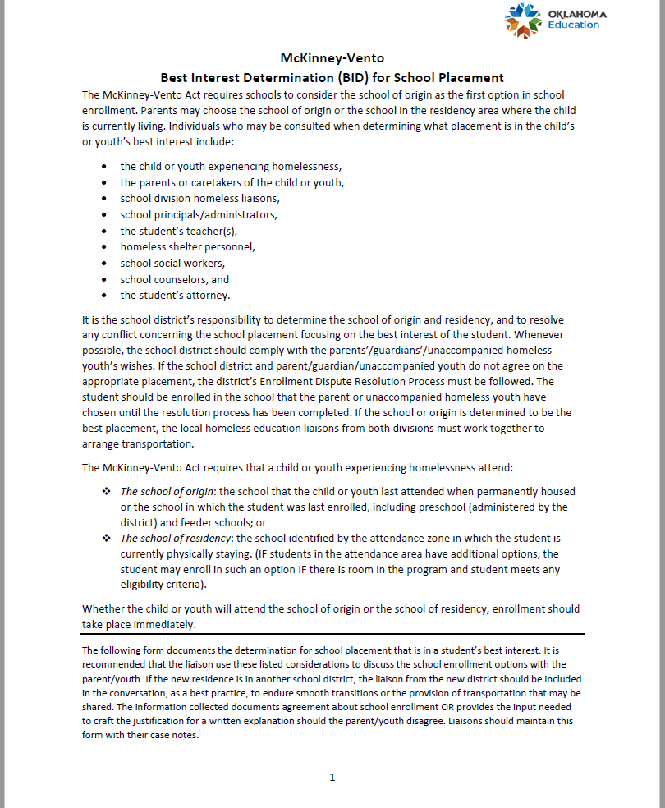
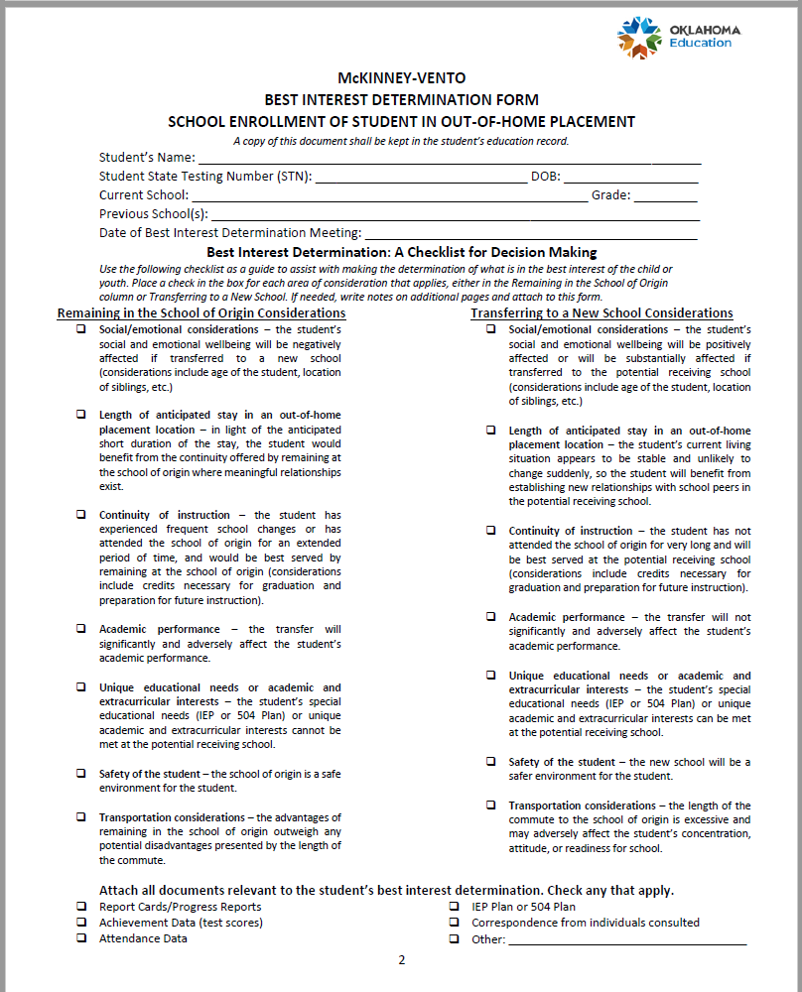

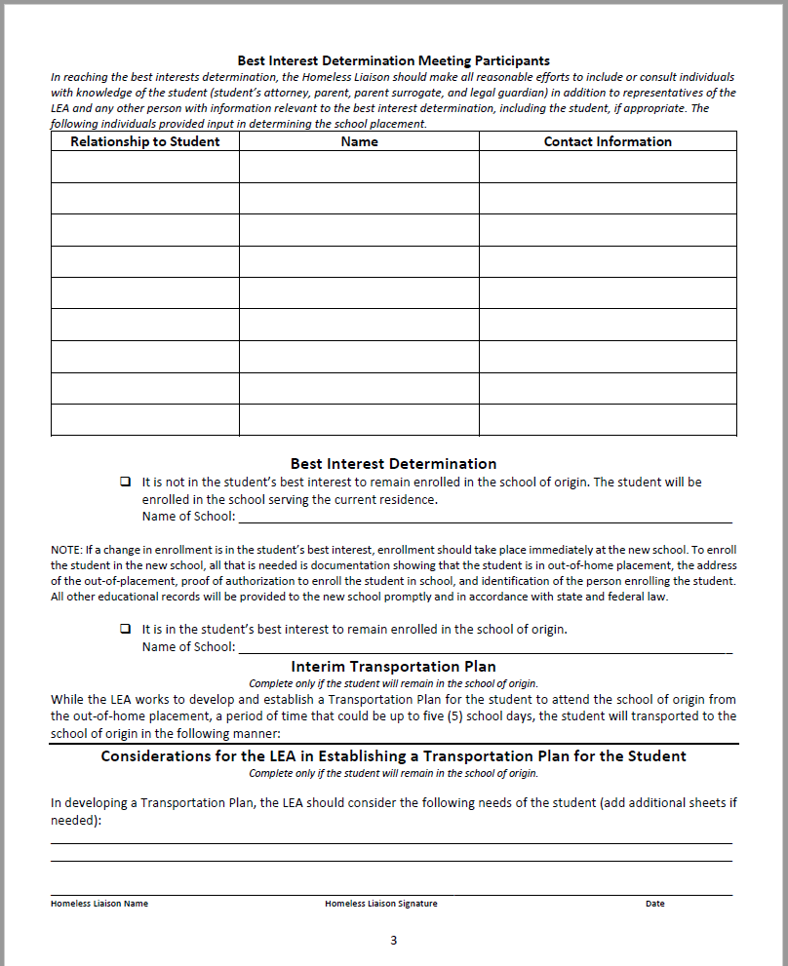

Best Interest Determination (BID) for School Placement (Foster Care)
This form is available for download on the Office of Title Services webpage.

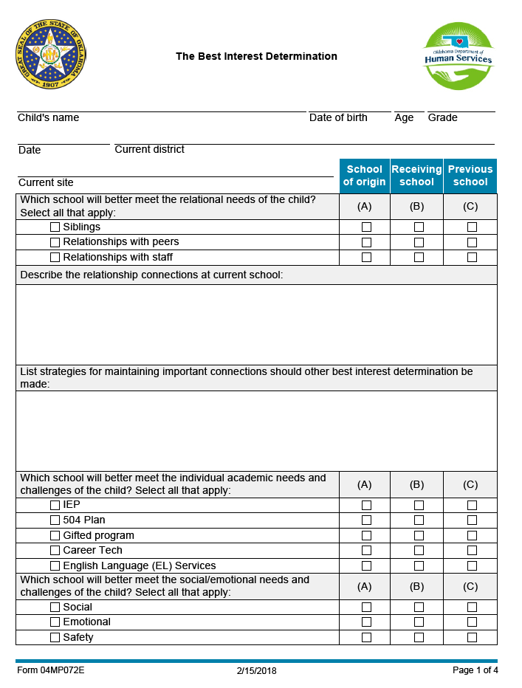
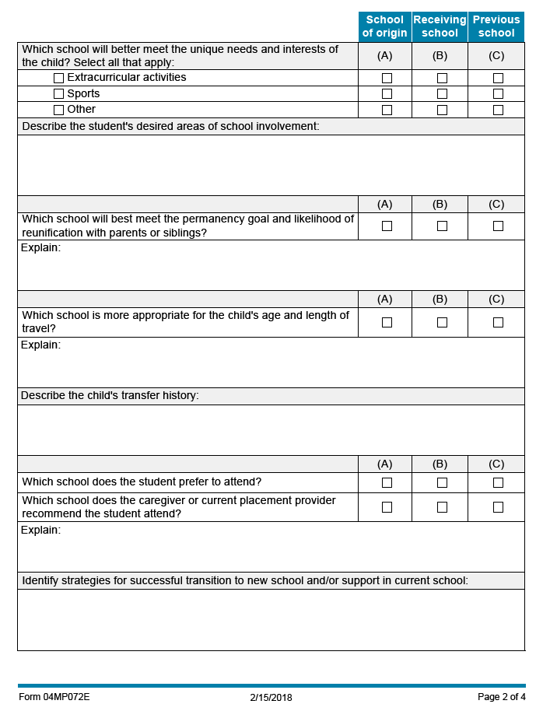
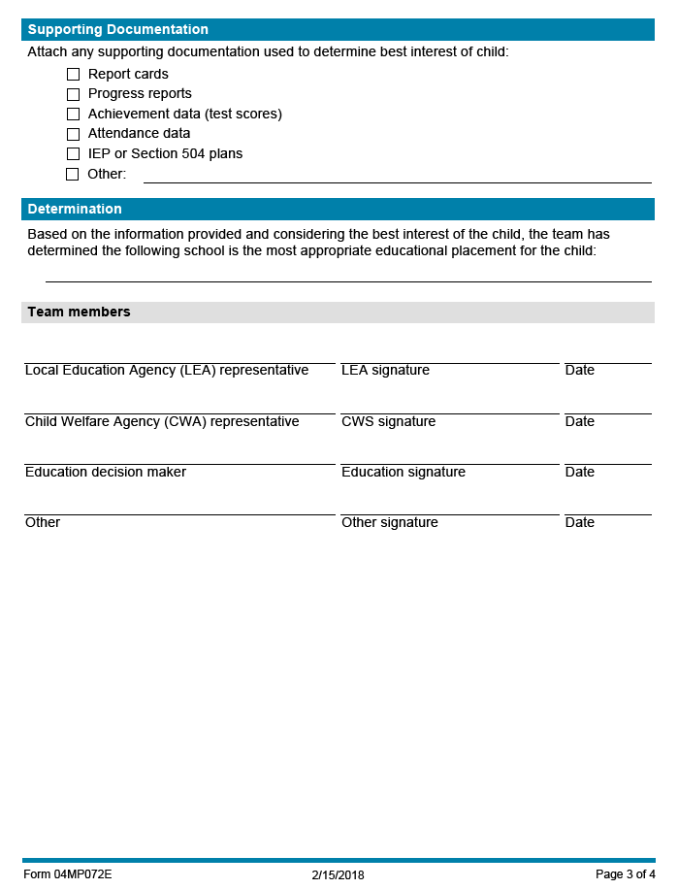
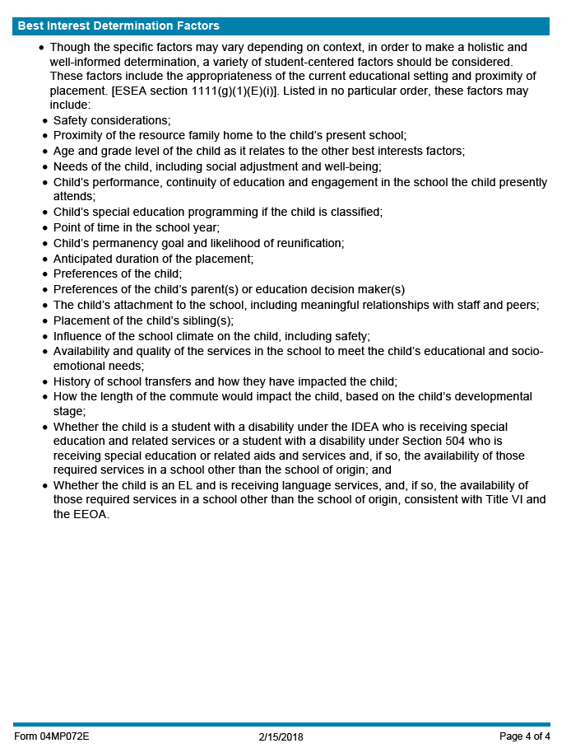
ESSA Tribal Consultation Agreement

This document is available for download as part of the Tribal Consultation Guide on the Office of American Indian Education webpage.

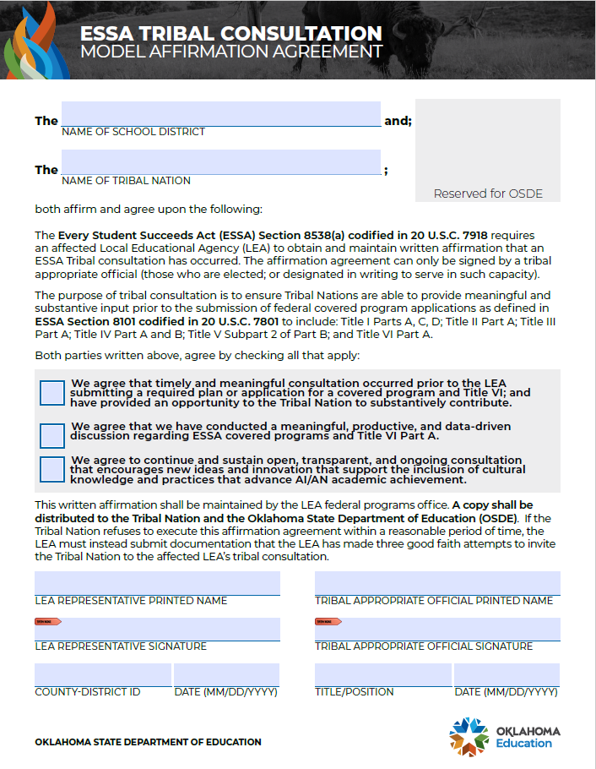
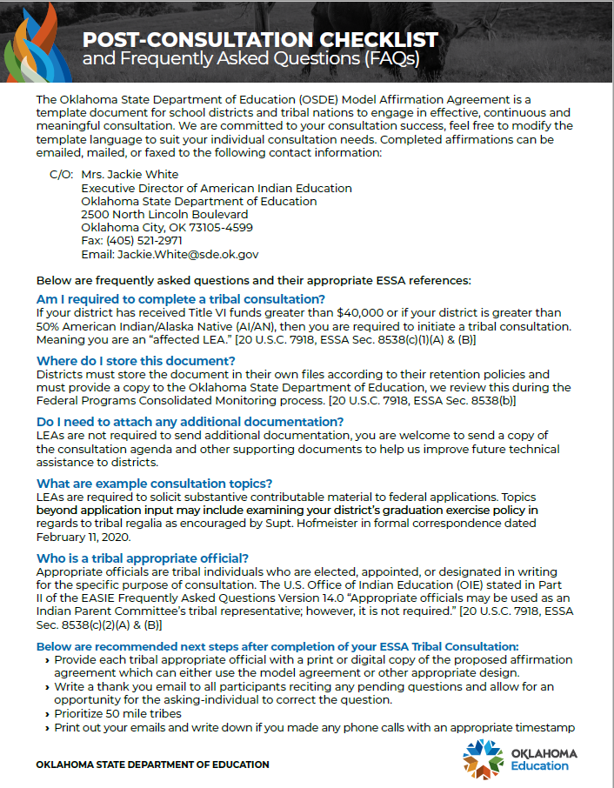

Regulations Regarding Evidence-Based Research and Interventions

The term “Evidence-based” appears throughout the Every Student Succeeds Act where it’s meaning in the context of education is defined. The Interim Final Requirements for the American Rescue Act (ESSER III) also mandate that ARP/ESSER III funds must be used on “Evidence-based interventions.”

Original ESEA definition of “Evidence-Based Intervention” ESEA Section 8101(21)(A)

… the term “evidence-based,” when used with respect to a State, local educational agency, or school activity, means an activity, strategy, or intervention that –

i) Demonstrates a statistically significant effect on improving student outcomes or other relevant outcomes based on –
I) strong evidence from at least one well-designed and well-implemented experimental study;
II) moderate evidence from at least one well-designed and well-implemented quasi-experimental study; or
III) promising evidence from at least one well-designed and well-implemented correlational study with statistical controls for selection bias; or
ii)
I) demonstrates a rationale based on high-quality research findings or positive evaluation that such activity, strategy, or intervention is likely to improve student outcomes or other relevant outcomes; and
II) includes ongoing efforts to examine the effects of such activity, strategy, or intervention.

A series of tables describing a number of evidence-based interventions, along with their assigned rankings (Tier 1 – strong evidence, Tier 2 – moderate evidence, etc.) and links to the literature and studies behind them can be found on the Office of Title Services (OTS) webpage and scroll down to the Evidence-Based Practice tile.

Sample Intervention/Program Evaluation From

This form is available for download.
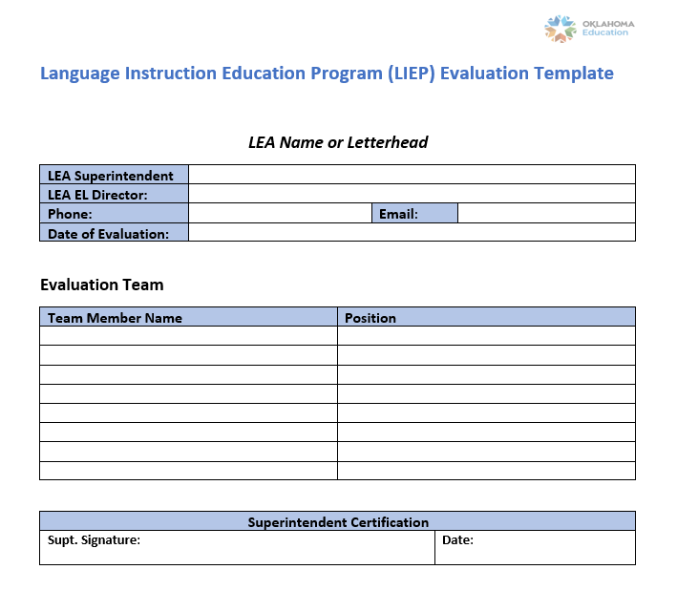

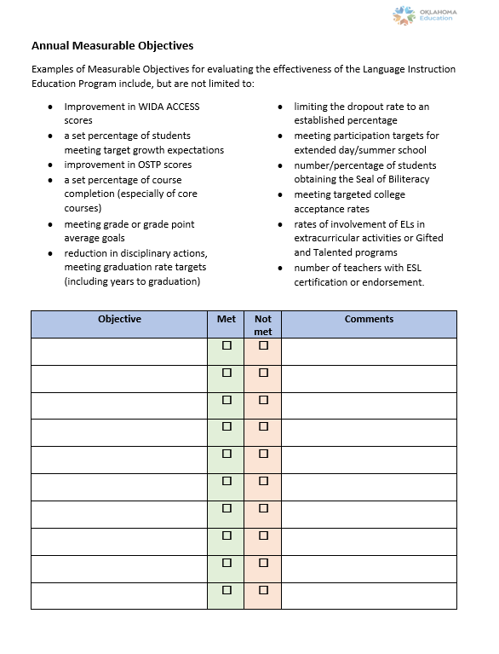

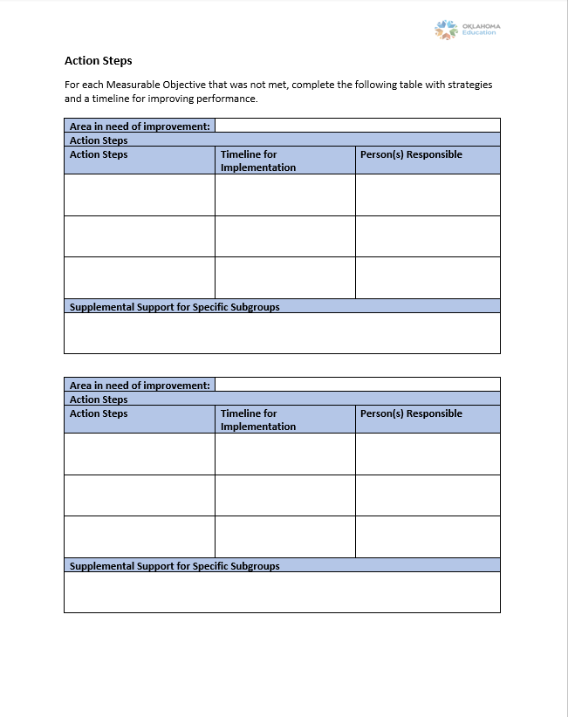

List of Required Policies and Procedures

Components of all the required administrative policies and procedures may be found in Every Student Succeeds Act (ESSA) and the Uniform Grant Guidance. According to the Oklahoma Administrative Code §210:35-3-48(a)(1) policies must be approved by the local board of education.

Required Policies
- Compensation Policy 2 C.F.R §200.430(a)(1)
- Travel Policy 2 C.F.R. §200.475
- Federal Programs Complaint Policy 34 C.F.R. §300.151, 34 C.F.R. §75.1(b)
- Military Recruiter Access Policy ESEA Section 8528
- Conflict of Interest Policy 2 C.F.R. §200.112, 2 C.F.R. §200.318(c)(1), 34 C.F.R. §75.525
- Homeless Students’ Rights Policy McKinney-Vento Homeless Assistance Act, Sec.722; Title 42 U.S.C. §11432(g)(1)(F)(i)(ii)(iii); §11432(g)(1)(J)(i)(ii)(iii);§11432(g)(1)(I)
- Parent and Family Engagement Policies (District and School Site) ESEA Section 1116(a)(2), ESEA Section 1116(b)(1)

Required Written Procedures
- Inventory procedures 2 C.F.R §200.302 (b)(4), 2 C.F.R §200.314, 2 C.F.R §200.453, 2 C.F.R. §200.313
- Cost allowability procedures 2 C.F.R. §200.302(b)(7)
- Financial management system procedures 2 C.F.R. §200.302(a)
- Cash management procedures 2 C.F.R. §200.302(b)(6), 2 C.F.R. §200.305
- Internal control procedures 2 C.F.R. §200.303
- Procurement procedures 2 C.F.R. §200.318, 2 C.F.R. §200.319, 2 C.F.R. §200.320, 2 C.F.R. §200.321, 2 C.F.R. §200.322, 2 C.F.R. §200.323, 2 C.F.R. §200.324, 2 C.F.R. §200.325, 2 C.F.R. §200.326, 2 C.F.R. §200.327,
- Maintenance of Effort procedures ESEA Section 8521
- Comparability procedures ESEA Section 1118(c)(1)(A)
- Time Distribution Records procedures 2 C.F.R. §200.430(i)
- Record management procedures 2 C.F.R. §200.335
- Written standards of conduct covering organizational conflicts of interest for an LEA that has a parent, affiliate, or subsidiary organization that is not a state, local government, or Indian tribe. 2 C.F.R. §200.318(c)(2)
- Professional Development (PD) procedures/plan 70 O.S. § 6-192
- Homeless confidentiality procedures McKinney-Vento Homeless Assistance Act, Sec.722, Title IX A; Title 42 U.S.C. §11432] (3)(G)
- Migrant Education Program (MEP) quality control procedures ESEA Section 1303(f)
- Procedures for monitoring the accuracy of information on the original Certificate of Eligibility (COE) in MIS2000 34 C.F.R §200.89(b)
- Homeless Complaint Resolution Procedures McKinney-Vento Homeless Assistance Act, Section 722; TITLE 42 U.S.C. §11432(g)(3)(B)(iii)
- Procedures that federal funds (Title II, Part A, Title IV, Part A and Title V) are not used to supplant state and local funds ESEA Section 2212(g), ESEA Section 4110, ESEA Section 5232
- Procedures for migrant students who qualify for Priority for Services (PFS) ESEA Section 1304(d)
- Procedures for migrant students who qualify for Continuation of Services ESEA Section 1304(e)
- Procedures for determining program services to nonpublic students and teachers ESEA Section 1117(a)(1)(A), ESEA 8501(c)
- Procedures for monitoring federal programs at participating nonpublic schools ESEA Section 1117(a)(1)(B), ESEA 8501(a)(3)(A)
- Nonpublic School Complaint procedures ESEA Section 1117(b)(2), ESEA 8501(c)(2)
- Procedures for alternative placements of neglected or delinquent students ESEA Section 1414(c)(13), ESEA Section 1423(13)
- Procedures for transitioning students from neglected/delinquent institutions to locally operated programs ESEA Section 1414(c)(9), ESEA 1423(7)

Single Audit

Background
Each year, the federal government provides over $400 billion–one-sixth of the federal budget–in grants to non-federal entities (states, local and tribal governments, colleges and universities, and other non-profit organizations). Audits are a primary tool used by the federal government to ensure that these funds are expended properly.

Basic Requirements
All non-federal entities that expend $750,000 or more of federal awards in a year are required to obtain an annual audit in accordance with the Uniform Grant Guidance (UGG) Code of Federal Regulations (CFR) Subpart F. 2 C.F.R § 200.501(a) reads - A non-Federal entity that expends $750,000 or more during the non-Federal entity’s fiscal year in Federal awards must have a single or program-specific audit conducted for that year in accordance with the provisions of this Part. Entities expending less than $750,000 in a year are exempt from federal audit requirements but must make records available for review or audit by federal agencies or pass-through entities (non-federal entities from whom they receive Federal funds), if requested.

What is a Single Audit?

The single audit is a tool to help program and tribal management monitor federal program activities. A single audit includes a review of both your organization’s financial statements and compliance with federal award requirements for those programs identified as "major programs" (based on application of the risk based approach and criteria outlined in 2 C.F.R § 200.518 and .519) for the audit. Through the audit process the auditors determine whether your organization’s financial statements fairly present the financial position of the organization and whether they are presented in accordance with Generally Accepted Accounting Principles (GAAP) or another comprehensive basis of accounting. Both the financial statement audit and the compliance audit provide information on the internal controls design appropriateness and operating effectiveness, which enables management to identify systematic weaknesses in a timely manner.

Primary Responsibilities
In addition to the responsibility to administer federal awards in compliance with federal requirements, the non-federal entities have a key role to play in the single audit process:

- Identifying federal awards received and expended. The non-federal entity is required to account for federal funds received and expended by individual award. This information is usually provided in grant award documents. Check with the awarding agency if there are any questions.

- Preparing financial statements and a Schedule of Expenditures of Federal Awards (SEFA). Most non-federal entities prepare annual financial statements for their own purposes and are familiar with the process. An auditor can usually answer any questions on financial statement preparation.

- Obtaining the audit and ensuring it is completed. The single audit must be performed by an independent auditor and the reporting package (which includes the audit report) must be submitted to the Federal Audit Clearinghouse within 30 days after your organization receives the audit report or nine months from your organization’s fiscal year end. The single audit must also be submitted to the pass-through entity. Contact the Office of Financial Accounting at the Oklahoma State Department of Education for additional information.

- Taking corrective action on audit findings. The non-federal entity is required to prepare a corrective action plan that addresses each audit finding. The affected federal awarding agency(ies) or pass-through entity(ies) will contact the non-federal entity on the acceptability of the corrective action plan or alternative actions.

Failure to meet the single audit requirements could result in the non-federal entity having to repay grant monies and/or losing access to future federal funding.

¹This form is applicable for institutions that are requesting documentation from students who are enrolling in college for the 20XX-XX award year who were not previously determined to be an unaccompanied homeless youth, or an unaccompanied youth who is self-supporting and at risk of homelessness. Students who were determined to be unaccompanied homeless youth, or at unaccompanied youth who is self-supporting, and at risk of homelessness, in the prior award year are presumed to be independent for each subsequent year at the same institution, unless the student informs the institution that circumstances have changed, or the institution has specific conflicting information about the student’s independence and has informed the student of this information.

