Amanda Otis  State Purchasing Director  Central Purchasing | 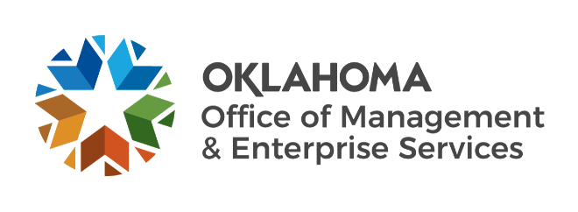 | Mark Wood  OMES Director

Central Purchasing Solicitation Intake Form

This completed form must be attached to the requisition for any solicitation that OMES Central Purchasing (CP) will administer. If an agency needs assistance to complete this document or with drafting their specifications to ensure a quality solicitation, reach out to central.purchasing@omes.ok.gov.

Agency confirms having conducted a search of available statewide contracts for this good/service and that this acquisition is not available through an existing contract.

AGENCY INFORMATION
Agency CPO name: Click or tap here to enter text.
Agency CPO email: Click or tap here to enter text. Phone number: Click or tap here to enter text.
Email(s) of other agency contacts that should be notified of updates: Click or tap here to enter text.
Name of agency signature authority: Click or tap here to enter text.
Email of agency signature authority: Click or tap here to enter text.
Agency legal review name: Click or tap here to enter text.
Agency legal review email: Click or tap here to enter text.
Will agency attorney sign the contract to approve content? Click or tap here to enter text.
Physical address for invoice submission:
Street address: Click or tap here to enter text.
City, State ZIP code: Click or tap here to enter text.
Invoicing email: Click or tap here to enter text.
General description of the good or service being procured: Click or tap here to enter text.

IT SOLICITATION ONLY
Provide the name and contact information for your designated IT stakeholder. If your agency has an internal CTO, list that person as the IT stakeholder.
If your agency does not have a CTO, list the OMES IT stakeholder assigned to your project in the Project Initiation Request (PIR) in ServiceNow.
IT stakeholder name: Click or tap here to enter text. IT stakeholder email: Click or tap here to enter text.

EVALUATION TEAM (OMES CP recommends at least three and at most five team members.)
Name: | Click or tap here to enter text. | Email: | Click or tap here to enter text.
Name: | Click or tap here to enter text. | Email: | Click or tap here to enter text.
Name: | Click or tap here to enter text. | Email: | Click or tap here to enter text.
Name: | Click or tap here to enter text. | Email: | Click or tap here to enter text.
Name: | Click or tap here to enter text. | Email: | Click or tap here to enter text.

SUGGESTED INTERESTED SUPPLIERS (Add additional lines as needed.)
Company name: Click or tap here to enter text.
Company point of contact name: Click or tap here to enter text.
Company point of contact email: Click or tap here to enter text.

Company name: Click or tap here to enter text.
Company point of contact name: Click or tap here to enter text.
Company point of contact email: Click or tap here to enter text.

GENERAL SPECIFICATIONS FOR THE SOLICITATION (Describe.)
Click or tap here to enter text.

CHECKLIST (Check the box of each completed item.)
Please complete the following required solicitation documents, which can be found on the OMES Central Purchasing Template Contract Documents page:
CP Solicitation Intake Form.
Bidder Instructions – Agency is responsible for middle section of the cover page. OMES Central Purchasing completes Event number, dates and contracting officer information.
Attachment A – Specification or description of what good or service is being procured.
Evaluation Tool – Required before posting. Evaluator names are required before receiving supplier responses.

The documents listed below are optional. If you have questions about what attachments are necessary for your specific procurement, please contact your lead CPO. If additional assistance is needed, please contact central.purchasing@omes.ok.gov.

Attachment C – Additional terms that the agency wants to attach to this agreement.
Attachment G – Federal terms. (Recommended when federal funds are being utilized.)
Exhibits – Examples: Cost Template, Supplier Response Template, etc.

