iPhone Outlook Setup

Overview
Steps to set up Outlook on iPhone.

Instructions
- Open the Outlook app. Select the photo/circle icon in the top left corner.
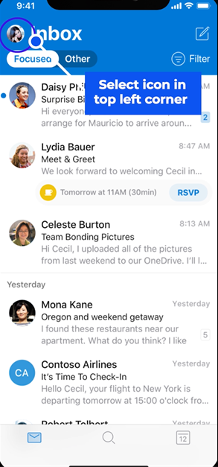

- Select the gear icon at the bottom left corner. Then, select Office 365.
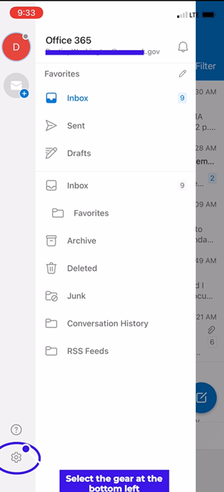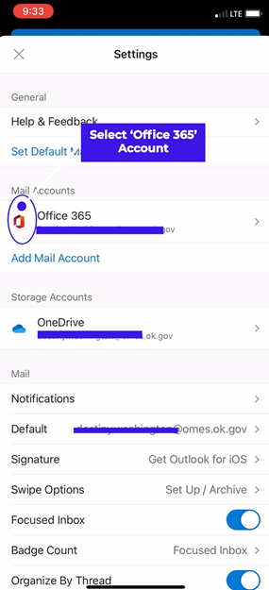

- Slide the button right to turn on Save Contacts. Then, select Save to my iPhone.
- Select OK to allow Outlook to access your contacts.
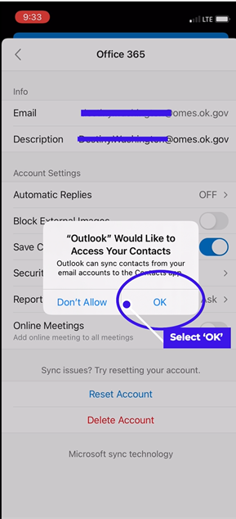
- Swipe up and go into Settings to begin contacts and calendar sync. Select Contacts.
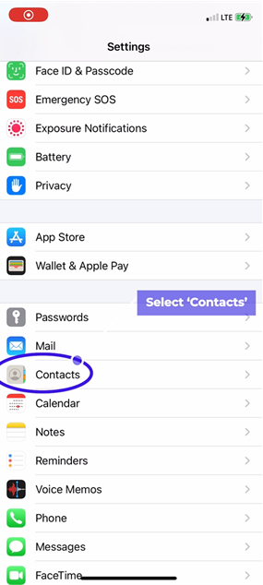
- Select Add Account. Then, select Microsoft Exchange.

- Enter your email. Sign into the Oklahoma portal.
- Slide the button left to turn off Mail.

- If you need additional help, contact the OMES Service Desk.

