iPhone Intune Setup

Overview
Steps to set up Intune on an iPhone that needs to be reset first.

Instructions
- Begin iPhone wipe. Go to Settings and select General. Next, select Reset. Then, select Erase All Content and Settings.
- You may get another message asking if you’re sure you want to continue. Select Erase All & Keep Cellular Plans.
- The phone will restart. Begin the setup by selecting your preferences.

- A Remote Management screen will pop up. OMES will then begin configuring the iPhone.
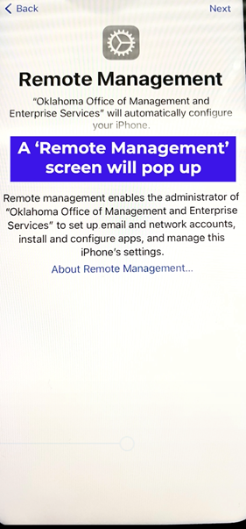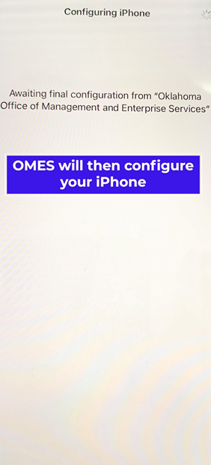
- After configuration, a Company Portal will pop up. Select Sign in. Then, enter your email.
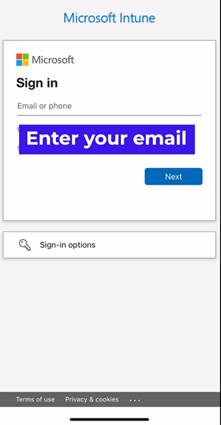

- Enter your credentials to sign into the Oklahoma portal.
- Select OK to set up notifications.
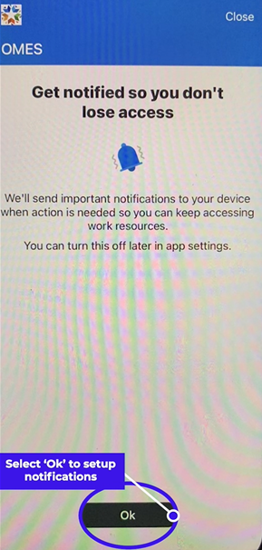

- Once you see the Check Device Settings screen, the device settings are complete. Don’t set a new password; swipe up to go back to the home screen.
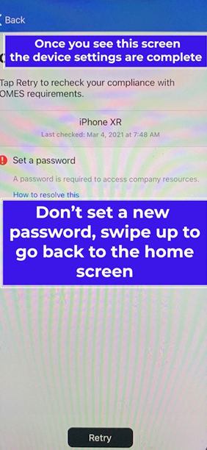
- Passcode Requirement notification will pop up. Select Change Now. Then, enter a new passcode.
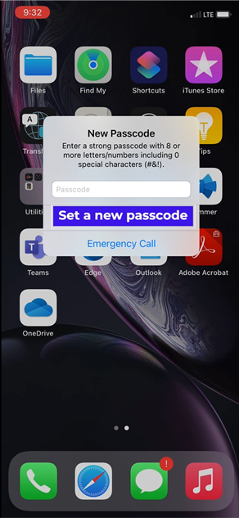

- If you need additional help, contact the OMES Service Desk.

