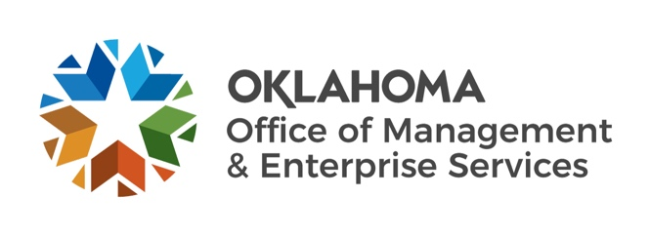
June 2021 BOE Budget Highlights

Purpose of June BOE meeting: To certify funds available for FY 2022 as a result of law changes made during the 2021 legislative session.

What’s changed since February BOE meeting:
- 2021 legislative session adjourned.
- ROADS Fund added as an authorized fund and is included in the total budget.
FY 22 Impact Summary of 2021 Session Law Changes*
General Revenue Fund (95%) | 1017 Fund | ROADS Fund | Special Cash Fund | State Transportation Fund
($140,576,378) | ($292,146,358) | $575,000,000 | $57,315,210 | ($19,315,210)
*Please see the June BOE packet Schedule 5 for a list of the bills along with the fiscal impact for each bill
that affected each of the funds.

FY 2022 highlights:
All Certified Funds Collections Estimate = $6,915,732,053; Appropriations Authority (95%) = $6,569,945,451
All Certified Funds change from February Estimate = decrease of $147,975,134; Appropriations Authority (95%) decreased $140,576,378
General Revenue Collections Estimate = $6,642,298,328; Appropriations Authority (95%) = $6,310,183,411
Total Budget (all certified and authorized funds, plus cash): $9,948,810,340
Total Budget change since February BOE: $308,334,399 or 3.2%
Total Authorized Expenditures (total amount spent by the Legislature): $9,064,748,251
Total Supplemental Expenditures: $233,722,507
Unencumbered/Unspent Difference: $884,062,089
FY 2023 estimates will be made in the upcoming December Board of Equalization meeting.

Comparison of February 2021 Expenditure Authority and
June 2021 Expenditure Authority
 | February 2021 Expenditure Authority | June 2021 Expenditure Authority | Difference
General Revenue Fund  (FY 2022) | $6,450,759,789 | $6,310,183,411 | ($140,576,378)
Total Authorized Budget | $9,640,475,940 | $9,948,810,340 | $308,334,399
*Total Authorized Budget includes General Revenue Fund and other funds. See June BOE Packet Appendix 1 for more detail.

Comparison of June 2021 Expenditure Authority and
2021 Session Authorized Expenditures
 | June 2021 Expenditure Authority | 2021 Session Authorized Expenditures | Difference
General Revenue Fund  (FY 2022) | $6,310,183,411 | $6,065,155,775 | ($245,027,636)
Total Authorized Budget | $9,948,810,340 | $9,064,748,251 | ($884,062,089)
*Total Authorized Budget includes General Revenue Fund and other funds. See June BOE Packet Appendix 2 for more detail.

Summary of Reserves and Unencumbered/Unspent Revenues
Fund | Amount
Rainy Day Fund (RDF) | $58.7 million
Revenue Stabilization Fund (RSF) | $171.2 million
Total Reserves (RDF and RSF) | $229.9 million
Anticipated Unspent Budget | $884.1 million
Current FMAP Rate Preservation Fund Balance | $33.5 million
FMAP Rate Preservation Fund Deposit | $164.1 million
Total | $1,311.6 million
*Requires end-of-year reconciliation.

The Official June BOE packet can be found online at the following link: https://oklahoma.gov/omes/services/budget/boe-packets.html.

