Eligibility renewals returning: WHAT PROVIDERS NEED TO KNOW

Due to COVID-19, Medicaid renewals were paused. However, Oklahoma will soon be required to restart eligibility reviews for all SoonerCare members. OHCA estimates approximately 300,000 ineligible members will be disenrolled from SoonerCare over a period of 9 months.
OHCA is sending four letters to affected members:

There will be a special enrollment period on the Affordable Care Act Marketplace for those who lose their Medicaid coverage due to the return of eligibility renewals. The special enrollment period will stretch from March 31, 2023, to July 31, 2024. If a member is no longer eligible for SoonerCare, OHCA will send their information to the ACA Marketplace. To find local, in-person help with finding a health care plan that is right for you on the ACA Marketplace, go to www.healthcare.gov/find-assistance.
If you have a member who has questions about this process, please refer them to MySoonerCare.org where they can update their information and find an FAQ about this process. If they still have question, they can also call the SoonerCare helpline at 800-987-7767.
Because members will lose coverage in phases, it is important providers verify eligibility on the date of EVERY service and not use a date span.
HOW TO CHECK ELIGIBILITY ON THE PORTAL
Step 1. Log into the Provider portal and select the elgibility tab. Then select Eligibility Verification.
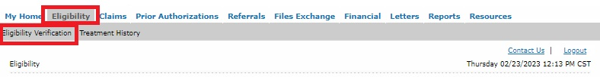
Step 2. Enter Member’s information. Enter the date of service in the “From Date” and “To Date”.
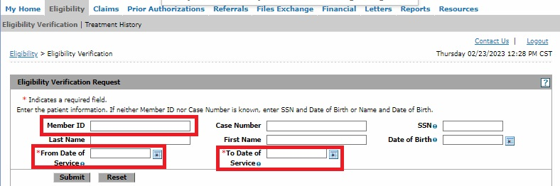
Step 3. Verify program coverage for the date of service.
