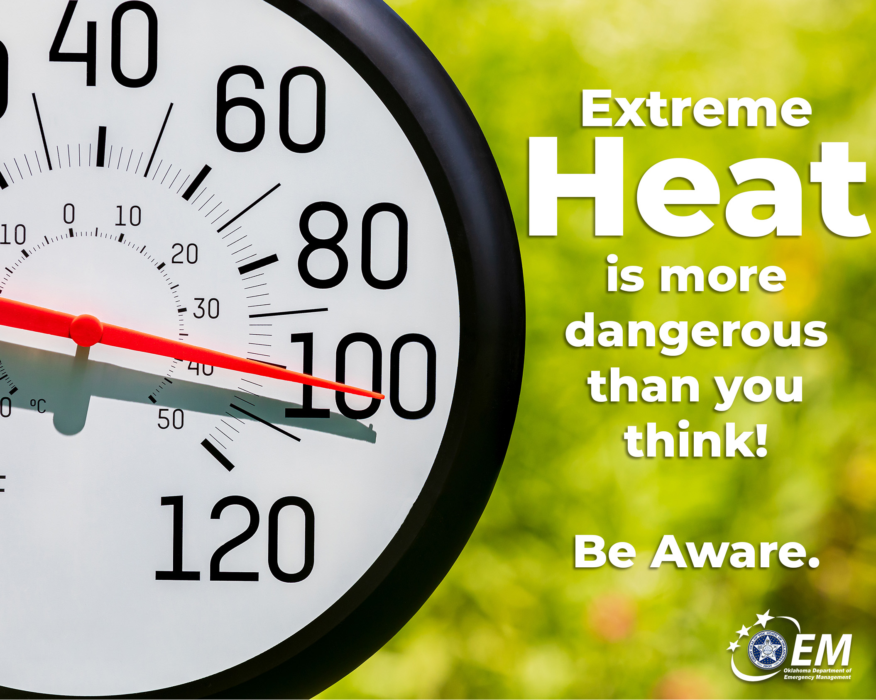

Extreme Heat is More Dangerous Than You Think
When people think about dangerous weather, 🌪️ tornadoes and 💦 floods often come to mind. But did you know, according to the National Weather Service, 🌡️ extreme heat is the number one weather-related killer in the United States?

The good news is that heat-related illnesses are often preventable. Drinking plenty of water, limiting time outdoors during the hottest part of the day, and finding ways to stay cool can help you avoid serious health problems.

A little preparation today can help you stay safe all summer long. ☀️

#ReadyOK #HeatSafety #OKWX

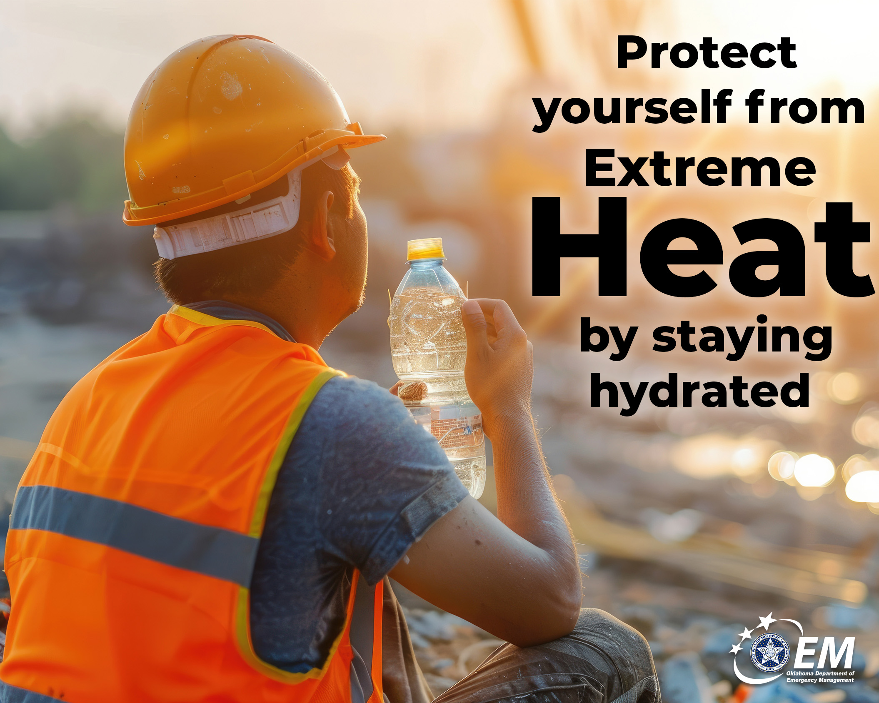

💧Stay Hydrated
Your body works harder to stay cool during hot weather, which means you lose fluids more quickly than you may realize.

Don't wait until you're thirsty to drink water. 💧Sip water throughout the day, especially if you're spending time outdoors. If you're working or exercising in the heat, take frequent water breaks and avoid drinks with excessive caffeine or alcohol, which can contribute to dehydration.

💧💧💧Staying hydrated is one of the easiest ways to protect yourself from ☀️heat-related illness.

#ReadyOK #HeatSafety #OKWX

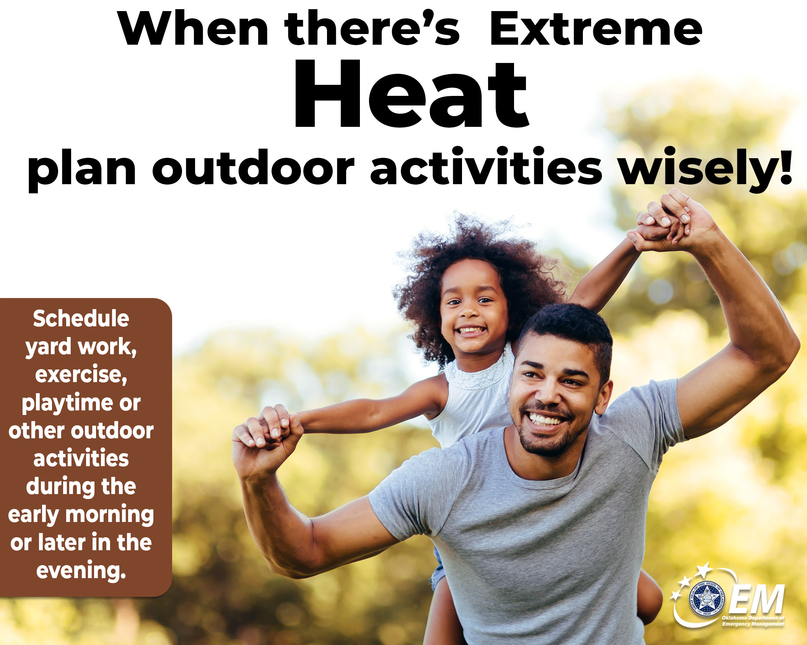

Plan Outdoor Activities Wisely
☀️Summer is a great time to enjoy the outdoors, but timing matters.

If possible, schedule yard work, exercise, or other outdoor activities during the early morning or later in the evening when temperatures are cooler. If you must be outside during the hottest part of the day, take frequent breaks in the shade or air conditioning and drink plenty of water💦.

Listening to your body is just as important as checking the forecast.

#ReadyOK #HeatSafety #OKWX

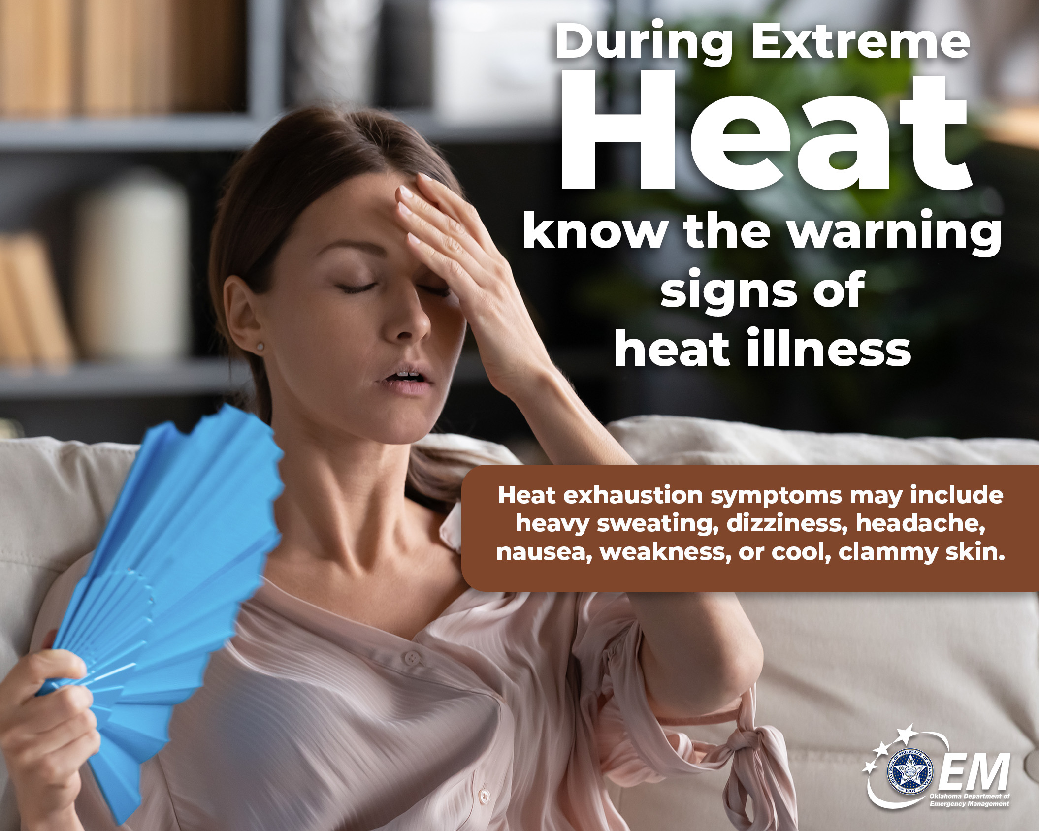

Know the Signs of Heat Illness
☀️ Extreme heat can affect anyone, but knowing the warning signs can help you respond quickly.

Heat exhaustion symptoms may include heavy sweating, dizziness, headache, nausea, weakness, or cool, clammy skin.

Heat stroke is a medical emergency. Watch for confusion, a high body temperature, hot or dry skin, seizures, or loss of consciousness. Call 911 immediately if you suspect someone is experiencing heat stroke.

Quick action can save a life. 🚑🚨

#ReadyOK #HeatSafety #OKWX

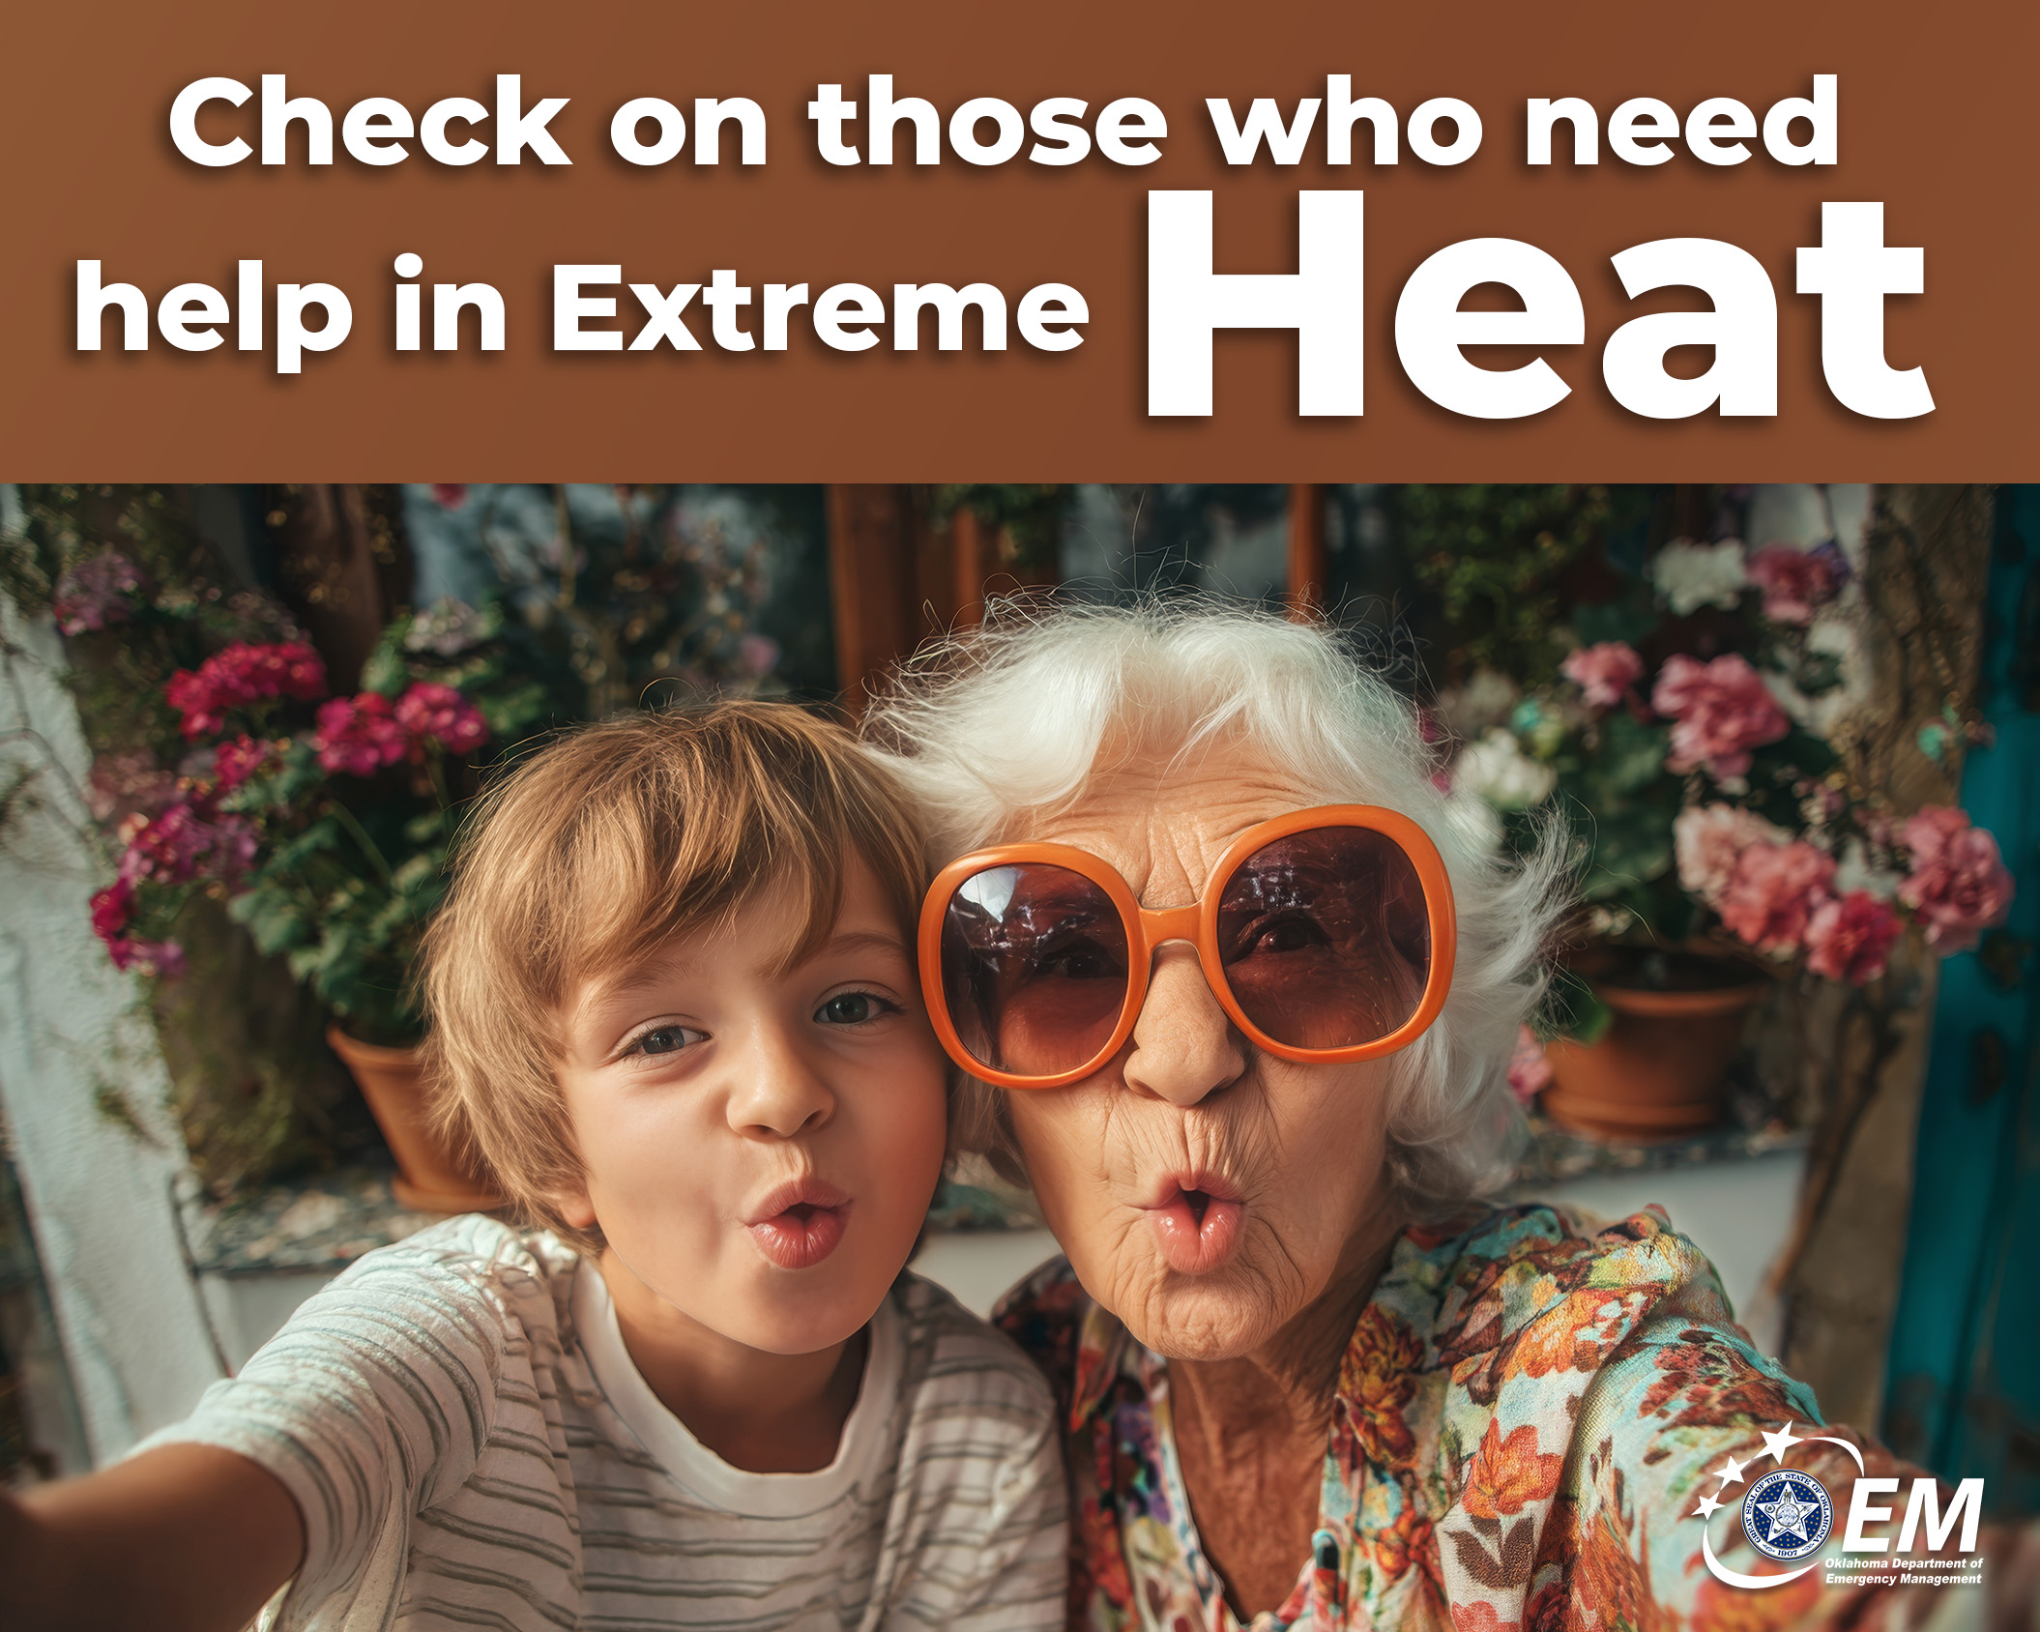

Check on Those Who May Need Extra Help
☀️Extreme heat can be especially dangerous for older adults, young children, people with chronic health conditions, and anyone without access to air conditioning.✇🌫

Take a few minutes to check on family, friends, or neighbors during periods of extreme heat. A simple phone call, text, or visit can make sure they're staying cool, drinking enough water 💧, and doing okay.

Sometimes the best emergency preparedness starts with checking on one another.

#ReadyOK #HeatSafety #OKWX



Dress for the Heat
What you wear can make a difference on hot days.

Choose lightweight, loose-fitting, and light-colored clothing 👕whenever possible. A wide-brimmed hat 👒and sunscreen can also help protect you from the sun☀️ while reducing your risk of overheating.

Small choices can make outdoor activities safer and more comfortable.

#ReadyOK #HeatSafety #OKWX

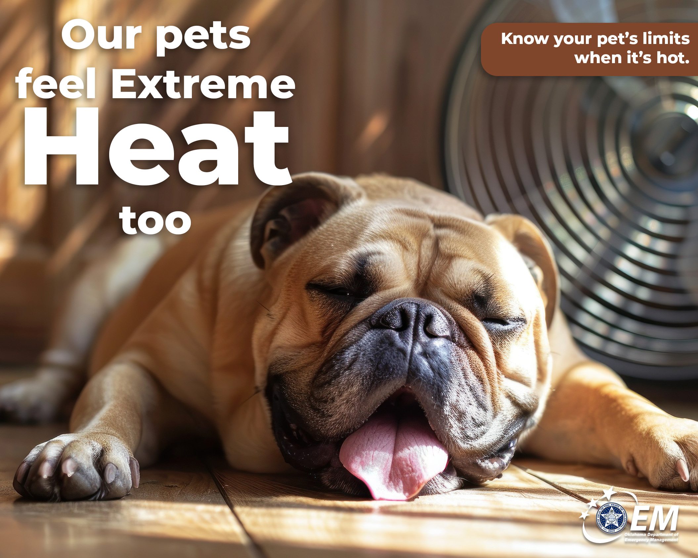

Don't Forget Your Pets
Our pets feel the heat too. 🐶🐱

Make sure they always have access to fresh water and shade, and avoid exercising them during the hottest part of the day. Remember, hot pavement can burn paws in just a matter of seconds. If it's too hot for your hand, it's too hot for their feet.🐾

Don’t leave your pets unattended in a parked car🚗 during extreme heat. We know errands are more enjoyable when our pets go too, but for their safety, leave them at home. 🏠

#ReadyOK #HeatSafety #OKWX

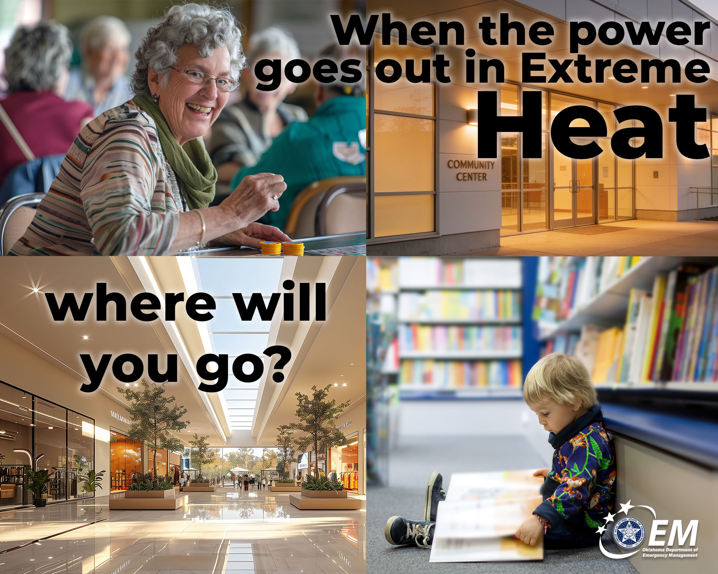

🔌Power Outages During Extreme Heat
Summer storms and increased demand on the electrical grid can sometimes lead to power outages.

If your air conditioning goes out, have a backup plan. Know where you can go to cool off, such as a library📖, community center🏛️, or another air-conditioned public building🛍️. Keep your phone charged and have flashlights, batteries, and water readily available.📱🔦🔋💧

Planning ahead can make an unexpected outage much easier to manage.

211 Heartline lists these cooling centers: https://heartline.ok.networkofcare.org/211/services/advanced-search.aspx?k=%22Extreme%20Heat%20Cooling%20Programs%22

211 of Eastern Oklahoma search or call for cooling centers near you: https://www.navigateresources.net/tulh/

#ReadyOK #HeatSafety #OKWX

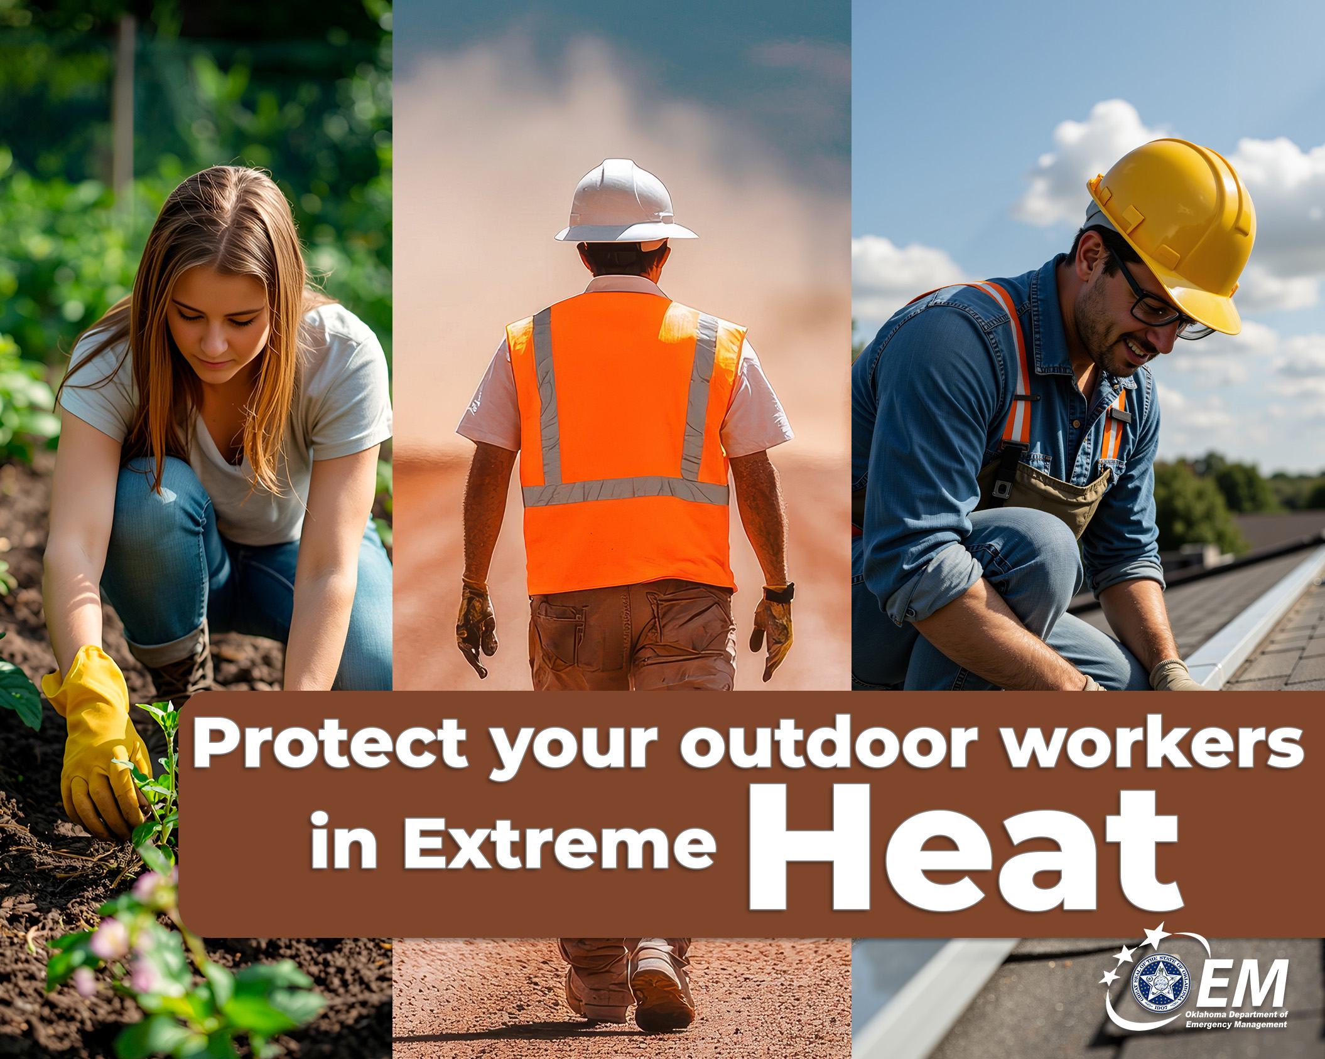

Protect Outdoor Workers
If your job requires you to work outside ☀️🌱🧱🚧, protecting yourself from the heat should be part of your daily routine.

💧⌚👕Drink water often, take scheduled breaks in the shade, wear lightweight clothing, and watch for signs of heat illness in yourself and your coworkers.

Heat-related illnesses can develop quickly, but they're often preventable with the right precautions.

#ReadyOK #HeatSafety #OKWX

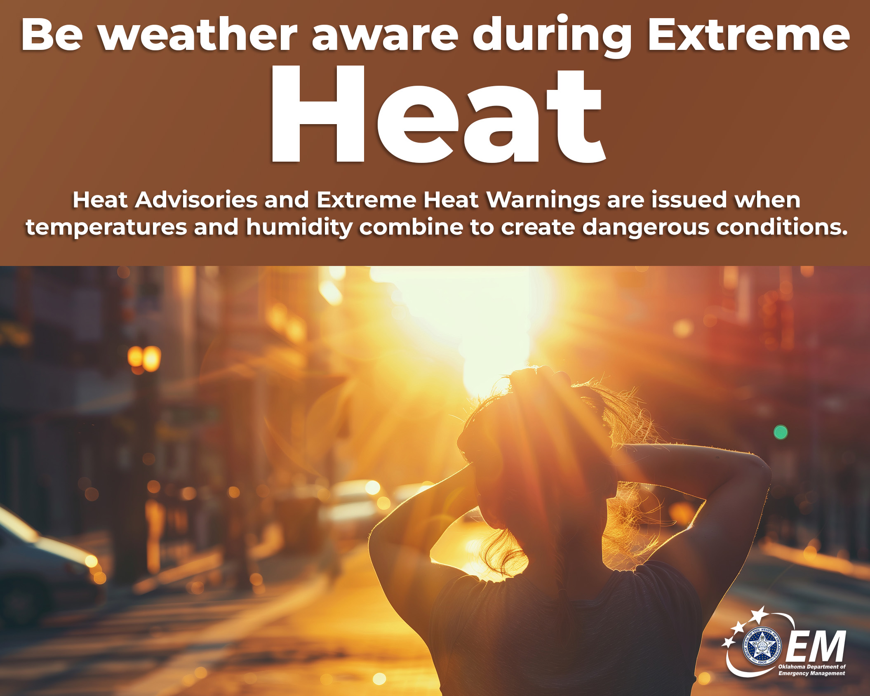

Stay Weather Aware
Before heading outdoors, check the forecast.

☀️⚠️Heat Advisories and Extreme Heat Warnings are issued when temperatures and humidity combine to create dangerous conditions. Knowing what to expect can help you adjust your plans and avoid unnecessary exposure.

Being weather aware 👀 isn't just for storms. It's important during extreme heat too.

#ReadyOK #HeatSafety #OKWX

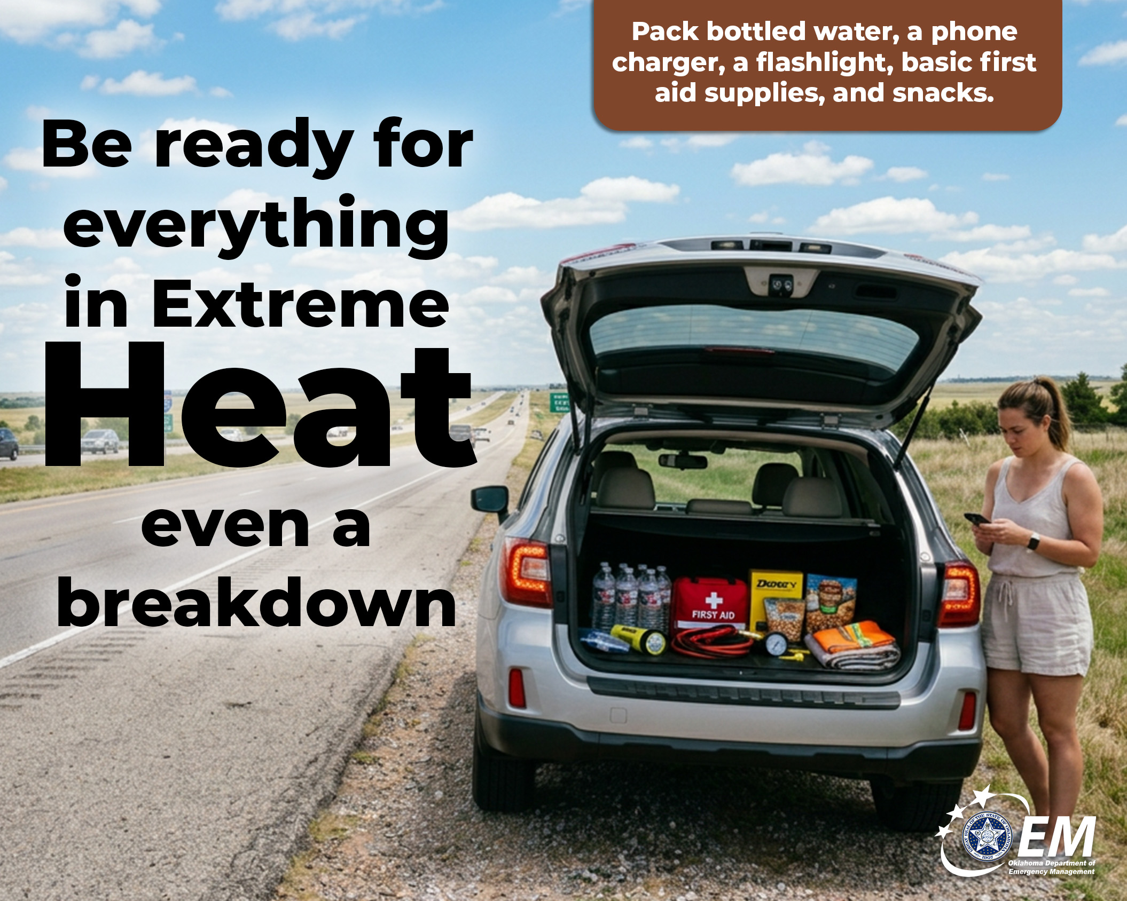

Keep an Emergency Kit in Your Vehicle
🚙If you're traveling during the summer, your vehicle should have more than just a full tank of gas.

Pack bottled water, a phone charger, a flashlight, basic first aid supplies, and snacks. If your vehicle breaks down in extreme heat, these simple items can help keep you safe until help arrives.💧🔦🔋🍪👨‍🔧

Preparation doesn't stop when you leave home.

#ReadyOK #HeatSafety #OKWX

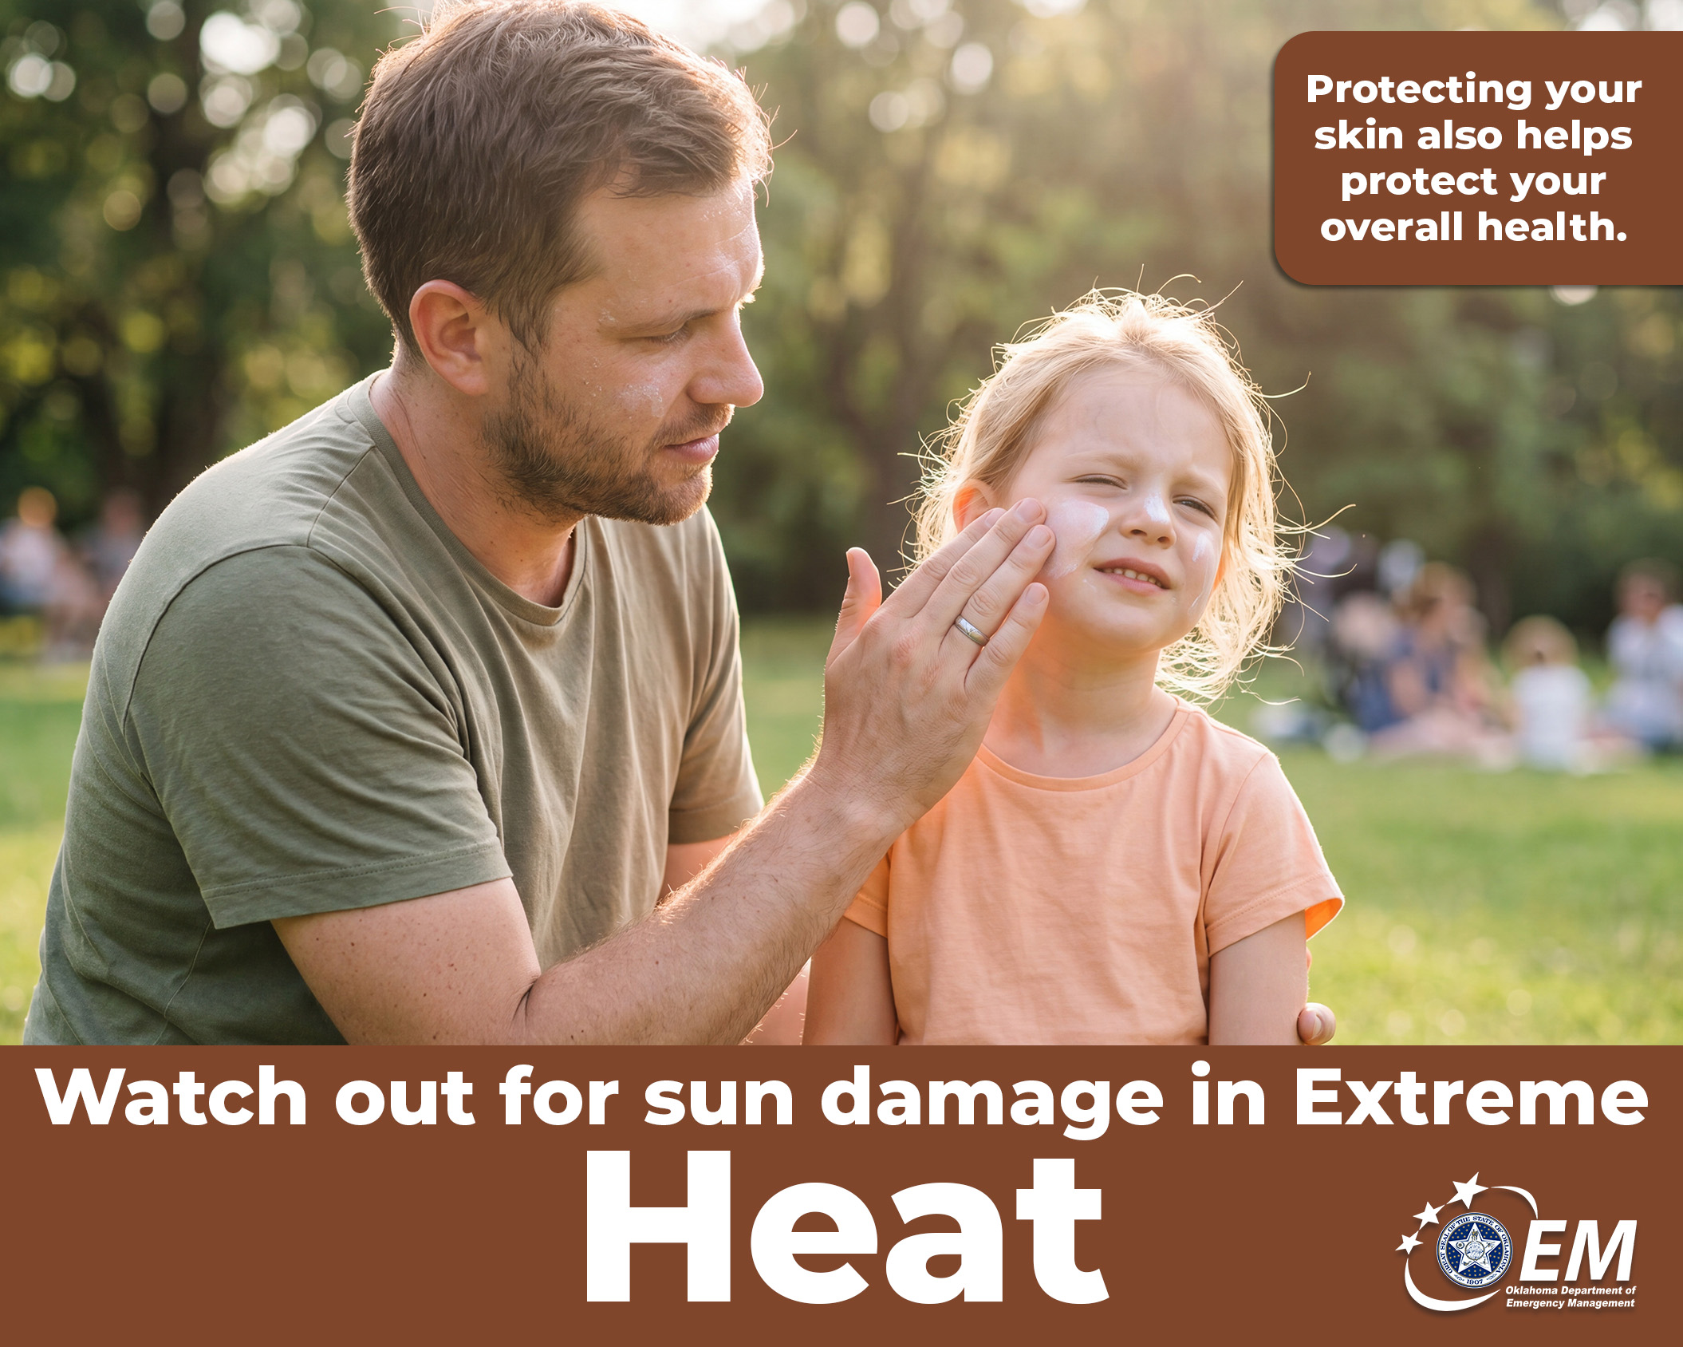

Sun Safety Matters
☀️Too much sun can lead to sunburn, dehydration, and heat-related illness.

Apply sunscreen before going outside and reapply it throughout the day, especially if you're swimming or sweating. Wear sunglasses 😎 and seek shade ☂️whenever possible.

Protecting your skin also helps protect your overall health.❤️

#ReadyOK #HeatSafety #OKWX

