Presenting Sponsor
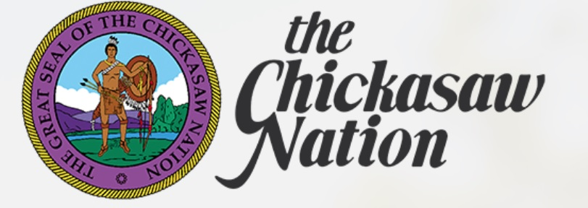

Sapphire Sponsors
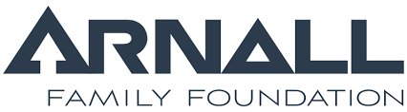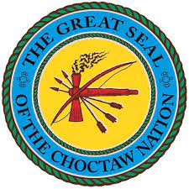

Onyx Sponsors
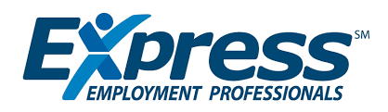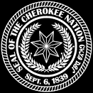
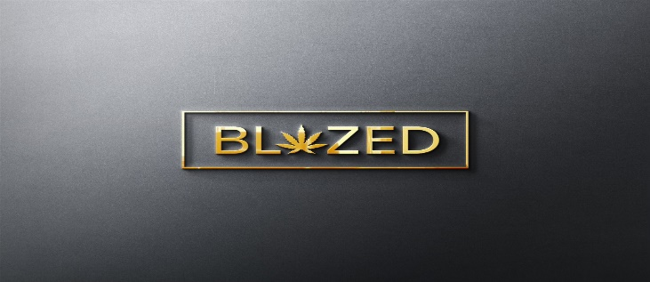

Pearl Sponsors

AMY Consulting Anna Belle Weidemann
Bad Penny Factory BancFrist
Ben Graves Family Trust ChappelWood Financial Services
Conner Saddleriver Trust Cox
Coyle Law Firm Cyndi Byrd
Dr. Janet Barresi Encore Professionals
Fort Sill National Bank Forword Inc
James Baker Group Jerry and Carleen Burger
Jones PR Kerr Foundation
Leslie Osborn Logatore, LLC

Loves Maybrey Bank
Metro First Realty Mo Anderson Trust
NBC OG&E

Oklahoma County Elected Officials OSU

Paul and Molly Wehrenberg Richard Dobbs Trust
Robert and Carol Hefner, VI Ruffle Family Trust
Sneary Farms Snowtree Media
SNP/Drybar Stone Sisters Pizza
The Potts Family Foundation The Winchester Group
Urogynecology of Oklahoma, PLLC Western Concepts

