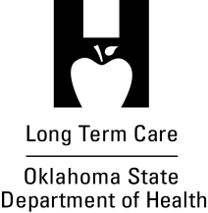

Assisted Living Optional Plan of Correction Form
Customer Feedback

Did you find the assisted living optional plan of correction form and instructions helpful?
Yes
No
Did not use

What about the form or instructions did you find or not find helpful?
Please let us know if there is anything you would like to see changed or improved on the form or instructions.
Please return with your plan of correction or fax to 405.271.2206 or email to LTC@health.ok.gov. Thank you for your feedback.

