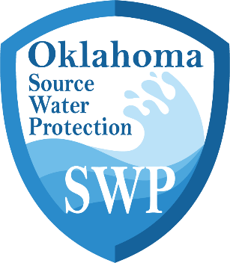

[System Name]
Source Water Protection
Action Plan

Public Water Supply Name: | [System Name]
PWSID:
Address:
County:

Date of Last Source Water Assessment: | Click or tap to enter a date.

Date of Action Plan Completion: [Insert Date]

State of Oklahoma
Department of Environmental Quality
Water Quality Division
Source Water Protection Program
707 N. Robinson
Oklahoma City, Oklahoma 73101-1677

Description of Water System
[System Name] serves portions of [County Name] County, Oklahoma and receives water from # Choose an item source(s). [Source Name] is located [Description of location of source]. The area surrounding this source is primarily Choose land use.. <repeat for any additional sources>.
The Source Water Protection Area(s) and the water system service area are currently experiencing Choose an item. Choose an item. of the following land use categories: commercial, industrial, etc.. <note if no growth in any land use type. Note any notable decreases>. Population in the service area has also Choose an item. over the last decade. As of the date of this plan, the population served by this system is #.
The water system consists of # wells/intakes. The system treats water through [Describe the treatment process]. There are # storage tanks throughout the system that can hold a total of <further describe differences if multiple storage units>. The wells/intakes are located within [describe area i.e. a farm, a park, grass field, etc.] which is owned by Click or tap here to enter text.. The system has a total of # connections with an average daily demand of # gallons per day and a peak of # gallons per day.
The following table provides the personnel of [System Name] responsible for the creation and implementation of this SWP Action Plan.
Name | Title | Phone/Contact

Additional assistance regarding Source Water Protection may be provided by the Oklahoma Department of Environmental Quality. Please reach out via email to DEQ.CapDev@deq.ok.gov
Purpose of Plan Development
This action plan shall serve as a roadmap for coordinating efforts within the Public Water Supply (PWS) and with utility partners towards mitigating existing and potential future threats to source water quality. These efforts are made with the intent to improve the overall resilience of the water supply through protecting the source waters of the system. This plan was composed following the completion of a Source Water Assessment which serves to better inform what management activities/projects should be of the highest priority to the system. This plan may also be useful for justification of activities when applying to receive governmental and/or private funds.
Source Water Assessment - Overview
The most recent Source Water Assessment for this system was completed on Select Date. A copy of the SWP Report for this assessment can be found [enter location (utility office, city hall, etc.)].
Overall, [System Name] received a susceptibility score of [Score], which is considered Choose an item. susceptibility. [Source Name] had the highest susceptibility score earning a [Score]. <If only one source, reword the previous statement as needed> The primary land use within the SWPA of this source is [Overall SWPA #1 land use] with [Zone A land use] being the primary land use within zone A. High concentrations of this land use [Provide explanation regarding with this land use can lead to, positive or negative]. The potential source of contamination (PSOC) of most concern for this source is [name of PSOC] located at [address of PSOC] with a Choose an item. vulnerability score of [vulnerability score]. The contamination categories of concern with this PSOC is/are [organics, inorganics, etc.], specifically <insert contaminant specifics if known>. This source has a Choose an item. sensitivity score of [source sensitivity score]. This score is primarily a result of [explain the sensitivity score based on the parameters].
<repeat this summary for each source, or if many sources, with the top 3 susceptibility score sources>

SWP Management Strategies and Goals
Priority | PSOC/Management Area | Management Activity | Status/Schedule | Estimated Cost/ Funding Source
1
2
3
4
5

Source Water Contingency Planning
The goal of contingency planning is to identify and document how the utility will prepare for and respond to drinking water shortages or emergencies that may occur due to short- and long-term water interruption, or incidents such as spills or contamination. Utilities should examine their capacity to protect their intake, treatment, and distribution system from contamination. They should also review their ability to use alternative sources, minimize water loss, and operate during power outages.
In the case of a contaminant spill, isolating or diverting the contaminant from the source and intake for a public water system is an important strategy in an emergency. If the type of contaminant is one that floats on the surface of the water, such as a lighter petroleum product like diesel or gasoline, spill booms could be placed around the drinking water intake to divert and/or catch the contaminants. Alternatively, utilities can choose to pump floating contaminants from the water or chemically neutralize the contaminant before it enters the treatment facility.
In the case of major contamination of the source water, the public utility may benefit from the ability to cut off water from entering the system. This could potentially be done via closing valves, lowering hatches or gates, raising the intake piping out of the water, or shutting down pumps.
In the case of [System Name], the method by which raw water flow could be stopped would be via:
Utilities should also have a method in place for how raw water could be sampled in the case of contamination in order to identify the movement of a plume and allow for maximum pumping time before shutting down an intake. The amount of time that an intake can remain closed depends on the water infrastructure and should be determined by the utility before an emergency occurs. The longer an intake can remain closed in such a case, the better. Treated water storage capacity in such an emergency also becomes extremely important. Storage capacity can directly determine how well a water system can respond to a contamination event and how long an intake can remain closed.
In the case of [System Name], the current ability to provide water from storage is:
It is important for a utility to plan for emergencies in order to know how to appropriately and quickly respond when they occur. For communication, response networks, and response resource information, refer to the [System Name] Emergency Response Plan.
A copy of the Emergency Response Plan can be found:
Future water supply needs must be considered. With the population of Click or tap here to enter text.on a current trend to Choose an item. over the next five years, it is imperative that the utility considers not only quality but also quantity when it comes to source water planning.
Is the utility able to meet water demands with the current production capacity over the next 5 years? If so, explain how you plan to do so. If not, describe the circumstances and plans to increase production capacity:

When conducting updates to the [System Name] Emergency Response Plan, utility communication plans, and asset management plans, source water protection should be considered.

Appendix A. Action Plan Resources and Planning Assistance
Examples of Management Strategies
On-lot Septic Systems
Propose that the city or town develop an ordinance requiring pumping of all septic systems on a three to five year cycle. A copy of the proposed ordinance can be found in the appendix of this plan. The system and Township should split the cost of development and enactment of the ordinance. The system will provide information on homeowner grants to cover these costs. An educational program should be implemented prior to enactment of the ordinance.
Education/Outreach
The PWS <will develop><utilize existing> educational material to target <targeted group>. The system will budget $100 annually for the copying and mailing costs associated with the educational program. Each customer of the system will be mailed a copy of the educational brochure along with their quarterly water bill. <Include further discussion on how the educational material will be distributed and the expected outcome of the educational program.>
Outreach materials from EPA: NPS Outreach Featured Products | Nonpoint Source Outreach Toolbox | US EPA
SWPA Signs
These signs notify the traveling and recreating public that they are in a water supply area. These signs will contain information such as the number of miles the public will be traveling through this area, and the spill response number to call if there is a hazardous spill or accident. Signs will be located along Route <number> as indicated on map <map number>. The cost per sign is approximately $400 and will be paid for by the PWS via a grant from the League of Women Voters. The Township will erect the sign at the OK Department of Transportation approved location. Their time will be donated as an in-kind service.
Build up Riparian Zones
The PWS will improve riparian vegetation along the banks of <little creek> where <farmers land> intersects. Additional vegetation will be planted along these banks and reinforcement to the current bank will be implemented. In addition, fencing will be put up to limit livestock access to the stream to reduce direct exposure of the stream to animal byproducts and to assist in the efforts to stabilize the streambank. Funds for this project will come from <funds source>.
Inspect Construction Sites
The PWS will keep an eye on local construction sites to ensure their erosion and sediment controls (ESC) are intact and working as intended. Water personnel will provide training on ESC topics through the Environmental Regulation Training Center and will implement these measures in other areas as they deem necessary. Though training and inspections are of no cost, the time employees worked on this will be accounted for in the budget.
Zoning/Subdivision & Land Development Ordinance Revisions
<county, township> will incorporate environmentally sensitive site design standards in future Zoning Ordinance and Subdivision and Land Development ordinances. <or> <township> will modify Zoning to include SWPAs. The PWS will pay for the advertising and legal costs associated with the zoning amendments. This funding will be provided from the “Source Water Protection Fund”.
Revisions to system Emergency Response Plan
<system name> will review and update their Community Water Supply Emergency Response Plan on an annual basis. This will include adding provisions for the Source Water Protection Plan <describe funding source>.
Survey of Businesses
<township, city or private water company> will survey the commercial and industrial businesses within the township for hazardous material use and storage. This information will be used to evaluate applicability of the Emergency Operations Plan. This information will also be used to educate the businesses on safe use and storage of these hazardous materials. <describe funding source>
Additional Management Practice Ideas
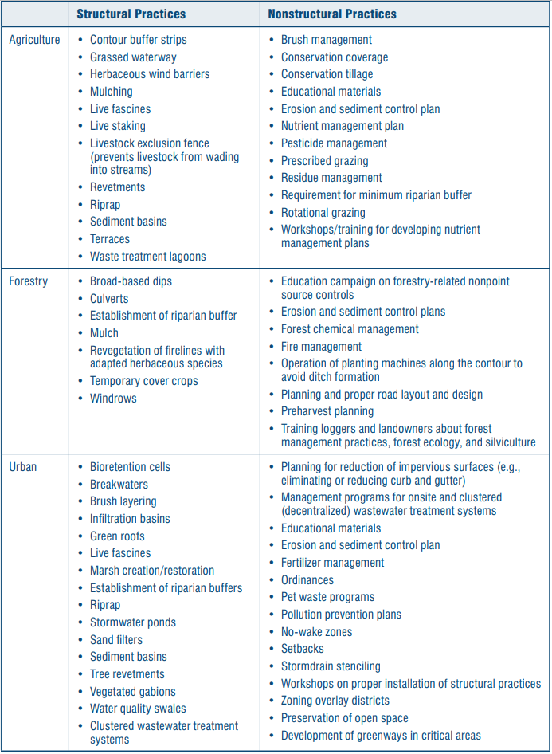
from EPA Handbook for Developing Watershed Plans to Restore and Protect Our Waters ch.10
Regulatory Approaches for Nonpoint Sources (EPA Watershed Plans Handbook)
- Local stormwater ordinances and permits. Local stormwater ordinances may require development applicants to control stormwater peak flows, total runoff volume, or pollutant loading. Stormwater ordinances that apply these requirements to redevelopment projects (not just new development areas) can help mitigate current impacts from existing development. Developers could be required to implement stormwater practices such as bioretention cells, stormwater ponds, or constructed wetlands to meet performance standards for the development set forth in the ordinance.
- Local development ordinances and permits. Local development and subdivision ordinances may require development applicants to meet certain land use (e.g., commercial versus residential), development intensity, and site design requirements (e.g., impervious surface limits or open space, riparian buffer, or setback requirements). Although it might be difficult to add open space to the redevelopment plan of an already-developed area, equivalent off-site mitigation or payment in lieu might be required. Similarly, a riparian area might be revegetated and enhanced.
- Federal or state forest land management plans. Corporate, federal, and state owners of forest lands are often required to develop and implement forest management plans. These plans usually include management practices for logging, road construction, replanting, and other activities. A number of states also have forestry practice regulations that cover logging practices by individuals or private landowners. Such regulations may have requirements such as notification of intent to log, development of and compliance with a management plan that includes the use of management practices, and notification of termination of activities. Watershed planners can review recent or existing forest management plans in the watershed, discuss with managers which plans and practices are working well, and identify areas that could be strengthened.
- Federal or state grazing permits. Federal or state lands that are leased to individuals often require permits that specify conditions and management practices that must be adhered to for the term of the permit. These practices and conditions might include limiting the number of livestock allowed to graze, establishing off-stream watering or fencing in sensitive watershed areas, and other water quality protection measures. Watershed planners can review existing permits in the watershed, discuss with managers which practices are working well, and identify areas that could be improved.
- Decentralized wastewater management. Many states and counties are developing or upgrading their management programs for onsite and clustered wastewater treatment systems. These programs usually include an inventory and analysis of existing systems; inspections; risk assessments; projections of future treatment needs; and development of standards for new system designs, operation and maintenance, inspections, corrective actions, and residuals management.
Practices to implement:
- Ordinances for protecting habitats
- Aquatic buffers
- Fee simple land purchase
- Conservation easements (landowner grants recipient responsibility for protection and management)
- Conservation tax credits
- Transfer development rights (TDRs)
- Purchase development rights (PDRs)
- Landowner and public sector stewardship
- Greenways (ecologically significant natural corridors)
- Greenprinting
- Open space preservation
- Conservation or biodiversity banking
- Reserving or reclaiming flow (legal)
- Adoption of regulatory floodways
- Floodplain and riparian zoning
- Dam removal
- Conservation education
- Monitoring
Reasons for management strategies:
Management practices can be categorized several different ways, such as ‘source’ controls versus ‘treatment’ controls, ‘structural’ controls versus ‘nonstructural’ controls, or ‘point source’ controls versus ‘nonpoint’ source controls. The following summarizes some of the reasons for management strategies that could fall into any of these categories:
- Protecting water resources and downstream areas from increased pollution and flood risks
- Conserving, protecting, and restoring priority habitats
- Setting aside permanent aquatic and terrestrial buffers
- Establishing hydrologic reserve areas
- Acquiring ground water rights
- Reducing the availability of pollutants (e.g., reducing fertilizer, manure, and pesticide applications)
- Reducing the pollutants generated (source reduction such as erosion control)
- Slowing transport or delivery of pollutants by reducing the amount of water transported or by causing the pollutant to be deposited near the point of origin
- Causing deposition of the pollutant off-site before it reaches the waterbody
- Treating the pollutant before or after it is delivered to the water resource through chemical or biological transformation
Additional Resources for Management Strategies:
AFOs/CAFOs: EPA National Management Measures for the Control of Nonpoint Pollution from Agriculture
EPA Management Strategies for Non-point sources: National Management Measures to Control Nonpoint Source Pollution from Agriculture | US EPA
NRCS: Consultation with NRCS staff when considering management actions in rural areas is highly recommended - Oklahoma | Natural Resources Conservation Service
NRCS: management strategies for farmland - Conservation at Work Video Series | Farmers.gov
EPA Management Strategies: Handbook for Developing Watershed Plans to Restore and Protect Our Waters, March 2008

