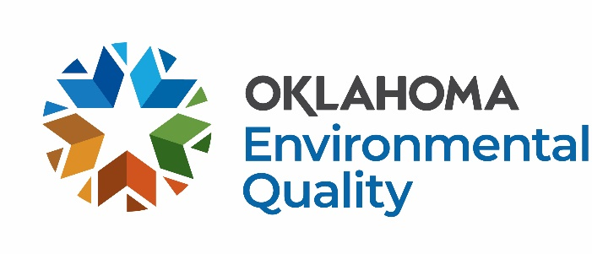

Wasted Food Management Grant Application FY27

Wasted Food Management grants are for a wide range of projects to reduce wasted food by diverting it from disposal to higher use. Example projects include, but are not limited to the following:

School/University Food Share Programs
- Establish school food share programs, such as “share tables” or “food re-service”:
- Leftovers from school dining are used to feed those who need it within the school community.
- The remainder of edible food is redirected quickly to local food banks for distribution.
- Anything left that cannot be salvaged in another way is composted.

University Sustainability Research Projects
- Conduct research to define existing food recovery infrastructure for purposes of food recovery and recycling:
- Identify sources of recoverable food, e.g., restaurants, grocery and convenience stores, university cafeterias, etc.
- Identify resources for matching generators of recoverable food with recovery organizations and distributors.
- Identify applicable laws, regulations, health codes, and ordinances that relate to food donation.
- Create database of resources, e.g., GIS maps to share the research outcome.
- Develop a program such as a mobile app to match recoverable food resources with recovery organizations.

Community Food Recovery Startup Expense Assistance
- Bins/baskets to collect recovered food – size and type vary by school/food pantry partnership and refrigerator space available.
- Educational materials such as signs, posters, and social media promotions.
- Labels attached to the bins, e.g., stating the contents are for donation.
- Refrigerators or coolers, e.g., to hold the food until picked up for delivery to food redistribution center.

For more information and application deadlines, visit the DEQ website at: https://oklahoma.gov/deq/divisions/land-protection/sust-materials-management/funding-opportunities/funding-opportunities-for-communities.html
Basic Information:
- Funding is limited, grant money is not guaranteed.
- Grantees must enter into a formal Agreement with DEQ and register as a Payee at Oklahoma Supplier Portal.
- No funds are available until a fully executed Purchase Order and Contract is issued.
- Funds spent prior to the execution of the formal agreement are not reimbursable.
- All awarded funding must be spent in the fiscal year granted.
- Agreements expire June 30, 2027.
- Final invoices are due by August 31, 2027, invoices submitted after August 2027 may not be reimbursed.
- DEQ does not reimburse buildings, vehicles, laptops, or drones.
- DEQ will reimburse 80% of equipment costing $5,000-$50,000.
Process for Receiving Funds
- Application is submitted.
- The application is reviewed and scored through committee; additional information is requested as needed.
- Award notices are sent out.
- DEQ drafts the Agreement and sends it to the Awardee to sign and return.
- After signature is received, a copy of the executed Agreement and Purchase Order is sent to the Awardee.
- The Awardee may begin to spend funds intended for reimbursement.
- Funds spent prior to a fully executed Agreement and Purchase Order (between steps 1-5) are not reimbursable.
- The Awardee is required to submit monthly invoices, metrics, photos, and descriptions of each month’s work.
- DEQ reimburses invoices within 45 days.

Application Submittal Instructions
Return by e-mail to:

SWGrants@deq.ok.gov with the subject line,
“[Organization] FY27 [grant type] Grant Application DEQ”
e.g., Oklahoma County FY27 Professional Services Grant Application DEQ

Or send a hard copy to:

Oklahoma Department of Environmental Quality
ATTN: Libby McCaskill, Land Protection Division
P.O. Box 1677
Oklahoma City, OK 73101-1677

Wasted Food Management Grant Application FY27

The following information must be provided before a contract for reimbursement is considered. Scoring will be based on the following categories: environmental improvement, feasibility, collaboration, public outreach, sustainability, scope of work and budget, quality of proposal, and past performance, if applicable. This form has been prepared to be applicable to a wide range of projects and as a result some of the questions may not seem directly applicable to what you propose. Please answer the questions to the best of your ability based on the information you have.
Date:

1. Applicant Name:

2. Dollar Amount Requested:

3. Contact Information:
Name/Title:
Phone Number:
E-mail Address:

4. Signatory Authority for Organization with Legal Authority to Sign Contract with DEQ:
Name/Title:
Phone Number:
E-mail Address:

5. Physical Address:
Reimbursements will go to this mailing address*:
*The address provided here must be registered with the State in the Oklahoma Supplier Portal.

6. Attach a detailed scope of work and detailed budget for the project.

7. Project Description:

- What type of project is being proposed (e.g. School Share program, community food recovery/distribution, research project, other)?
- Is this a new project or will it support existing efforts?
- What is the source of wasted food to be managed with this project?
- What happens to the wasted food now?

- Who will be served by the project?
- Describe your plans for public outreach to the community, please list social media handles if applicable.
- Are you partnering with anyone else to implement this program? If so, describe.
- What is the total cost of the program?
- Have you received a previous grant from DEQ? If yes, what year(s), what dollar amount(s) of funding was provided, and how much of that funding did you spend?
- What metrics will you track monthly to demonstrate Return on Investment (ROI)?
- Is there any other information that you would like to share?
- How did you hear about DEQ’s Solid Waste Management Grant Program?

