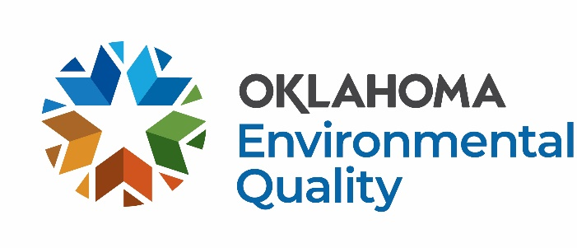

Professional Services Grant Application FY27

These grants are for Non-Profit Organizations that successfully demonstrate sole-source provisions of services and for projects that do not fall into one of the other Solid Waste Management Grant categories such as one-time clean-ups, technical assistance, facility start-up support, and more. Grants are provided on a reimbursement basis.

For more information and application deadlines, visit the DEQ website at: https://oklahoma.gov/deq/divisions/land-protection/sust-materials-management/funding-opportunities/funding-opportunities-for-communities.html
Basic Information:
- Funding is limited, grant money is not guaranteed.
- Grantees must enter into a formal Agreement with DEQ and register as a Payee at Oklahoma Supplier Portal.
- No funds are available until a fully executed Purchase Order and Contract is issued.
- Funds spent prior to the execution of the formal agreement are not reimbursable.
- All awarded funding must be spent in the fiscal year granted.
- Agreements expire June 30, 2027.
- Final invoices are due by August 31, 2027, invoices submitted after August 2027 may not be reimbursed.
- DEQ does not reimburse buildings, vehicles, laptops, or drones.
- DEQ will reimburse 80% of equipment costing $5,000-$50,000.
Process for Receiving Funds
- Application is submitted.
- The application is reviewed and scored through committee; additional information is requested as needed.
- Award notices are sent out.
- DEQ drafts the Agreement and sends it to the Awardee to sign and return.
- After signature is received, a copy of the executed Agreement and Purchase Order is sent to the Awardee.
- The Awardee may begin to spend funds intended for reimbursement.
- Funds spent prior to a fully executed Agreement and Purchase Order (between steps 1-5) are not reimbursable.
- The Awardee is required to submit monthly invoices, metrics, photos, and descriptions of each month’s work.
- DEQ reimburses invoices within 45 days.

Application Submittal Instructions
Return by e-mail to:

SWGrants@deq.ok.gov with the subject line,
“[Organization] FY27 [grant type] Grant Application DEQ”
e.g., Oklahoma County FY27 Professional Services Grant Application DEQ

Or send a hard copy to:

Oklahoma Department of Environmental Quality
ATTN: Libby McCaskill, Land Protection Division
P.O. Box 1677
Oklahoma City, OK 73101-1677

Professional Services Grant Application FY27

The following information must be provided before a contract for reimbursement is considered. Scoring will be based on the following categories: environmental improvement, public outreach, collaboration, sustainability, scope of work, budget, quality of proposal, and past performance, if applicable.

This form has been prepared to be applicable to a wide range of projects and as a result some of the questions may not seem directly applicable to what you propose. Please answer the questions to the best of your ability based on the information you have.

Date:

1. Legal Name of Organization:

2. Dollar Amount Requested:

3. Contact Information for Organization:
Name/Title:
Phone Number:
E-mail Address:

4. Signatory Authority for Organization with Legal Authority to Sign Contract with DEQ:
Name/Title:
Phone Number:
E-mail Address:

5. Physical Address:
Reimbursements will go to this address*:
*The address provided here must be registered with the State in the Oklahoma Supplier Portal.

6. Disclosure:
List any DEQ employee serving as a Board member or N/A:
Please note that if Board appointment occurs at any point during the grant process, including after an Agreement has been executed, disclosure should be made to SWGrants@deq.ok.gov.

7. Attach a detailed scope of work and detailed budget for the project.

8. Project Description:

- Describe your project and explain what type(s) of solid waste will be managed. How is this waste currently managed?

- If your project does not directly manage solid waste, explain how it supports solid waste management objectives.
- Will this project enhance related program(s) or effort(s)? Please describe.

- Who will be served by the program (municipalities, counties, regions, estimated population)?

- What is the environmental benefit of this project? (e.g. waste reduction, resource conservation, pollution prevention, litter abatement, education)?

- Describe your plans for public outreach to the community, such as news coverage, radio ads, flyers, posters, social media, and how often you will conduct the outreach. Please list your social media handles if applicable.
- Describe any public education aspects of your project/program.
- What is the total cost of the program?
- Are you partnering with anyone else to implement this program? If so, describe.
- Have you received a previous grant from DEQ? If yes, what year(s), what dollar amount(s) of funding was provided, and how much of that funding did you spend?
- How long do you intend for the program to remain in place?

- How will benefits be measured? How will you quantify the success of your project?
- Is there any other information that you would like to share?
- How did you hear about DEQ’s Solid Waste Management Grant Program?

