DEQ/OSU SOIL CLASSIFICATION MANUAL

Identifying Key Soil Characteristics for Design and
Sizing of Individual and Small Public
On-site Sewage Disposal Systems

September 2003

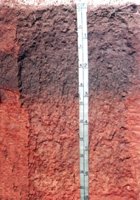

Brian J. Carter

Professor of Soil Morphology,

Genesis, and Classification

Oklahoma State University
Department of Plant and Soil Sciences
368 Ag Hall
Stillwater, OK 74078
Fax: 405-744-5269
email: bjc@mail.pss.okstate.edu
Phone: 405-744-6414
Table of Content

Title Page

Cover picture: Port Silt Loam …………………………………………………………………… 1

List of Tables 8
List of Figures 9
THE NECESSITY OF SOIL PROFILING FOR SEWAGE DISPOSAL SYSTEM USE 11
Soil as a Natural Resource 11

Soil as a living filter and chelator of toxic elements 11

Soil as a basis for land-use management and planning 12
Four General Soil Forming Processes 12
Introduction - soil organic and inorganic chemistry, and physics 12
Additions to the soil 14
Losses from the soil 15
Transformations within the soil 16
Translocations within the soil 17
Soil Morphology and Nomenclature 18
Application of soil morphology to soil forming processes and management 18
Soil individuals; types and series 24
Determining Soil Pore Volume 25
Soil bulk density (mass of dry undisturbed soil per unit volume) 25
Increasing bulk density with increasing soil depth 26
Soil particle size and soil bulk density relationships 26
Soil water content, bulk density, and porosity 27
The soil structure concept 27
Determining Rate and Amount of Water Movement Through Soil 28

Soil-water conductivity related to soil particle size distribution, soil
structure, and soil bulk density 28
Determining the slowest soil water conductivity layer 29
Applying Darcy’s equation to a general soil-water flow model 30
Determining Soil Biological Activity 31
General principles of waste degradation by soil microbes 31
Redoximorphic soil conditions influence soil microbes 32
Hazardous Materials in Disposal Systems 32
STANDARD APPROACH FOR OBTAINING SOIL PROFILE DESCRIPTIONS 33
Soil Profiles are Used to Identify Individual Soil Types 33
Soils consist of different layers (often called horizons) 33
Soils are a natural resource identified by individual types (often called soil series) 33

Soil types (or series) are identified by a unique sequence of layers (usually
3 to 7 layers within a depth of 2 meters below the soil surface) 34
Obtaining a Complete Soil Profile Description 35
A soil profile is an aggregated description of each soil layer 35
Soil layers are described by a set of features 35

A soil layer always consists of at least four features (the same four for
all layers) plus others deemed pertinent to the understanding of soil
processes and management at each location 35

Soil features are useful for both soil use and management as well as the
understanding of soil forming processes 37
Laboratory Analysis is Used to Support Field Soil Profile Descriptions 37
Overview of soil physical, chemical, and mineralogical laboratory analysis 37
Examples of laboratory analysis used to support soil profile descriptions 37
Soil particle size analysis (soil texture) 38
Types of Soil Excavations; Small or Large Volume Disturbance 38
Small volume soil auger or push-probe cores 38
Large soil excavations using backhoe or similar “heavy” equipment 38
Advantages and disadvantages of various methods of soil excavations 39
Remotely Sensed Techniques for Noninvasive Soil Investigations 39
Ground penetrating radar observations 39
Hammer seismograph techniques 39
Limitations of using remotely sensed data for soil interpretations 40
Individual residences Versus Multiple residences and developments 40
Individual residences 40
Multiple residences and developments 40
CLASSIFYING KEY SOIL CHARACTERISTICS FOR DESIGN AND SIZING OF INDIVIDUAL AND SMALL PUBLIC ON-SITE SEWAGE DISPOSAL SYSTEMS IN OKLAHOMA SOILS 40
Identification of Potentially Unsuitable Soils 40
Identification of Water Saturated Soil Layers 41
Introduction 41
Types of redoximorphic features 41
Redox concentrations. - These are zones of apparent accumulation of
Fe-Mn oxides, including: 41
Redox depletions. - These are zones of low chroma (chromas less than those
in the matrix) where either Fe-Mn oxides alone or both Fe-Mn oxides and
clay has been stripped out, including: 42
Quantity of redoximorphic features is indicated by three percentage classes
of the observed surface 42
Redoximorphic notations within soil profile descriptions 42
Soil Particle Size Distribution (Soil Texture) 43
Classification of soil particle sizes 43
Definitions of the soil texture classes 43
Sands. More than 85 percent sand, the percentage of silt plus 1.5 times the percentage of clay is less than 15 43
Loamy sands. Between 70 and 91 percent sand and the percentage of silt
plus 1.5 times the percentage of clay is 15 or more; and the percentage of
silt plus twice the percentage of clay is less than 30 44
Sandy loams. 7 to 20 percent clay, more than 52 percent sand, and the
percentage of silt plus twice the percentage of clay is 30 or more; or less
than 7 percent clay, less than 50 percent silt, and more than 43 percent sand 44
Loam. 7 to 27 percent clay, 28 to 50 percent silt, and 52 percent or less sand 45
Silt loam. 50 percent or more silt and 12 to 27 percent clay, or 50 to 80
percent silt and less than 12 percent clay 45
Silt. 80 percent or more silt and less than 12 percent clay 45
Sandy clay loam. 20 to 35 percent clay, less than 28 percent silt, and more
than 45 percent sand 45
Clay loam. 27 to 40 percent clay and more than 20 to 46 percent sand 45
Silty clay loam. 27 to 40 percent clay and 20 percent or less sand 45
Sandy clay. 35 percent ore more clay and 45 percent or more sand 45
Silty clay. 40 percent or more clay and 40 percent or more silt 45
Clay. 40 percent or more clay, 45 percent or less sand, and less than 40
percent silt 45
Including rock fragments within soil texture 46
Introduction 46

Rock fragment classes, based on volume percentages, are used to modify
soil texture classes 46
Step-by-step Procedure for Determining Suitability 48
Locate depth to limiting soil layer (if any) 48

Locate depth to a water saturated soil layer as identified by common or more
redoximorphic depletions with soil color of < 2 chroma and value > 4 (if any) 48
To continue to Step 4, 36 inches of separation must be present between the top of the ground to a impervious to boring layer or water saturated soil layer and 18 inches of separation from the bottom of the trench to a impervious to boring layer or water saturated soil layer (subsurface absorption system is unsuitable if condition is not met) ………………………………………………………………………………….48
Identify all soil textures (included percent rock fragments) between a depth of
12 and 48 inches and identify the most prevalent soil between 12 and 36 inches 48
Match the most prevalent soil texture to the soil group (Table 1), and then match the soil group to size the absorption system using Table 2. 48
Wastewater Treatment 49
INTERPRETATION OF KEY SOIL CHARACTERISTICS FOR DESIGNING AND
SIZING SEWAGE DISPOSAL SYSTEMS 49
Special Soil Features that May Cause Water Saturated Soil or Impervious to Boring 49
Lithic and paralithic materials 49

Fragipans 49
Natric layers 50
Petrocalcic layers 50
Criteria Established by Presence of Water Saturated Soil Layer 50
Formation of soil redoximorphic features 50
Duration of water saturated soil and impact on on-site sewage disposal systems 51
Criteria Established by Soil Particle Size Distribution 51
Loading rates by soil groups for conventional systems in Oklahoma 51
Minimum trench length for subsurface absorption systems 51
Using Current Soil Survey Information as a County or Regional Planning Tool 51
Identify benchmark soils for county or region 51
Apply suitability criteria established in section III A through D above to the
typical profiles for benchmark soil series found in USDA-NRCS county soil
survey information 52

Estimate county and regional areas of suitable and unsuitable soil
showing major limitations 52
Web Site For Soil Series Descriptions………………………………………………………52
Glossary 53
REFERENCE 55

List of Tables

Title Page

1. Terms for rock fragments 47

2. Loading rates by soil groups for conventional systems in Oklahoma 48

3. Minimum trench length (ft) for subsurface absorption systems 48
List of Figures

Page

1. Soil is a dynamic living filter fostering organisms that decompose and
recycle waste 11

2. A soil profile consisting of several layers (often referred to as horizons) 12

3. A soil exists based on the balance between four major soil forming processes;
additions, losses, transformations, and translocations 13

4. Soil can become buried if additions are rapid! 14

5. Surface erosion (soil loss) reduces soil depth 15

6. Soil leaching (soil loss) can be drastic e.g., formation of sinkholes in areas of
gypsum and limestone rock 16

7. Clay can form in a soil by the decomposition (transformation) of primary minerals
such as feldspar and mica originating in rock (scale = 2mm) 16

8. Clay is removed from surface soil horizons and deposited (translocation) in the
subsoil as clay films during precipitation (scale = 2mm) 17

9. Salts including hatite (NaCl), gypsum (CaSO₄·2H₂O), and calcite (CaCO₃) are
dissolved, moved, and deposited, (translocation) along wetting fronts in the soil 18

10. The textural triangle is used to group soil by the relative amounts of sand, silt,
and clay (<2mm fraction) 19

11. The Munsell color chart (Gretag Macbeth, 1994) is used to identify soil color 20

12. Soil structure is classified by size, strength, and shape of peds 21

13. Soil consistence is the ability of a soil to resist rupture or deformation under dry,
moist, or wet conditions 22

14. A soil profile photograph of a type along with its series text description 24

15. Diagram showing idealistic soil relationships between specific gravity (quartz),
pore space, solid space and bulk density 25

16. A typical trend of increasing bulk density with increasing soil depth 26

17. Diagram showing soil structure creating macropores and planes which expedite
water and air movement through soils 28

18. The size, continuity, and tortuosity of soil pores is a key factor for determining
water flow through soils 29

19. Idealistic diagram showing how Darcy’s law is used to determine saturated flow
through a soil during constant head conditions 30

20. Soil redoximorphic features are used to determine soil zones of water saturation 31

21. Diagram showing major soil horizon (layer) nomenclature 33

22. Four different soil types 34

23. Definition of key minor soil horizon nomenclature used to subdivide major
soil horizon names and identify key soil features 36

- THE NECESSITY OF SOIL PROFILING FOR SEWAGE DISPOSAL SYSTEM USE
- Soil as a Natural Resource
- Soil as a living filter and chelator of toxic elements
The soil is both an anaerobic and aerobic biological community of organisms that decompose organic debris into simply organic material and eventually to humus, CO₂ and H₂O (Figure 1). Depending on the flow of water through a soil, the soil can be thought of as either 1) aerobic, 2) anaerobic, or 3) various degree of each. Since soil organisms decompose organic material (mostly depending on concentration) the soil is considered as a dynamic living filter.
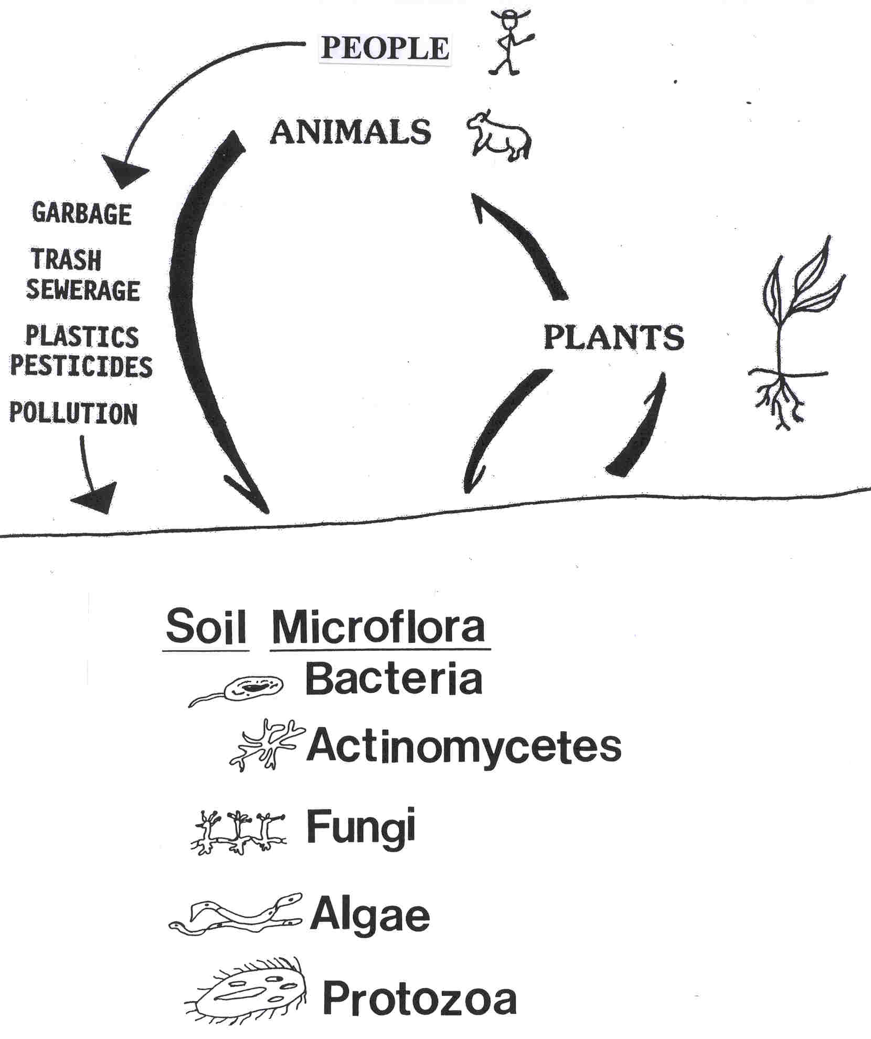
Figure 1. Soil is a dynamic living filter fostering organisms that decompose and recycle waste.
Inorganic materials are also absorbed and modified by biogeochemical and geochemical soil processes. Toxic elements are sequestrated within recalcitrant humus complexes.

- Soil as a basis for land-use management and planning
Soils are a complex layered system. Soils are classified and identified by the number and characteristics of these layers (also called horizons) (Figure 2). Most people think of the soil as only the surface layer (since other layers require excavation to observe). However individuals who observe road cuts and view excavations realize that soils are a layered system.
Figure 2. A soil profile consisting of several layers (often referred to as horizons).

The characteristics of soil layers and the unique sequence of layers termed a soil type is considered a basic natural resource. The exchange of energy and mass between soil layers is the major determinant of soil potential. Thus, soil as a natural resource is used directly for land-use management and planning.
- Four General Soil Forming Processes
- Introduction - soil organic and inorganic chemistry, and physics
Soils are a heterogeneous system for any particular soil property, at a specific time and controlled by chemical and physical gradients and fluxes. Soil conditions involve the knowledge of organic and inorganic compounds which may contain the following elements C, H, O, N, P, S, K, Ca, Mg, Al, Si, Fe, Na, Cu, Co, Mn, Mo, B, Cl as well as many others in trace quantities.
The unique sequence of soil layers termed a type is produced by combining four processes; additions, losses, transformations, and translocations (Figure 3). These four general soil forming processes vary in intensity from place to place due to differences in climate, type of plant and animal community present, topography, time, and type of rock that is the parent material for the soil.
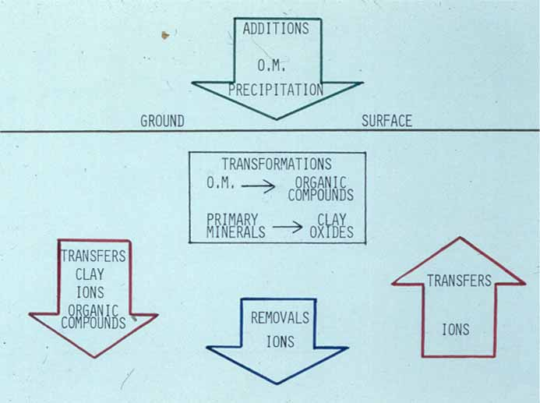
Figure 3. A soil exists based on the balance between four major soil forming processes; additions, losses, transformations, and translocations.

- Additions to the soil
Major additions occur to soils including overflow sediments, eolian particles, and organic matter. Deposition of soil material from eroding landscape surfaces occurs especially along some floodplain and footslope hillslope positions. Volcanic ash and wind erosion are significant types of eolian additions to soils. Precipitation also brings small amounts of materials containing such elements as sulfur and nitrogen. Usually additions to the soil are relatively slow and they are incorporated to the upper soil layer without burying the soil. If massive amounts of material is rapidly added to soil, sufficient to bury the soil, then the material is considered new geologic soil parent material (Figure 4). Usual additions to the soil do not bury a soil.
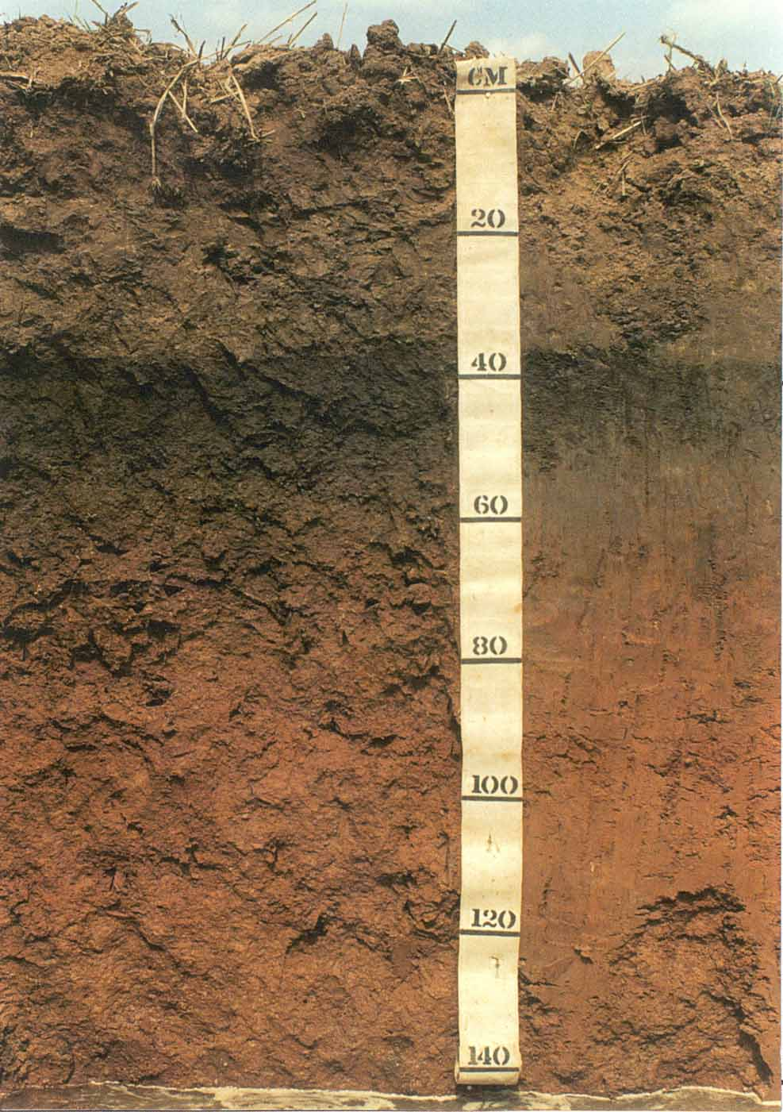
Figure 4. Soil can become buried if additions are rapid!
Organic matter is added to a soil as plant roots, and plant and animal debris. Organisms such as chemolithotrophs and photolithotrophs fix carbon from the air into the soil. Inert atmospheric N is fixed by soil microorganisms. Chemorganothrophs recycle dead animal and plant remains and build humus in soils.

- Losses from the soil
Soil losses occur in several ways. One mode of loss occurs when the surface soil layer erodes (Figure 5). Soil conditions affecting surface soil erosion are slope gradient, plant cover, and soil infiltration rate. Surface erosion is reduced by
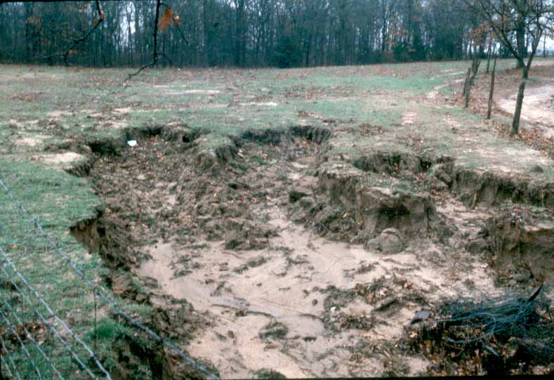
Figure 5. Surface erosion (soil loss) reduces soil depth.

maintaining a thick plant cover on the soil. Leaching causes the loss of dissolved materials from the soil to the underlying vadose zone and often the ground water. Leaching is often referred to as geochemical erosion. Common soil solutes reaching the ground water are Ca⁺², Mg⁺², K⁺, Na⁺, SO₄⁻², Cl⁻, NO₃⁻, and HCO₃⁻. A striking example of leaching and geochemical erosion is soil formed from limestone producing karst topography (sinkholes) (Figure 6). Gases are also released from the soil by the decomposition of organic material. These gases can be in the form of CO₂, CH₄, N₂O, and H₂S, as well as others.

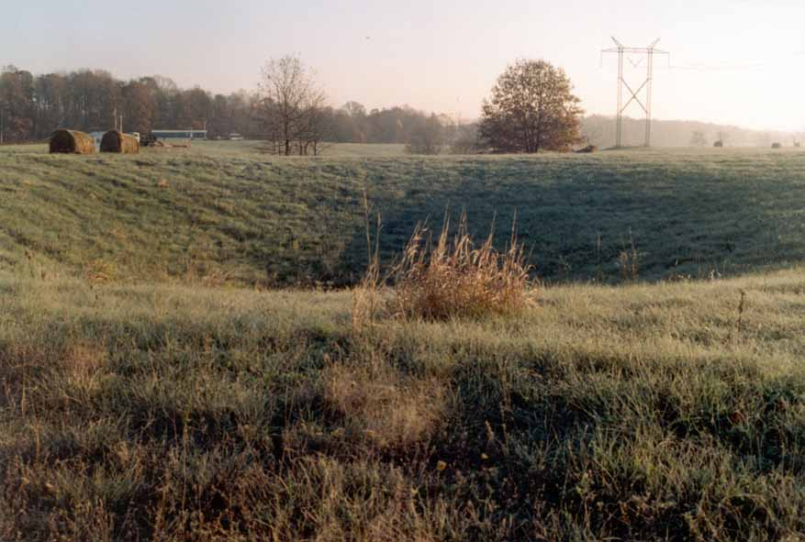
Figure 6. Soil leaching (soil loss) can be drastic e.g., formation of sinkholes in areas of gypsum and limestone rock.

- Transformations within the soil
Inorganic and organic compounds are weathered in the soil to produce clay (Figure 7)
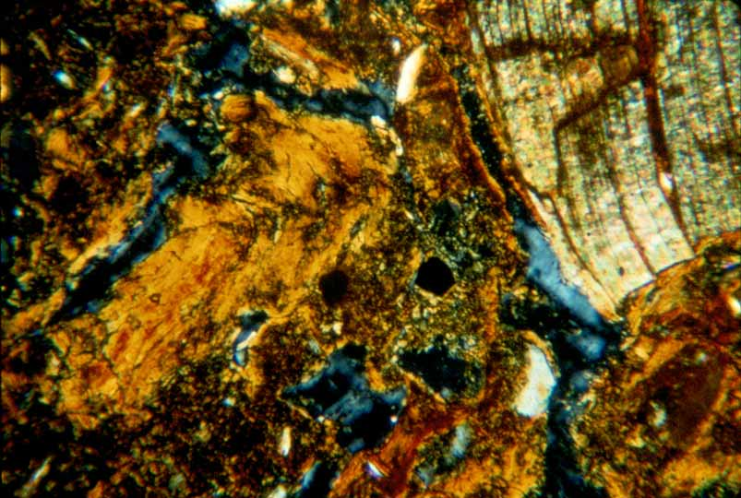
Figure 7. Clay can form in a soil by the decomposition (transformation) of primary minerals such as feldspar and mica originating in rock (scale = 2mm).

Clay
Pore
Mica
and humus. Some transformations occur rapidly; hours to days while others are slow; months to years. The formation of iron and aluminum oxides from primary minerals is also a major soil transformation. The rate and types of weathering products are dependent on the amount of soil water, soil oxygen, soil heat and movement, and removals of reactants and products from the soil system. Transformations occur mainly by oxidation-reduction, hydrolysis, hydration, and chelation within the soil.
- Translocations within the soil
Translocations within the soil are often considered as the relocation of solids (such as clays and organic matter) and solutes (Ca⁺², Mg⁺², K⁺, Na⁺, Cl⁻, SO⁻²₄, HCO₃⁻). Translocations of liquids and gases do occur but are often overlooked when evaluating soil layers. Translocations modify soil texture and pH. Translocations of clay from upper soil layers to lower soil layers cause these lower subsoil layers to be rich in clay compared to surface layer (Figure 8). Also, movement of cations and
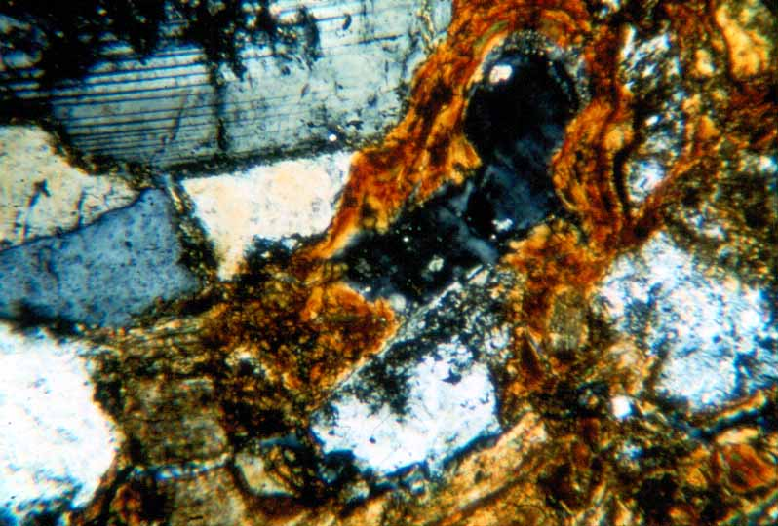
Figure 8. Clay is removed from surface soil horizons and deposited (translocation) in the subsoil as clay films during precipitation (scale = 2mm ).
Quartz
Pore
Clay
Feldspar
anions cause acidification of surface layers and alkalization and salinization of subsoil layers (often forming calcite, CaCO₃; or gypsum, CaSO₄·2H₂O) (Figure 9).

Soil Morphology and Nomenclature
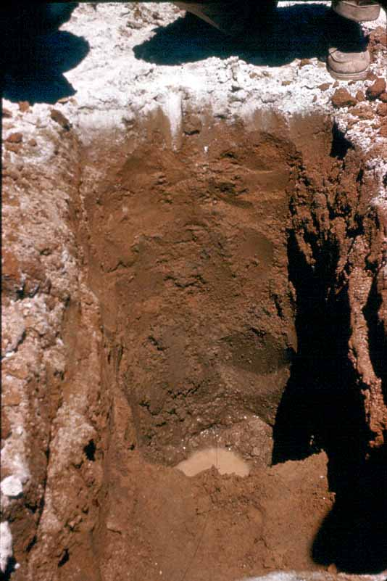
Figure 9. Salts including halite (NaCl), gypsum (CaSO₄·2H₂O), and calcite (CaCO₃) are dissolved, moved, and deposited, (translocation) along wetting fronts in the soil.

- Application of soil morphology to soil forming processes and management
Soil morphology is the field description and naming of soil layers using a sequence identifying specific characteristics; texture, color, structure, consistence and special features (Figures 10, 11, 12, and 13). Laboratory and field analytical methods support the use of this science. Soil morphology is used to determine how soils form, are used for production of food and fiber, and to determine suitability for construction and application of waste material for storage and degradation.

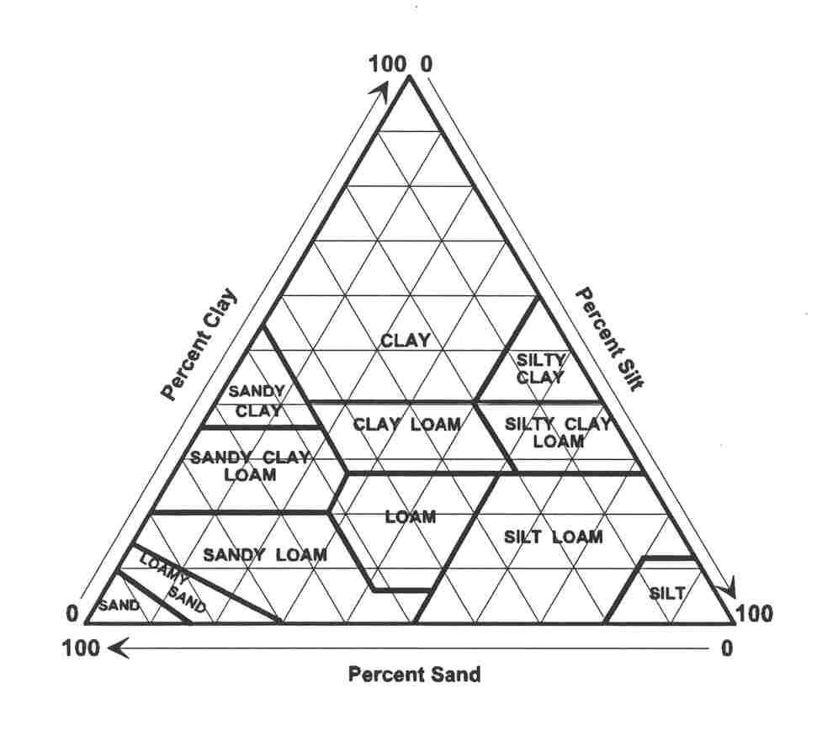
Figure 10 The textural triangle is used to group soil by the relative amounts of sand, silt, and clay (<2mm fraction)

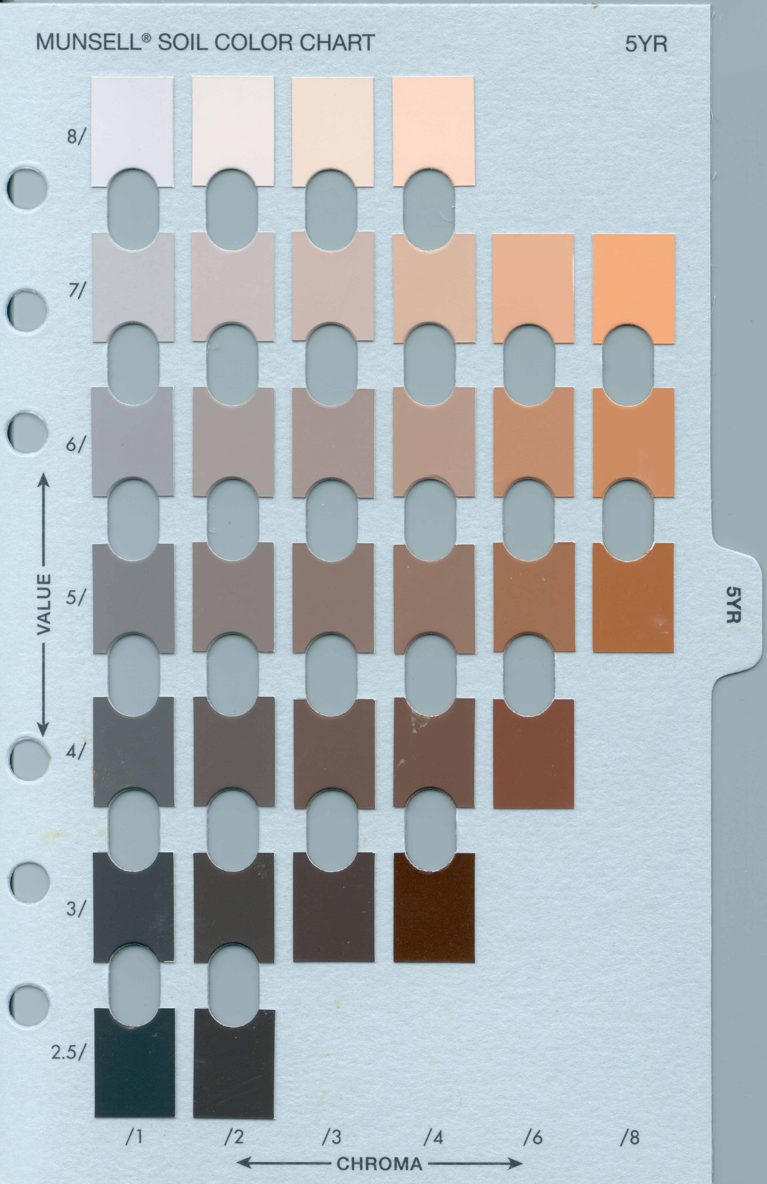
Figure 11. The Munsell color chart (Gretag Macbeth, 1994) is used to identify soil color

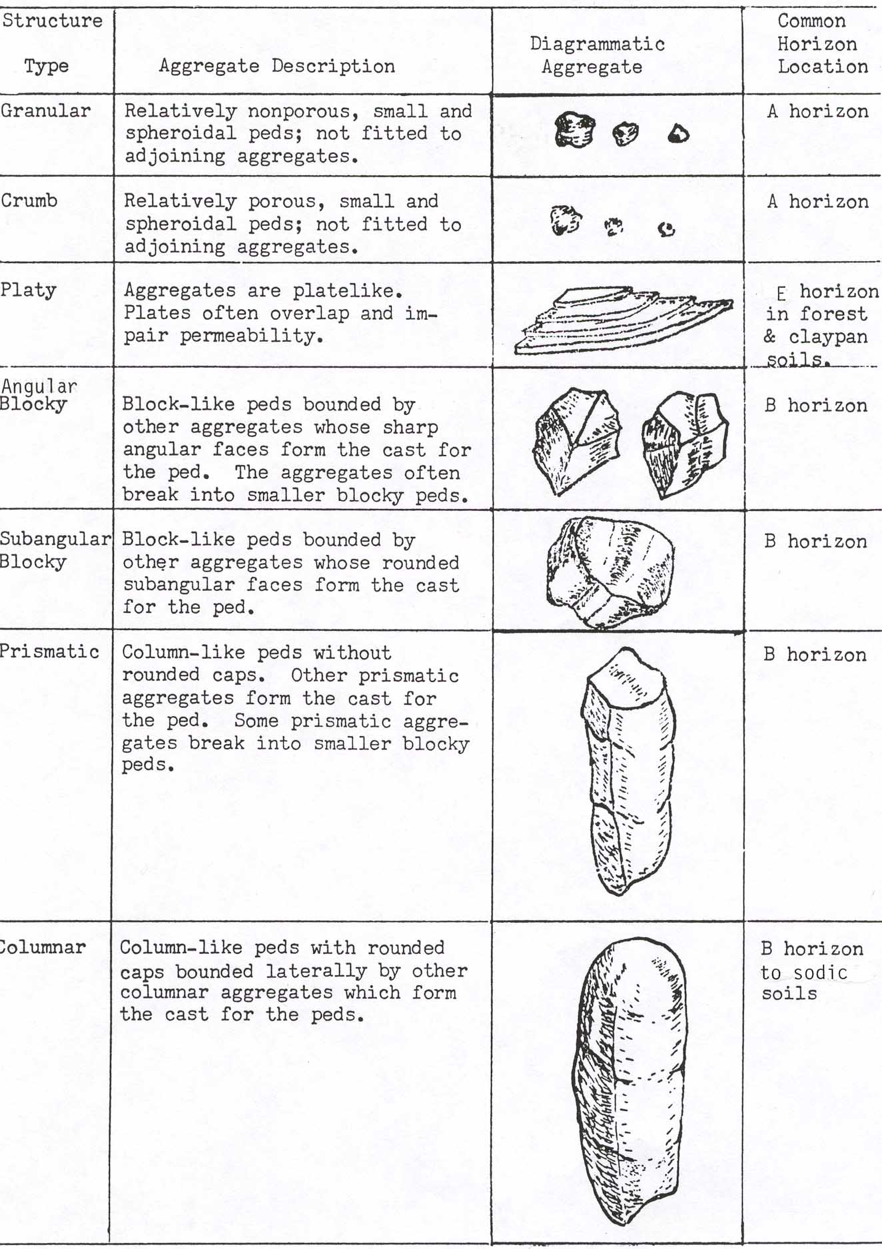
Figure 12. Soil structure is classified by size, strength,, and shape of peds

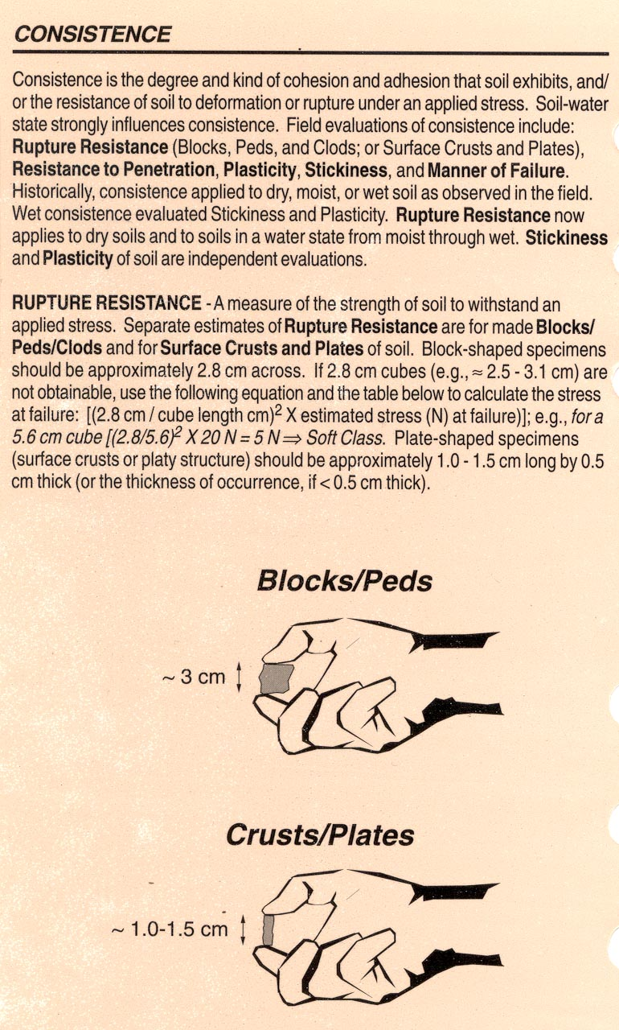
Figure 13. Soil consistence is the ability of a soil to resist rupture or deformation under dry, moist, or wet conditions

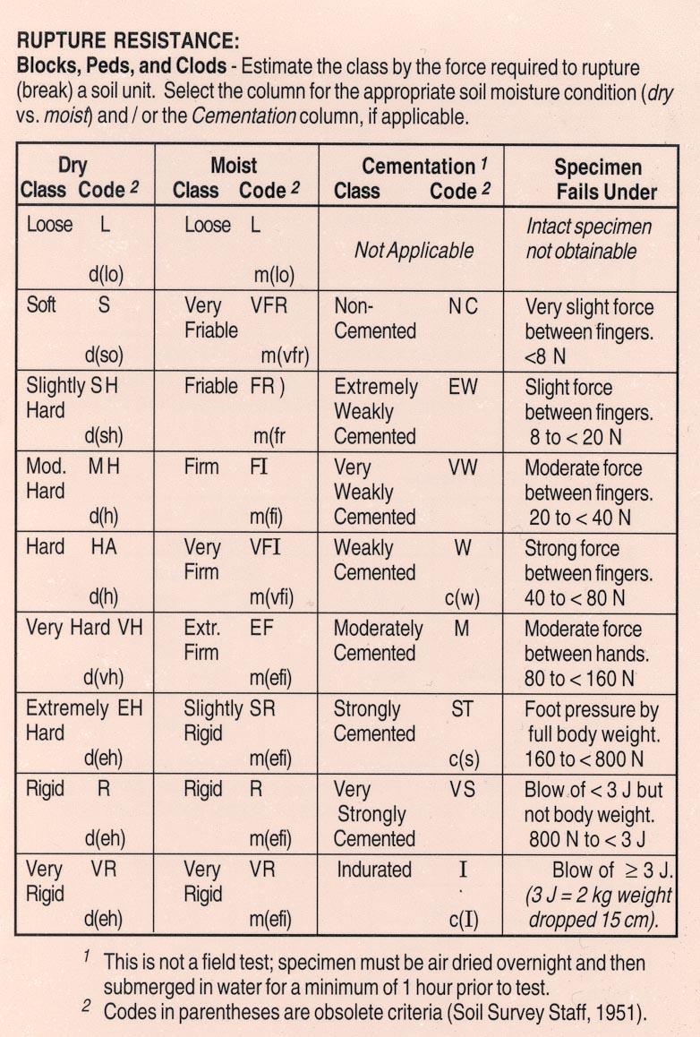
Figure 13. Soil consistence is the ability of a soil to resist rupture or deformation under dry, moist, or wet conditions (continued)

- Soil individuals; types and series
A name (usually of a nearby location; town, city, etc.) is given to the unique sequence of soil layers (soil type). Each soil name (or type) is given a range for the values of the characteristics for each layer (Figure 14). The soil name along with a specified range in characteristics for each layer is called a soil series. Soils form a complex continuum across the landscape and are difficult to classify compared to organisms, which often have easily identifiable boundaries. Key characteristics e.g. soil depth, clay content and thickness of surface layer are selected within a particular area to differentiate soil series boundaries. The characteristics may change from one area to the next based on important soil features and land management practices for that area. A common soil map at a scale of approximately 1:25,000 (e.g. county soil survey planning tool, Natural Resources Conservation Service (NRCS), United State Department of Agriculture (USDA)) is usually meant for determining general land use practices and may need further field investigation for specific application to proposed site specific land use.
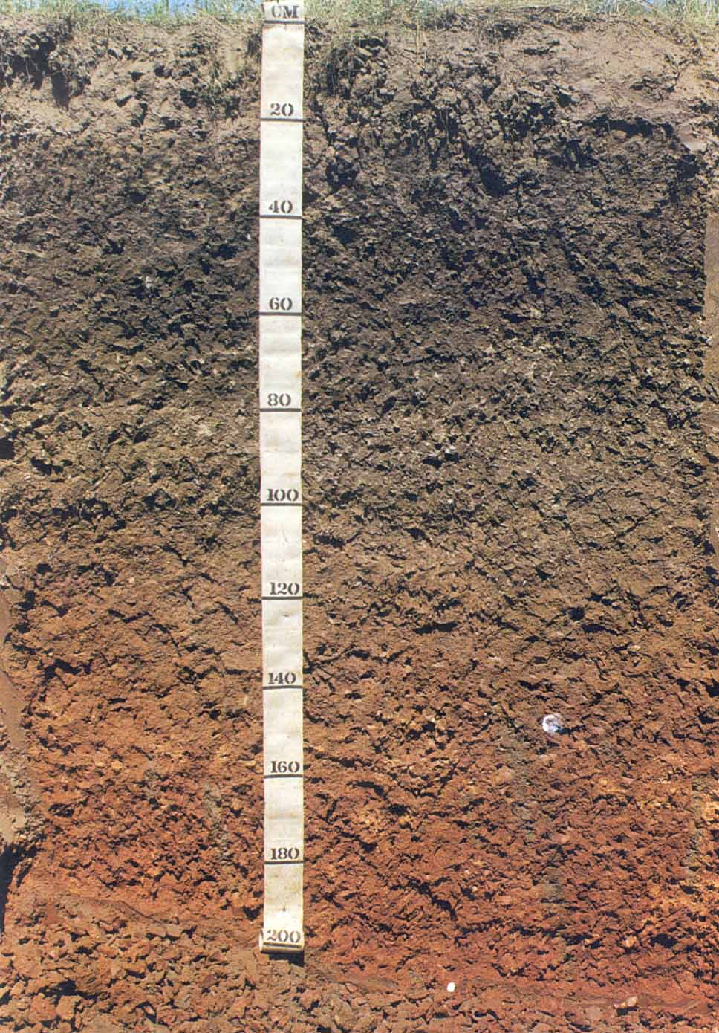
Figure 14. A soil profile photograph of a type along with its series text description

- Determining Soil Pore Volume
- Soil bulk density (mass of dry undisturbed soil per unit volume)
An important basic parameter for all soils is the relative amount of pore space and solid space. The bulk density (mass of dry soil divided by its undisturbed volume) is the central property used to determine soil mass and porosity (Figure 15). Bulk
Figure 15. Diagram showing idealistic soil relationships between specific gravity (quartz), pore space, solid space and bulk density

density is sometimes estimated based on previous evaluations or directly determined by field and laboratory analytical methods. Soil bulk density remains constant over hundreds of years unless disturbed by anthropogenic activity such as heavy equipment, tillage compaction, or excavations. Anthropologic disturbances are often drastic and permanent. Bulk density increases with increasing soil depth for undisturbed (“natural”) soils. Values for bulk density are usually given in grams per cubic centimeter or mega grams per cubic meter (g/cm³ = Mg/m³). Rock usually contains a small amount of pore space compared to soil. Rock bulk densities are commonly greater than 2.0 g/cm³. A solid cubic centimeter of the mineral quartz is 2.65 g/cm³ (specific gravity).
- Increasing bulk density with increasing soil depth
Soil pore space increases as soil forms from rock. The lower bulk density in soils as compared to rock is important and allows for the rapid colonization of terrestrial environments by plants, animals, and microbes. The weathering and dissolution of minerals in rocks and the swelling of the soil due to plant roots, and animal and microbial action enables the soil bulk density to be as low as 1.0 g/cm³ in surface layers and typically be about 1.5 g/cm³ in subsoil layers (Figure 16).
Figure 16. A typical trend of increasing bulk density with increasing soil depth
- Soil particle size and soil bulk density relationships
Bulk densities are slightly larger (0.1 grams/cm³) for layers with sandy and silty soil textures compared to layers containing clayey soil textures. However, the continuity between pores and pore size varies between different soil textures. Larger more continuous pores in sandy and silty soils, compared to clayey soils, allows greater exchange of air between soil layers and the atmosphere. Large continuous pores also permit rapid water movement through sandy and silty compared to clayey soils.

- Soil water content, bulk density, and porosity
Bulk density allows a gross estimate of total pore volume. But when utilizing subsoil layers with relatively high bulk densities (>1.5 g/cm³), the quality of the pore volume is needed to determine the rate of water movement through soil. Pore volumes in clayey soils contain a greater solid surface area to pore volume ratio compared to sandy and silty soils. The adhesion and cohesion forces associated with water and soil surface areas (matric potential) modify properties of gases and liquids that can occupy soil pore volume. For example, the same amount of water applied to both a dry clayey soil compared to a dry sandy soil, with the same bulk density, would present greatly different water availabilities for root uptake. The film of water surrounding the clay particles will be thin compared to the film of water around the sand. The clayey soil therefore would seem “dry” to a plant root compared to the sandy soil.
5. The soil structure concept
Though soil texture is often cited as a key soil characteristic for estimating soil porosity and air-water relationships, soil structure must also be included. Soil structure is a concept and a key soil characteristic (Figure 17). The concept is especially important for the upper soil layers near or at the soil surface where the forces of 1) wetting and drying, 2) freeze-thaw, 3) root penetration, 4) animal burrowing, and 5) extension of microbial biomass e.g., fungal hyphae, act to bind and aggregate soil particles into groups. The description of soil structure is the shape, size, and rigidity of these groups. By describing soil structure in a soil layer an observer indicates that both soil structure and texture must be used to determine soil porosity and air-water relationships. Porous soil structure is a desirable characteristic. Soil structure permits greater air and water movement through claying soils and greater retention of water in typically dry excessively drained sandy soils. Soil structure can be destroyed by compaction with heavy equipment, tillage, and cultivation or other soil disturbances.
Figure 17. Diagram showing soil structure creating macropores and planes which expedite water and air movement through soils

- Determining Rate and Amount of Water Movement Through Soil
- Soil-water conductivity related to soil particle-size distribution, soil structure, and soil bulk density
The size and continuity of soil pores are key factors for determining water flow through soils (Figure 18). The size and continuity of soil pores are dependent upon soil particle-size distribution, structure, and bulk density. Surface soil layers (unless compacted or eroded) have higher soil-water conductivities compared to subsurface layers. Surface soil layers are less clayey, have stronger soil structure, and are more porous compared to subsurface layers. Movement of clay from surface to subsurface layers, and a large humus content and biological activity of the surface layers are primary reasons why surface soil layers are more conductive compared to subsurface layers.

Figure 18. The size, continuity, and tortuosity of soil pores is a key factor for determining water flow through soils
2. Determining the slowest soil water conductivity layer
The saturated flow of water though a soil depends on the layer with the lowest soil-water conductivity. Dense clayey soil layers with weak soil structure transmit water very slowly. Other dense layers are lithic and paralithic (rock and soft slightly fractured rock, respectively), fragipans (weakly cemented layers), natric (dispersive layers containing abundant exchangeable sodium), and petrocalcic (layers cemented by CaCO₃ called soil-formed limestone). These layers and layers immediately above lack sufficient oxygen for aerobic decomposition.

3. Applying Darcy’s equation to a general soil-water flow model
Soil-water saturated flow follows an equation proposed by Henri Darcy a French engineer (1856) (Figure 19). This equation relates the quantity of water (Q) moving through a soil to the hydraulic gradient (H), the length of the flow path (L), the cross sectional area (A), time period (T), and the hydraulic conductivity of a soil layer (K), as follows:
Figure 19. Idealistic diagram showing how Darcy’s law is used to determine saturated flow through a soil during constant head conditions
where: Q = gallons/hour (1 gallon = 231 cubic inches)
K* = inches/hour (a constant for each specific layer)
A = inches squared (area circle = πr²)
T = hours
H = height of water in inches above a reference level
L = length of flow path in inches
*K is the soil parameter, which can be estimated by observing and determining soil particle size distribution (texture), structure, and bulk density.

- Determining Soil Biological Activity
- General principles of waste degradation by soil microbes
Soil microbes are resilient organisms, which can adapt to a range in life-support conditions. They do however follow and need basic requirements for life including; food, shelter, and water. Waste materials including sewage meet the requirement of microbial food which provides the organisms with energy, carbon, and many nutrients. Shelter to microorganisms is often simply the reduction in extremes of heat, solar radiation, and moisture. Rapid decomposition of organic waste products are best accomplished within temperatures ranging from 5°C to 25°C, lack of direct exposure to solar radiation, and moderate soil moisture conditions which allow air movement through soil. Movement of air through soil allows removal of carbon containing gases e.g. CO₂, and a steady supply of oxygen for aerobic decomposition. Continuous yearly treatment of organic waste is best when the waste is applied to the subsoil where temperature extremes are damped but still shallow enough to take advantage of soil porosity.
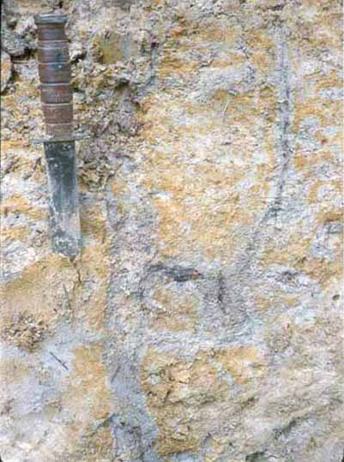
Figure 20. Soil redoximorphic features are used to determine soil zones of water saturation

- Redoximorphic soil conditions influence soil microbes
If soil water movement is very slow, oxygen is excluded from the soil because of water saturated soil conditions. Anaerobic decomposition will occur but is slow. If soil saturated with water persists for weeks to months anaerobic decomposition of all waste applied to this soil may not occur. Movement of untreated waste to the ground water and surface water will then occur. Oxidation of organic wastes by microbes in the presence of free oxygen (aerobic decomposition) is preferred because of the greater decomposition rate compared to reduced decomposition of waste without free oxygen (anaerobic). The occurrence of water saturated soil is identified by observing soil color (Figure 20). Gray soil colors usually indicate anaerobic decomposition. Red soil colors indicate aerobic decomposition. Water saturated soil conditions can be predicted and modified by knowing the soil hydraulic conductivity, occurrence of impervious soil and water recharge loading volume and rate.
- Hazardous Materials in Disposal Systems
Hazardous materials including e.g. cleaning agents, solvents and pesticides may inadvertently be released into septic systems. These materials can temporarily suppress microbial decomposition of waste. Most of these toxic materials are organic and will eventually be decomposed by microbes. However, if hazardous materials, are frequently released into septic systems they will pass through the systems and contaminate soil and water resources. Some of the hazardous materials are inorganic chemicals e.g. chloride, bromide, boron, copper, lead, and zinc. These elements and their associated compounds can accumulate in the septic system and may permanently suppress microbial decomposition. Amounts of hazardous inorganic materials must be kept to a minimum to assure efficient decomposition of organic waste.

- STANDARD APPROACH FOR OBTAINING SOIL PROFILE DESCRIPTIONS
- Soil Profiles are Used to Identify Individual Soil Types
- Soils consist of different layers (often called horizons)
Six major layers (horizons) are used to identify a soil (Figure 21). All six layers may not be present in every soil. These six layers include: O - predominantly organic material with some inorganic material, A - inorganic material with humus, E - inorganic material which has been washed of compounds e.g. clay, humus, and solutes by water moving vertically and horizontally, B - inorganic materials enriched by clay, humus, and solutes, from wetting fronts caused by water movement, C - inorganic materials showing chemical weathering i.e., oxidation-reduction, hydrolysis, hydration, chelation, due to exposure to the atmosphere, and R and D - inorganic material not weathering by exposure to the atmosphere (rock types).
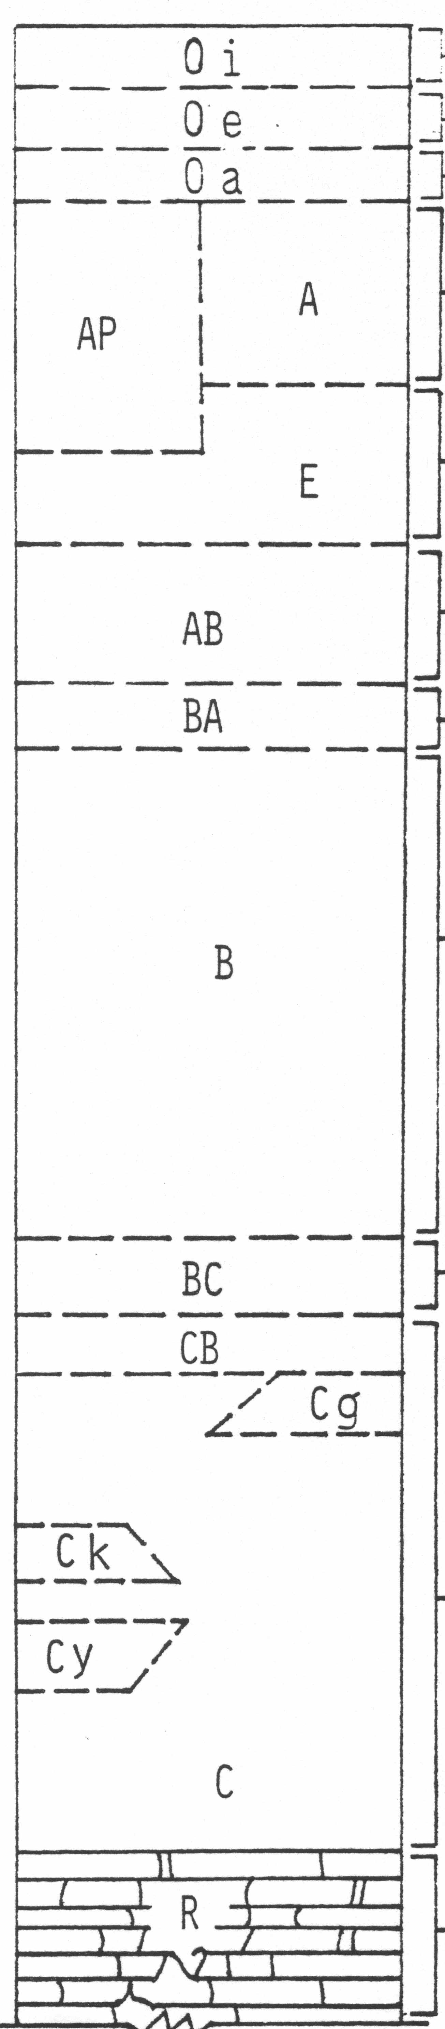
Figure 21. Diagram showing major soil horizon (layer) nomenclature
2. Soils are a natural resource identified by individual types (often called soil series)
Rock exposed to the atmosphere will weather and form soil. Soil as a natural resource is often a continuum across the landsurface. Depending on the presence and absence of the six major layers, this soil continuum is divided into soil series. Each soil series contains a range in acceptable characteristics, which serve to define it.
- Soil types (or series) are identified by a unique sequence of layers (usually 3 to 7 layers within a depth of 2 meters below the soil surface)
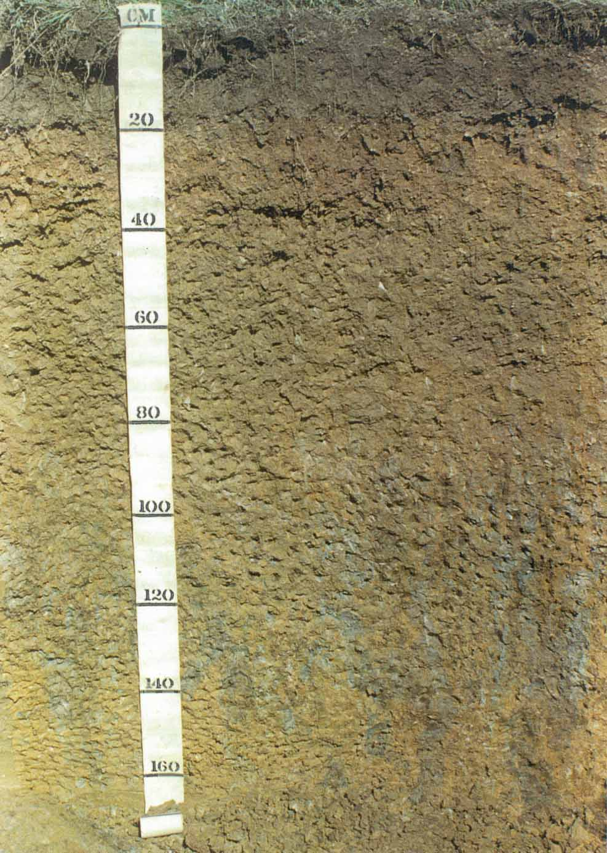
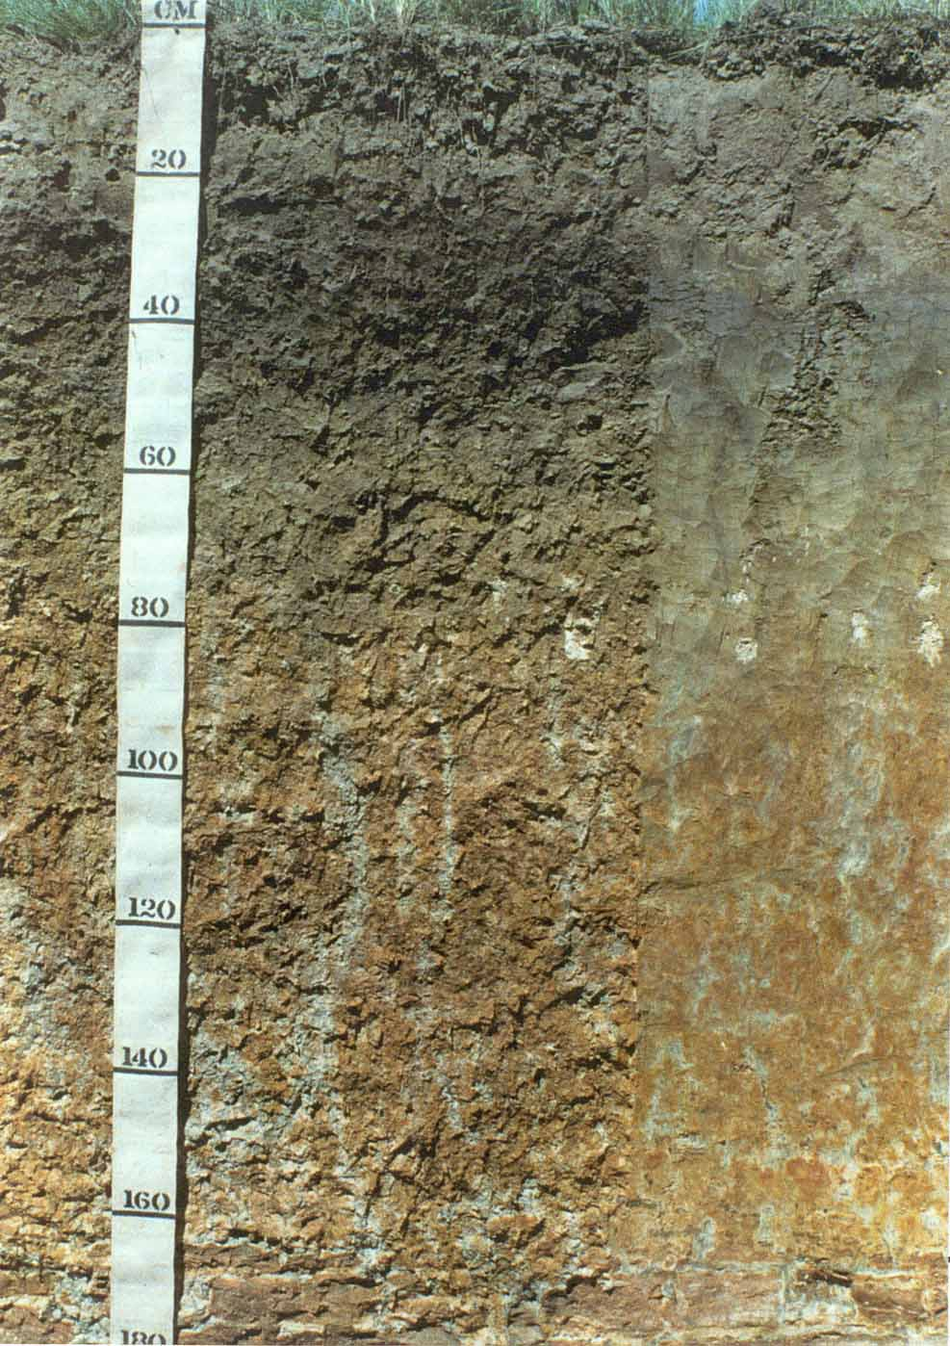
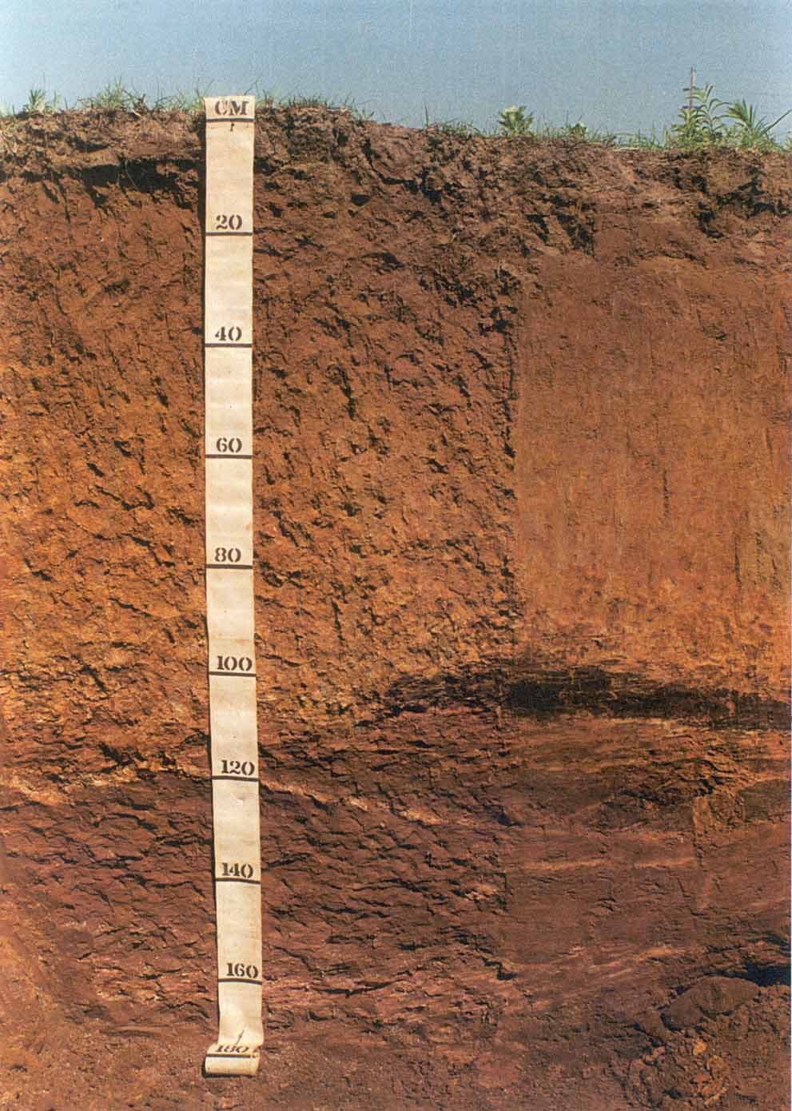
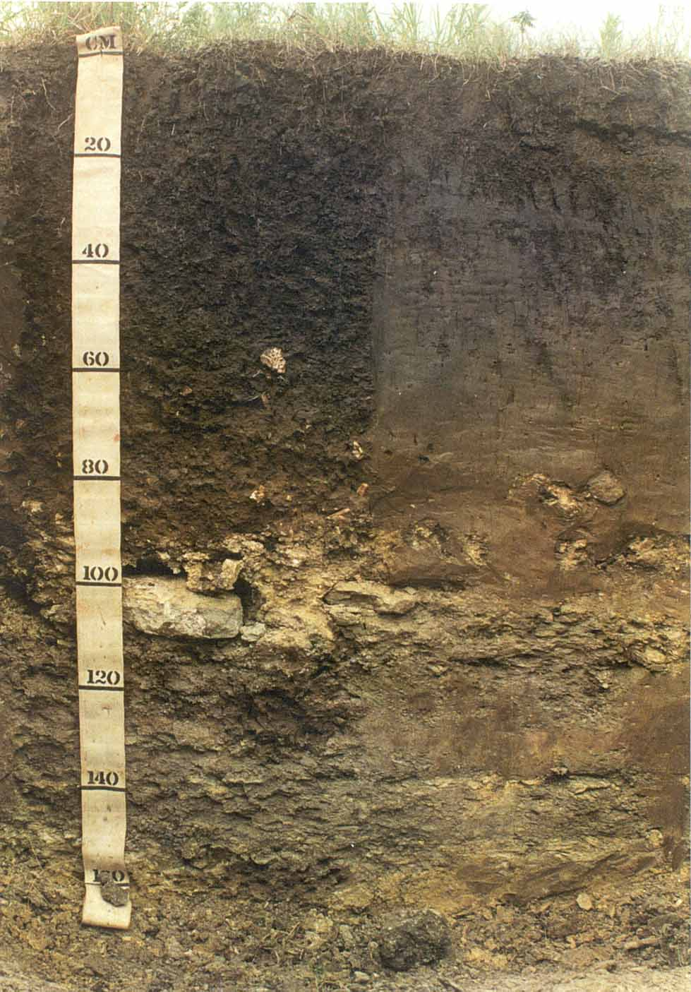
Figure 22. Four different soil types
Each location on the earth contains a unique soil (Figure 22). A soil profile description at a particular location is a soil type. Thickness and kinds of soil layers will vary from location to location. A defined range in soil layer thickness, type and characteristic (a group of soil types) is collectively called the soil series. A soil type is a subset of a series. Soil series and types usually contain 3 to 7 layers within a depth of 2 meters. A two-meter depth is a practical arbitrary lower limit to a soil and does not actually define an upper or lower limit to soil formation and weathering.
- Obtaining a Complete Soil Profile Description
- A soil profile is an aggregated description of each soil layer
A soil profile description identifies a soil type and eventually the soil series. A soil profile contains a description of each soil layer and boundary condition.
- Soil layers are described by a set of features
Each soil layer within a soil profile is described by using the same protocol. This protocol includes determining features that are salient to soil use and management or the processes of soil formation.
- A soil layer always consists of at least four features (the same four for all layers) plus others deemed pertinent to the understanding of soil processes and management at each location
Soil color, structure, texture, and consistence are routinely determined for each soil layer. In addition special features are included which help further define a layer i.e., pH, mineral precipitates including concretions and nodules, roots, animal burrows, and cavities. The thickness of each layer is also recorded along with the horizon name e.g., O, A, E, B, C, D, R, and Figure 23. Soil layer horizons are subjective i.e., depends on the experience of the observer.

Horizon Suffixes – Historically referred to as “Horizon Subscripts”, and more recently as “Subordinate distinctions”. (Historical codes and conversions are shown in the “Soil Taxonomy Section”.)

Horizon  Suffix² | Criteria
a | Highly decomposed organic matter
*b | Buried genetic horizon (not used with C horizons)
c | Concretions or nodules
d | Densic layer (physically root restrictive)
e | Moderately decomposed organic matter
f | Permanently frozen soil or ice (permafrost) continuous subsurface ice; not seasonal
ff | Permanently frozen soil or ice (“Dry” permafrost); no continuous ice; not seasonal³
*g | Strong gleying
h | Illuvial organic matter accumulation
i | Slightly decomposed organic matter
j | Jarosite accumulation³
jj | Evidence of cryoturbation³
*k | Pedogenic carbonate accumulation
m | Strong cementation (pedogenic, massive)
*n | Pedogenic sodium accumulation
o | Residual sesquioxide accumulation (pedogenic)
* p | Plow layer or other artificial disturbance
q | Secondary (pedogenic) silica accumulation
*r | Weathered or soft bedrock
s | Illuvial sesquioxide accumulation
*ss | Slickensides
*t | Illuvial accumulation of silicate clay
v | Plinthite
*w | Weak color or structure within B (used only with B)
*x | Fragipan characteristics
y | Pedogenic accumulation of gypsum
z | Pedogenic accumulation of salt more soluble than gypsum
¹ Keys to Soil Taxonomy, 6th Edition, 1994.
² Keys to Soil Taxonomy, 7th Edition, 1996
³ NRCS Soil Classification Staff, 1997; personal communication
*Most commonly used in Oklahoma.

Figure 23. Definition of key minor soil horizon nomenclature used to subdivide major soil horizon names and identify key soil features
- Soil features are useful for both soil use and management as well as the understanding of soil forming processes
Soil texture, depth to impervious to boring and wetness as determined from redoximorphic features are interpretations made from a soil profile description that can be used to determine design and sizing of individual and small public on-site sewage disposal systems. Several observations of these soil characteristics must be made within the proposed sewage disposal site location. Each soil type determined from a soil profile description may be part of one or more soil series. The most limiting soil type and series should be used for designing and sizing disposal systems.
- Laboratory Analysis is Used to Support Field Soil Profile Descriptions
- Overview of soil physical, chemical, and mineralogical laboratory analysis
The most widely determined laboratory soil analysis is major plant nutrient content i.e., nitrogen, phosphorus, and potassium. Soil nutrient content along with pH of the surface layer is used by agronomists to predict crop yield and calculate fertilizer applications. Soil plant nutrient analysis determines available forms of nutrients, which are often variable over time and have requirements that change with crop choice. Laboratory analysis used to identify soil types and series include those that do not change appreciably over several years.
- Examples of laboratory analysis used to support soil profile descriptions
Laboratory measurements of physical, chemical and mineralogical properties can be made to support field soil observations. Examples of these analysis include, bulk density, particle-size distribution, hydraulic conductivity, pH, cation exchange capacity, exchangeable bases, soluble salts, organic matter content, and clay mineral identification. These analyses are performed on all soil layers.

- Soil particle size analysis (soil texture)
The relative amounts of sand, silt, and clay-sized particles within a soil layer are determined by applying Stokes Law. Soil is dispersed in a column of water and the relative amounts of each particle size are determined by the rate of fall through the column of water over several hours. This relatively simple and inexpensive method can be used to calibrate field determinations made by manipulating moist soil samples.
- Types of Soil Excavations; Small or Large Volume Disturbance.
- Small volume soil auger or push-probe cores
The use of small soil auger or push-probe cores that are several inches in diameter and length should be the first choice in profiling soil. Soil augers and cores samples can be done by hand or by using small motors. Rapid retrieval of small auger or core samples can be more efficient compared to large excavations when determining soil types for an area. If more information is needed or anomalies occur during small sample investigations a large excavation can be made to help answer these soil profile description questions.
- Large soil excavations using backhoe or similar “heavy” equipment
Large surface exposures (soil pits) of freshly dug soil are ideal for viewing soil profiles. These large exposures are 36 inches wide and allow repeated analysis of soil characteristics and soil boundaries, which determine soil layers. Smaller features associated with animal burrows or other soil anomalies are clearly identified. Large soil excavations disturb large volumes of soils, which may reduce soil quality in the immediate area. Also large excavations may require “heavy” or expensive equipment, which may not be available at the site investigation area

- Advantages and disadvantages of various methods of soil excavations
Augered soil samples are less desirable compared to core or shallow pits. Augers twist the soil into a sample container. Twisting and smearing obscures soil features especially soil structure. Larger augers, 3 inch diameter buckets compared to 1 inch diameter buckets will preserve some soil structure. Determining depth to rock can be difficult when using soil cores. Soil cores penetration is often stopped not only by rock but also by dry sandy soils, which do not compact away from the cutting tip and therefore stop entry of the probe into the soil. Dry sandy soils may sometimes incorrectly be interpreted as rock. For soil profilers with limited experience, a shallow pit yields the best soil profile description.
- Remotely Sensed Techniques for Noninvasive Soil Investigations
- Ground penetrating radar observations
Ground penetrating radar uses pulses of radar waves to determine dense soil layers and rock. Ground penetrating radar is pulled along the ground producing a linear chart recording, which identifies subsurface soil features to a depth of 1 to 2 meters. Ground penetrating radar is useful on a relatively small scale of 10 to 30 feet or more. Ground penetrating radar does not disturb the soil.
- Hammer seismograph techniques
Hammer seismograph techniques use sound waves produced by striking a hammer on a plate laid (or a small explosion) on the soil surface. The refracted sound waves that move through the soil are collected by a series of detectors (geophones). Depth to rock, groundwater, and other dense layers can be identified for depths up to 30 feet below ground surface. Hammer seismograph information does not disturb the soil but yields depth information for a point midway along 100 feet observation line.

- Limitations of using remotely sensed data for soil interpretations
Remotely sensed data derived from ground penetrating radar and hammer seismograph techniques will supplement but not replace actual interpretation made by directly observing the soil. Remotely sensed data does not provide direct information about soil texture or redoximorphic features.
- Individual residences Versus Multiple residences and developments
- Individual Residences
Soil interpretations for a single residence are made from a minimum of three soil excavations (auger, core, and/or shallow pit). Observations are made within the area of the proposed sewage disposal site.
- Multiple residences and developments
Soil survey maps may be used to help identify major soil types in the proposed development. This information will help the developer determine lot sizes and possible wastewater treatment options. Site specific soil profiles must be performed to determine the actual design and size of the on-site system.

III. CLASSIFYING KEY SOIL CHARACTERISTICS FOR DESIGN AND SIZING OF INDIVIDUAL AND SMALL PUBLIC ON-SITE SEWAGE DISPOSAL SYSTEMS IN OKLAHOMA SOILS
- Identification of Potentially Unsuitable Soils
Conditions, which limit use of earth material as soil, are unsuitable for adsorption fields. Soil layers which restrict plant roots, microbial activity, excavations, and water flow are extremely dense (usually greater than 1.8 g/cm³ soil bulk density) and sometimes (cemented soil materials that don’t slack in water). These dense layers often have low porosity and low oxygen content, which limits biological activity. Soil impervious to boring should not be included as soil suitable for absorption fields. Possible impervious soils include lithic and paralithic materials (hard, soft, and fractured rock), petrocalcics (soil-formed limestone or caliche), fragipans (dense soil layers), and natric layers (dense sodium-rich soil layers)
- Identification of Water Saturated Soil Layers
- Introduction
Redoximorphic (redox) features associated with wetness result from alternating periods of reduction and oxidation of iron and manganese compounds in the soil and are used to determine water saturated soil layer. Reduction occurs during saturation with water, and oxidation occurs when the soil is not saturated. The reduced iron and manganese ions are mobile and may be transported by water as it moves through the soil. Certain redox patterns occur as a function of the patterns in which the ion-carrying water moves through the soil and as a function of the location of aerated zones in the soil. Redox patterns are also affected by the fact that manganese is reduced more rapidly upon aeration. These processes create characteristic color patterns. The reduced iron and manganese ions may be removed from a soil if vertical or lateral fluxes of water occur, in which case there is no iron or manganese precipitation in that soil. Wherever the iron and manganese are oxidized and precipitated, they form either soft masses or hard concretions or nodules. Movement of iron and manganese as a result of redox processes in a soil may result in redoximorphic features.
- Types of redoximorphic features
- Redox concentrations. - These are zones of apparent accumulation of Fe-Mn oxides, including:
- Nodules and concretions, which are cemented bodies that can be removed from the soil intact. Concretions are distinguished from nodules on the basis of internal organization. A concretion typically has concentric layers that are visible to the naked eye. Nodules do not have visible organized internal structure. Boundaries commonly are diffuse if formed in situ and sharp after pedoturbation.
- Masses, which are noncemented concentrations of substances within the soil matrix; and
- Pore linings, i.e., zones of accumulation along pores that may be either coatings on pore surfaces or impregnations from the matrix adjacent to the pores. These can be old worm casts or root channels.
- Redox depletions. - These are zones of low chroma (chromas less than or equal to 2 in the matrix) where either Fe-Mn oxides alone or both Fe-Mn oxides and clay have been stripped out, including:
- Iron depletions, i.e., zones that contain low amounts of Fe and Mn oxides (turns grey) but have a clay content similar to that of the adjacent matrix (often referred to as albans or neoalbans); and
- Clay depletions, i.e., zones that contain low amounts of Fe, Mn, and clay (often referred to as silt coatings or skeletons).
3. Quantity of redoximorphic feature is indicated by three percentage classes of the observed surface
a. Few: less than 2 percent,
b. Common: 2 to 20 percent, and
c. Many: more than 20 percent.
4. Redoximorphic notations within soil profile descriptions
The notations must clearly indicate to which colors the terms for quantity apply. For example, “common grayish brown and yellowish brown redoximorphic depletions” could mean that each makes up 2 to 20 percent of the horizon. By convention, the example is interpreted to mean that the quantity of the two colors together is between 2 and 20 percent. If each color makes up between 2 and 20 percent, the description should read “common grayish brown (10YR 5/2) and common yellowish brown (10YR 5/4) redoximorphic depletions”.
- Soil Particle Size Distribution (Soil Texture)
- Classification of soil particle sizes
Soil texture (also known as particle size distribution) including fine earth (smaller than 2 mm diameter) as distinct from rock fragments (pebbles, cobbles, stones, and boulders). Soil texture refers to the weight proportion of the separates for particles less than 2 mm:
Very coarse sand: 2.0-1.0 mm
Coarse sand: 1.0-0.5 mm
Medium sand: 0.5-0.25 mm
Fine sand: 0.25-0.10 mm
Very fine sand: 0.10-0.05 mm
Silt: 0.05-0.002 mm
Clay: < 0.002 mm
Soil texture of fine earth or less than 2 mm is determined in the field mainly by feel. The content of rock fragments is determined by estimating the proportion of the soil volume that they occupy and then adding a prefix modifier to the soil texture name.
The texture classes are sand, loamy sands, sandy loams, loam, silt loam, silt, sandy clay loam, clay loam, silty, clay loam, sandy clay, silty clay, and clay. Subclasses of sand are subdivided into coarse sand, sand, fine sand, and very fine sand. Subclasses of loamy sands and sandy loams that are based on sand size are named similarly.
2. Definitions of the soil texture classes (simplified)
a. Sands. More than 85 percent sand.
*(1) Coarse sand. A total of 25 percent or more very coarse and coarse sand.
- Sand. A total of 25 percent or more very coarse, coarse, and medium sand.
(3) Fine sand. 50 percent or more fine sand; or a total of less than 25 percent very coarse, coarse, and medium sand and less than 50 percent very fine sand.
(4) Very fine sand. 50 percent or more very fine sand.

b. Loamy sands. Between 70 and 91 percent sand and the percentage of silt plus 1.5 times the percentage of clay is 15 or more; and the percentage of silt plus twice the percentage of clay is less than 30.
*(1) Loamy coarse sand. A total of 25 percent or more very coarse and coarse sand and less than 50 percent any other single grade of sand.
(2) Loamy sand. A total of 25 percent or more very coarse, coarse, and medium sand and a total of less than 25 percent very coarse and coarse sand, and less than 50 percent fine sand and less than 50 percent very fine sand.
(3) Loamy fine sand. 50 percent or more fine sand; or less than 50 percent very fine sand and a total of less than 25 percent very coarse, coarse, and medium sand.
(4) Loamy very fine sand. 50 percent or more very fine sand.
c. Sandy loams. 7 to 20 percent clay, more than 52 percent sand, and the percentage of silt plus twice the percentage of clay is 30 or more; or less than 7 percent clay, less than 50 percent silt, and more than 43 percent sand.
(1) Coarse sandy loam. A total of 25 percent of more very coarse and coarse sand and less than 50 percent any other single grade of sand.
(2) Sandy loam. A total of 30 percent or more very coarse, coarse, and medium sand, but a total of less than 25 percent very coarse and coarse sand, but a total of less than 25 percent very coarse and coarse sand and less than 30 percent fine sand and less than 30 percent very fine sand; or a total of 15 percent or less very coarse, coarse, and medium sand, less than 30 percent fine sand and less than 30 percent very fine sand with a total of 40 percent or less very fine sand.
(3) Fine sandy loam. 30 percent or more fine sand and less than 30 percent very fine sand; or a total of 15 to 30 percent very coarse, coarse, and medium sand; or a total of more than 40 percent fine and very fine sand, one half or more of which is fine sand, and a total of 15 percent or less very coarse, coarse, and medium sand.
(4) Very fine sandy loam. 30 percent or more very fine sand and a total of less than 15 percent very coarse, coarse, and medium sand; or more than 40 percent fine and very fine sand, more than one half of which is very fine sand, and total of less than 15 percent very coarse, coarse, and medium sand.
d. Loam. 7 to 27 percent clay, 28 to 50 percent silt, and 52 percent or less sand.
e. Silt loam. 50 percent or more silt and 12 to 27 percent clay, or 50 to 80 percent silt and less than 12 percent clay.
f. Silt. 80 percent or more silt and less than 12 percent clay.
g. Sandy clay loam. 20 to 35 percent clay, less than 28 percent silt, and more than 45 percent sand.
h. Clay loam. 27 to 40 percent clay and more than 20 to 46 percent sand.
i. Silty clay loam. 27 to 40 percent clay and 20 percent or less sand.
j. Sandy clay. 35 percent ore more clay and 45 percent or more sand.
*k. Silty clay. 40 percent or more clay and 40 percent or more silt.
*l. Clay. 40 percent or more clay, 45 percent or less sand, and less than 40 percent silt.
* Not suitable for a subsurface absorption field

3. Including rock fragments within soil texture
a. Introduction
Rock fragments are unattached pieces of rock 2 mm in diameter or larger that are strongly cemented or resistant to rupture. Rock fragments are described by size, shape, and, for some, the kind of rock. The classes are pebbles, cobbles, channers, flagstones, stones, and boulders (Table 3).
b. Rock fragment classes, based on volume percentages, are used to modify soil texture classes.
(1) Less than 15 percent: No adjectival or modifying terms are used in writing for contrast with soils having less than 15 percent pebbles, cobbles, or flagstones. the adjective “slightly” may be used however, to recognize those soils used for special purposes.
(2) 15 to 35 percent: The adjectival term of the dominant kind of rock fragment is used as a modifier of the textural term: “gravelly loam,” “channery loam,” “cobbly loam”.
- 35 to 60 percent: The adjectival term of the dominant kind of rock fragment is used with the word “very” as a modifier of the textural term: “very gravelly loam” “very flaggy loam”.

Table 1. Terms for rock fragments.
Size | Noun (shape) | Adjective
 | Spherical, cubelike, or equiaxial
2-75 mm diameter | Pebbles | Gravelly
2-5 mm diameter | Fine | Fine gravelly
5-20 mm diameter | Medium | Medium gravelly
20-75 mm diameter | Coarse | Coarse gravelly
75-250 mm diameter | Cobbles | Cobbly
250-600 mm diameter | Stones | Stony
600 mm diameter | Boulders | Bouldery
 | Flat:
2-150 mm long | Channers | Channery
150-380 mm long | Flagstones | Flaggy
380-600 mm long | Stones | Stony
600 mm long | Boulders | Bouldery
Fragment Content  % By Volume | Rock Fragment Modifier Usage
<15 | No texture adjective is used (noun only; e.g., loam).
15 to <35 | Use adjective for appropriate size; e.g., gravelly.
35 to <60 | Use “very” with the appropriate size adjective; e.g., very gravelly.
60 to <90 | Use “extremely” with the appropriate size adjective; e.g., extremely gravelly.
≥90 | No adjective or modifier. If ≤ 10% fine earth, use the appropriate noun for the dominant size class; e.g., gravel. Use Terms in Lieu of Texture.
TEXTURE MODIFIERS-Conventions for using “Rock Fragment Texture Modifiers” and for using textural adjectives that convey the “% volume” ranges for Rock Fragments-Size & Quantity.

- More than 60 percent: If enough fine earth is present to determine the textural class (approximately 10 percent or more by volume) the adjectival term of the dominant kind of rock fragment is used with the word “extremely” as a modifier of the textural term: “extremely gravelly loam,” “extremely bouldery loam.” If there is too little fine earth to determine the textural class (less than about 10 percent by volume) the term “gravel,” “cobbles,” “stones,” or “boulders” is used as appropriate.

- Step-by-Step Procedure for Determining Suitability
1. Locate depth to a soil layer impervious to boring (if any)
2. Locate depth to a water saturated soil layer as identified by redoximorphic depletions with soil color of < 2 chroma and value > 4 (if any)
3. To continue to Step 4, 36 inches of separation must be present between the top of the ground to a impervious to boring layer or water saturated soil layer and 18 inches of separation from the bottom of the trench to a impervious to boring layer or water saturated soil layer (subsurface absorption system is unsuitable if the separation from water saturated soil or impervious to boring is not met)
4. Identify all soil textures (included percent rock fragments) between a depth of 12 and 48 inches, and identify the most prevalent soil between 12 and 36 inches
5. Match the most prevalent soil texture to the soil group (Table 2), and then match the soil group to size the absorption system using Table 3.

Table 2. Loading rates by soil groups for conventional systems in Oklahoma.
Soil Group | Soil Textures | Application rate  Linear ft/gal/day
5 | Clay, silty clay (sandy clay w/ slickensides or weak soil structure) | unsuitable
4 | Clay loam and silty clay loam (sandy clay w/o slickensides and w/ moderate and strong soil structure) | 3.3
3 | Sandy clay loam, loam, silt loam, and silt | 1.7
2 | Sand, Sandy loam, and loamy sand, (not including coarse sand or loamy coarse sand) | 0.8
1 | Coarse sand and loamy coarse sand and (and all soils w/ rock fragment contents >35% by volume having continuous voids of greater than 1mm) | unsuitable

Table 3. Minimum trench length (feet) for subsurface absorption systems.
Soil Group | 2 Bedrooms or Fewer | 3 Bedrooms | Each Additional
2 | 160 | 210 | 50
3 | 340 | 450 | 110
4 | 660 | 880 | 220

- Wastewater Treatment
Proper treatment of wastewater is dependant on the amount of oxygen present in the unsaturated area below the absorption trench. Soil profiles assist in identifying soil conditions that are favorable to subsurface wastewater treatment. Most biological activity in the soil occurs within an area just a few inches below the trench bottom. In order for this infiltrative zone to remain effective in the treatment of wastewater, wetting and drying conditions should be provided. An adequate amount of acceptable soil must be between the bottom of the trench and a water-saturated soil to provide the aerobic environment needed to treat wastewater effluent. Increasing the strength of the wastewater or decreasing the bottom contact area of the absorption trench decreases the soils ability to effectively treat the wastewater.

- INTERPRETATION OF KEY SOIL CHARACTERISTICS FOR DESIGNING AND SIZING SEWAGE DISPOSAL SYSTEMS
- Special Soil Features that May Cause Water Saturated Soil or Impervious to Boring
- Lithic and paralithic materials (r)
Lithic and paralithic materials are rock (usually with > 3 hardness on the Moh scale) and fracture rock that is not considered soil. The contact between soil and bedrock (lithic materials) is called the lithic contact. Bedrock is not found to be a suitable filtering material, and can also limit water movement through the ground. Lithic and paralithic material are unsuitable for conventional absorption systems and are considered impervious to boring.
- Fragipans (x)
Fragipans are soil formed subsoil layers of dense, brittle (when moist), and very hard (when dry) soil materials. Fragipan layers limit water movement and biological activity and tend to show redoximorphic features, which is unsuitable for conventional absorption systems. Fragipans are similar to lithic and paralithic materials but unlike lithic materials they will slack when immersed in water. Fragipan are considered impervious to boring.
- Natric layers (n)
Natric layers are soil formed subsoils containing abundant sodium on the soil particle surfaces. Natric layers are dispersed and will be dense. Natric layers limit water movement and biological activity unsuitable and tend to show redoximorphic features, which is unsuitable for conventional absorption systems. Natric layers are considered impervious to boring.
- Petrocalcic/Caliche layers (k)
Petrocalcic layers are soil formed lithic materials. The soil is continuously cemented by CaCO₃. Petrocalcic layers are often called caliche. Petrocalcic soil layers are analogous to limestone and are considered impervious to boring. Petrocalcic layers are unsuitable for conventional absorption systems due to the fact that they are impervious to boring.
There are four stages of caliche. The first two stages are weakly to moderately developed and are not considered impervious to boring. Stages three and four are strongly developed and are considered impervious to boring . Caliche is typically found in the B-horizon and has a horizon suffix of “k” in stages I and II, but the horizon suffix will be “km” if the soil is in stages III or IV. This information can be found in the county soil survey.
- Criteria Established by Presence of Water Saturated Soil Layer
- Formation of soil redoximorphic features
Redoximorphic features associated with wetness result from alternating periods of reduction and oxidation of iron and manganese compounds in the soil. Reduction occurs during saturation with water, and oxidation occurs when the soil is not saturated. The reduced iron and manganese ions are mobile and may be transported by water as it moves through the soil. Certain redox patterns occur as a function of the patterns in which the ion-carrying water moves through the soil and as a function of the location of aerated zones in the soil. Redox patterns are also affected by the fact that manganese is reduced more rapidly than iron, while iron oxidizes more rapidly upon aeration. These processes create characteristic color patterns. The reduced iron and manganese ions may be removed from a soil if vertical or lateral fluxes of water occur, in which case there is no iron or manganese precipitation in that soil. Wherever the iron and manganese are oxidized and precipitated, they form either soft masses or hard concretions or nodules. Movement of iron and manganese as a result of redox processes in a soil may result in redoximorphic features that are defined as follows: Redox concentrations. - These are zones of apparent accumulation of Fe-Mn oxides and Redox depletions. - These are zones of low chroma (chromas less than those in the matrix) where either Fe-Mn oxides along or both Fe-Mn oxides and clay have been stripped out.
- Duration of water saturated soil and impact on on-site sewage disposal systems
Layers of soil that are saturated with water for periods of time longer than several weeks will contain redoximorphic features and be anaerobic. Water saturated soil layers (aquic layers) are unsuitable for conventional absorption systems . Aquic soil layers are usually endosaturated (all subsoil layers contained redoximorphic features) or episaturated (only one layer contains redoximorphic features).
- Criteria Established by Soil Particle Size Distribution
- Loading rates by soil groups for conventional systems in Oklahoma (Table 2)
- Minimum trench length for subsurface absorption systems (Table 3)
- Using Current Soil Survey Information as a County or Regional Planning Tool
- Apply suitability criteria established in section III A through D above to the typical profiles for benchmark soil series found in USDA-NRCS county soil survey information (Tables 2 and 3)
- Estimate county and regional areas of suitable and unsuitable soil showing major limitations (Appendices A through G)
- Web site for the soils series description:
http://ortho.ftw.nrcs.usda.gov/cgi-bin/osd/osdname.cgi
Glossary

Adhesion- steady or firm attachment

Aerobic- having molecular oxygen in the environment

Alkalization- accumulation of sodium ions on the exchange sites in a soil, producing high pH (>8.0)

Alluvium- soil deposited on the land by streams

Anaerobic- a condition in which molecular oxygen is absent from the environment

Biogeochemical- of or relating to the partitioning and cycling of chemical elements and compounds between the living and nonliving parts of an ecosystem

Bulk density- mass of dry soil divided by its undisturbed volume

Chelation- the formation of more than one bond between the metal ion and a molecule of the complexing agent, resulting in the formation of a ring structure incorporating the metal ion

Chroma- indicates the colors intensity, shown on the horizontal scale

Cohesion- in granular soils due to capillary forces associated with water

Colluvium- soil deposited by gravity

Concretions- firm to extremely firm irregularly shaped bodies with diffuse boundaries, when broken in half concretions have concentric layers.

Eluviation- movement of material in solution through the soil

Endosaturated- all subsoil layers contained redoximorphic features

Eolian- Pertaining to earth material transported and deposited by the wind including dune sands, sand sheets, loess, and parna.

Episaturted- only one layer contains redoximorphic features

Fragipan (x)- weakly cemented layer

Geochemical- the related chemical and geological properties of a substance

Geochemical erosion- removal from the entire profile

Gleyed soil- indicates low chroma (gray color) under poor drainage conditions

Heterogeneous- consisting of dissimilar or diverse ingredients or constituents

Hue- indicates its relation to Red, Yellow, Green, Blue, and Purple (specific wavelength of light)

Humus- undecayed plant and animal tissue resistant to short-term decay (organic matter)

Hydration- to cause to take up or combine with water or the elements of water

Hydraulic conductivity- the proportionality factor in Darcy's law as applied to the viscous flow of water in soil, i.e., the flux of water per unit gradient of hydraulic potential

Hydrolysis- a chemical process of decomposition involving the splitting of a bond and the addition of the hydrogen cation and the hydroxide anion of water

Leaching- the removal of soluble materials from one zone in soil to another via water movement in the profile

Lithic- rock

Illuviation – deposition from one horizon to another

Impervious soil-conditions which limit the use of earth material as soil

Matrix- the volume of ped interiors a soil horizon or subhorizon

Natric (n)- abundant sodium layers layer (sodic)

Nodules- firm to extremely firm irregularly shaped bodies with diffuse boundaries, when broken in half nodules have a uniform internal fabric

Organic- the organic fraction of the soil exclusive of undecayed plant and animal residues

Oxidation- the reduction of iron and manganese or other materials by the loss of one or more electrons by an ion or molecule and received by oxygen

Paralithic- fractured rock

Ped- an individual natural soil aggregate

Pedoturbation- mixing soil layers usually by animals or by other agents like frost

Petrocalcic (caliche-k)- layers cemented by CaCO₃

Recalcitrant- resistant to change- does not change

Reduction- the process by which oxygen is removed by the gain of one or more electrons by an ion or molecule, where the material is water saturated

Salinization- accumulation of soluble salts

Sandstone- sedimentary rock containing dominantly sand-size particles

Shale- Sedimentary rock formed by the hardening of a clay or silt deposit

Slickensides- Polished and grooved surfaces produced by one soil mass sliding past another

Solum- the upper part of a soil profile, above the C-horizon, in which the processes of soil formation are active (has soil structure)

Translocation- relocation of solids (clay and OM) and solutes within the soil profile

Vadose zone- the aerated moist region of soil above the permanent water table

Value-indicates its lightness shown on the vertical scale (gray scale)

Water saturated soil- soil characterized by either the presence of ground water or redoximorphic features identified by a soil color of less than or equal to two (2) chroma and greater than or equal to four (4) value

References

Baver, L.D. 1956. Soil Physics. John Wiley and Sons, Inc. New York.

Brady, N.C. and R.R. Weil. 1996. The Nature and Properties on Soil. Eleventh Edition. Prentice Hall, Upper Saddle River, New Jersey.

Environmental Protection Agency. 2002. On-site Wastewater Treatment Systems Manual. U.S. Government Printing Office, Washington, D.C.

Gee, G.W. and J.W. Bauder. 1986. Particle-size Analysis. In Methods of Soil Analysis; Part 1 Physical and Mineralogical Methods, Second Edition, A Klute, Editor. Agronomy #9, American Society of Agronomy. Madison, Wisconsin.

Hillel, D. 1982. Introduction to Soil Physics. Academic Press, Inc. San Diego, California.

Kleiss, H.J. and M.T. Hoover. 1998. Utilization, Treatment, and Disposal of Waste on Land; Soil and Site Criteria for On-site Systems. Soil Science Department Special Publication, North Carolina State University, Raleigh.

Schoeneberger, P.J. Wyscocki, D.A. Benham, E.C. and Broderson, W.D. 1998. Field book for describing and sampling soils (version 1.1). Natural Resources Conservation Service. USDA, National Soil Survey Center, Lincoln, NE.

Soil Science Society of America. 1984. Glossary of Soil Science Terms. Soil Science Society of America, Madison Wisconsin.

Soil Survey Staff. 1998. Keys to Soil Taxonomy, Eighth Edition. USDA; Natural Resources Conservation Service, Washington, D.C.

Soil Survey Division Staff. 1993. Soil Survey Manual. USDA Handbook #18. U.S. Government Printing Office. Washington, D.C.

Stiegler, J.H. and B.G. Bourlier. 2000. Land Judging in Oklahoma; 4-H Members Guide. Cooperative Extension Service Publication #148. Division of Agricultural Sciences and Natural Resources, Oklahoma State University, Stillwater.

Taylor, S.A. and G.L. Ashcroft. 1972. Physical Edaphology. W.H. Freeman and Company, San Francisco.

Winneberger, J.T. Correlation of Three Techniques for Determining Soil Permeability (1974). Journal of Environmental Health 37:108-118.

This Publication is issued by the Oklahoma Department of Environmental Quality as authorized by Steven A. Thompson, Executive Director. Ten copies have been produced at a cost of $2.08 each. Copies have been deposited with the Publications Clearinghouse of the Oklahoma Department of Libraries.

