|
OGX
Grantee Manual
Contents
Introduction 4
OGX Overview 4
System Requirements 5
Internet Connection 5
Internet Access 5
Enabling Cookies 5
Multiple Browser Windows 5
Adobe Acrobat DC 5
System Login Page 6
URL 6
OGX Portal Home Login Page Sections 6
Welcome/Announcements 6
OGX Portal Login Section 6
Logging in to the OGX Portal 6
Trouble Shooting Issues Logging in to the OGX Portal 7
User Information 9
Profile 10
Organizations 11
Home 12
Tabs 12
Home 12
Searches 12
Icons 12
Dashboard 13
My Tasks 13
Announcements 13
My Opportunities 14
Grant Opportunities 15
Starting a Grant Opportunity 15
Working on a Grant Opportunity 15
The Document Landing Page 15
Grant Opportunity Forms 16
Forms 16
Tools 18
Status Options 22
Related Documents 23
Searches 24
Applications 24
Financials 24
Programmatic Reports 25

Introduction

OGX Overview
The OGX Portal specializes in improving functionality and ease of use. These are the areas that the OGX Portal shines in:

- OGX Dashboard – The OGX Dashboard allows users to drill down through new reporting panels for funding account information, program budgets, and even view staff performance information.

- SAM.GOV System Interface – The new system interface automatically gathers address and contact information during registration and confirms a valid DUNS number. It also allows the system to check for expiration dates and confirm whether an organization can receive federal funding.

- Easy Configuration of Program Changes – The OGX portal takes advantage of a new drag-and-drop configuration engine to allow users to make changes to their programs. This includes easily updating forms, process flows, and management reports.

- Updated Accessibility Features – OGX was built from the ground up to adhere to ADA and WCAG 2.1 AA standards. The portal will also undergo regular 3rd party web accessibility compliance audits. It includes new options like a high contrast mode and new branding utilities, making it easier to accommodate individuals with disabilities.

System Requirements

The system was designed so that computer users can use it with little or no changes to their computer environment. The requirements that are mentioned below are common computer elements that should be already present.

Internet Connection
The grants management system is an internet application designed for and accessed via the internet.

Internet Access
This system was designed to be compatible with common up-to-date web browsers such as Microsoft Edge, Chrome, Firefox, or Safari. If the web browser is not update, the following message will display:

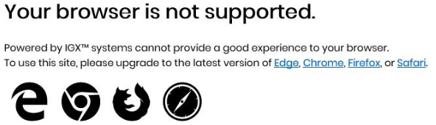

Enabling Cookies
The web browser must enable cookies for this site in order to access this portal.

Multiple Browser Windows
Do not open multiple windows or browser tabs while filling out the document, as this can cause issues with browser cookies resulting in either being kicked out of the system or work being lost.
NOTE: If the user needs to have multiple windows open please ensure that the user is using a separate browser session instead.

If utilizing Microsoft Edge, click on File New Session for each browser session. Other internet browsers will require third party add-ons to manage multiple browser sessions.

Adobe Acrobat DC
Adobe Acrobat DC (Adobe Acrobat Reader) is used to view PDF (Portable Document Format) documents. The system will automatically generate grant documents in PDF format using information that has been saved into the various narrative and budget pages. Using Adobe Acrobat DC, the user may choose to view, print, or save these documents. Users who do not have this software installed on their systems will need to download it from www.adobe.com.

System Login Page

URL
To access the OGX portal, type the following into the address bar of the web browser and press Enter.
https://ogx.ok.gov

NOTE: The OGX portal does not save the username and password. This option may be available for some browsers.

OGX Portal Home Login Page Sections

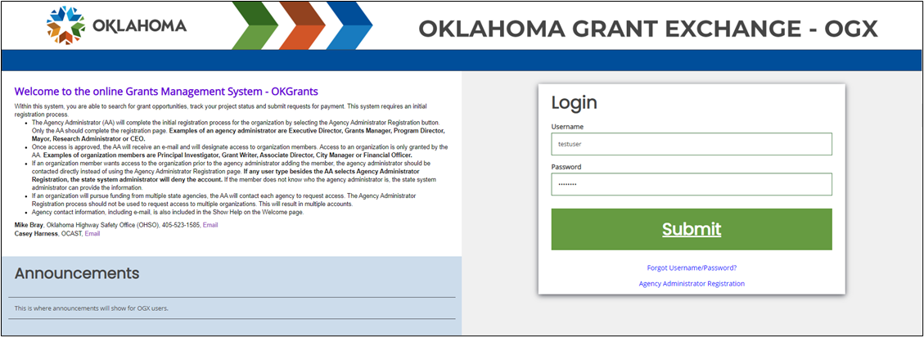
Figure 1 The Login Page

The OGX portal login page is organized into Public Reports, Welcome/Announcements, and Login sections.

Welcome/Announcements
This is the section where are welcomed to the portal and allowed to view posted announcements. These announcements may include links.

OGX Portal Login Section
The OGX portal login process requires a user to enter in a User Name and Password to login.
NOTE: The password field is case sensitive and will not recognize characters of the wrong case. Precision when entering the username into the username field will decrease the risk of error messages being generated by the system.

Logging in to the OGX Portal

User Name
The user name is created by the new user during the registration process OR by the user adding this user to the organization.

Password
The password is created automatically by the portal once a new user is added.

Submit Button
Push the Submit Button to login onto the OGX Portal.

Trouble Shooting Issues Logging in to the OGX Portal

Forgot Username
The OGX portal allows the user to request the retrieval of their username. To do so, complete the following steps:
- Click on the Forgot Username/Password! link.

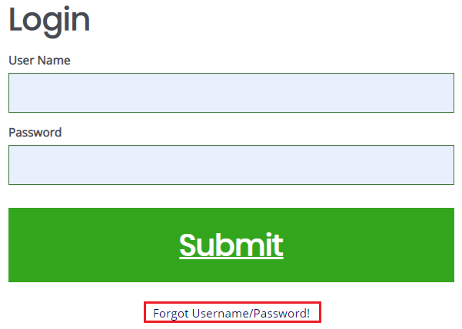

- Click on the Forgot Username link.

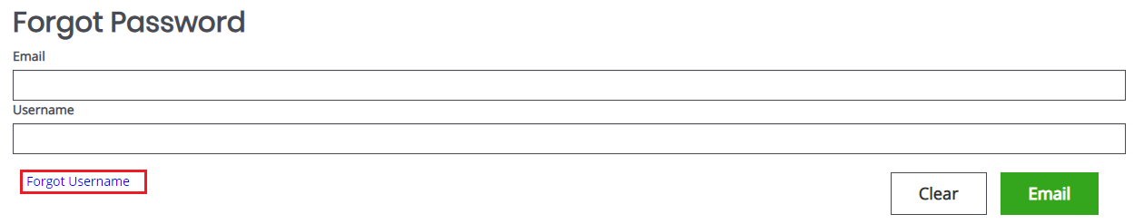

- Enter the email address and click on the Email button. An email will be sent to that email address with the user’s username.

- The user can follow the instructions in the “Forgot Password” section to allow them to log into the system.

“Locked Out”
Once a user has exceeded 3 login attempts for the portal, they are “locked out”. The user may use the Forgot Password link to request a temporary password at any point. Instructions for using the “Forgot Password” link are provided below.

Forgot Password
The OGX portal allows the user to request a temporary password be generated and sent to their email address. To do so, complete the following steps:
- Click on the Forgot Username/Password! link.
- Enter the username and the email address. Click on the Email button. A temporary password will be sent to the email address supplied.

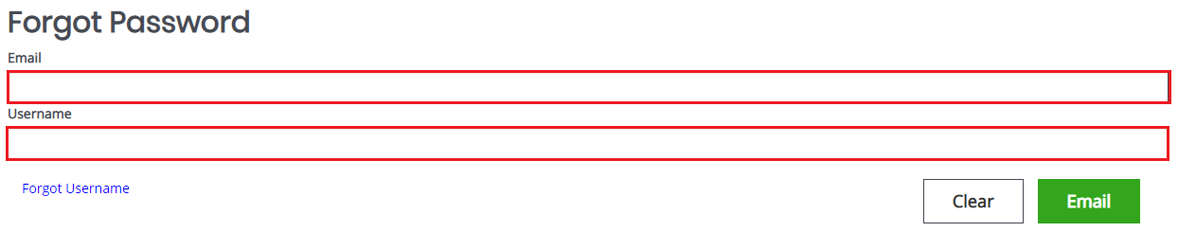

- Once the user has received a temporary password, they will need to login.
NOTE: The password field is case sensitive and will not recognize characters of the wrong case. Precision when entering the username into the username field will decrease the risk of error messages being generated by the system.

- At that point, the user will be brought directly to the Profile page and requested to create a new password. The user can use the Edit Password button at the bottom of the page to update the password. When the user clicks on the Edit Password button, the Password and Confirm Password fields are available.

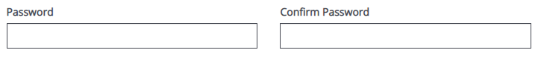

New User
The OGX portal allows the user to request access to the system. To do so, complete the following steps:
- Click on the New User? Click Here link.

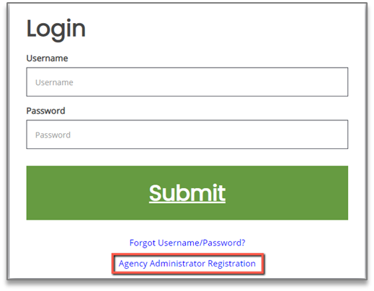

- Fill in the required fields (*) and any optional fields desired and click on the Save button.
NOTE: Users registering by the New User link will need to be approved by pre-existing OGX portal users.

NOTE: If a user attempts to access the system before they have been approved, the system will show their password as invalid.

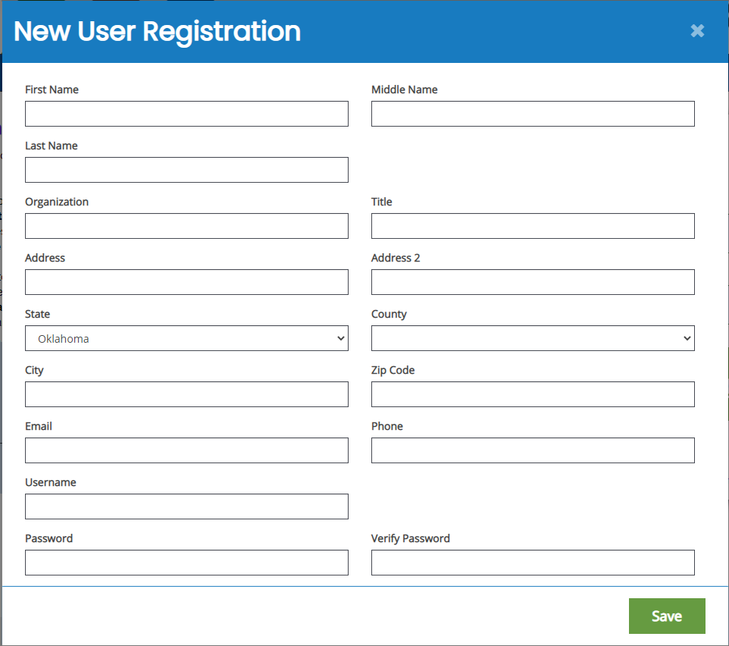

Legend
First Name (Required) – the first name of the registering user.
Middle Name – the middle name of the registering user.
Last Name (Required) – the last name of the registering user.
Organization (Required) – the name of the organization the registering user wants to register under.
Title – the position title of the registering user.
Street Address (Required) – the street address of the organization the user is registering for.
State (Required) – the state drop-down selection for the state of the registering user’s organization.
County (Required) – the county drop-down selection for the county of the registering user’s organization.
City (Required) – the name of the city of the registering user’s organization.
Zip Code (Required) – the zip of the registering user’s organization.
Email (Required) – the email address of the registering user.
Phone (Required) – the phone number of the registering user.
Username (Required) – the username the registering user wishes to register for.
Password/Verify Password (Required) – the password the registering user wishes to register for.

User Information

Once a person logs into the system, their Profile page and a list of organizations the individual belongs to is visible.

Profile
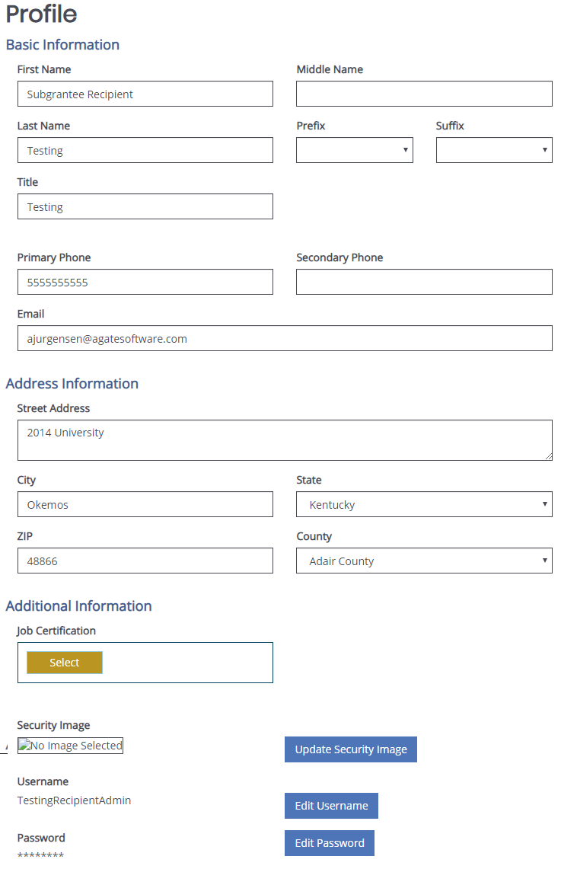

Basic Information Legend
First Name – the first name of the individual.
Middle Name – the middle name of the individual.
Last Name – the last name of the individual.
Prefix – an optional prefix for the individual.
Suffix – an optional suffix for the individual.
Title – the position title for the individual.
Primary Phone – the primary phone number for the individual.
Secondary Phone – the optional secondary phone number for the individual.
Email – the email address of the individual.

Address Information Legend
Street Address – the street address for the individual.
City – the city the individual’s street address is in.
State – the dropdown menu of the state the individual’s street address is in.
Zip – the zip code the individual’s street address is in.
County – the dropdown menu of the county the individual’s street address is in.

Additional Information Legend
Job Certification – a repository for uploading personal certification forms.

Security Image – an optional security image to implement as an additional security measure.

Username – a label containing the username of the individual and a button that allows the individual to update the username.

Password – a label containing the current password of the individual and a button that allows the individual to update the password.

Organizations
This section contains a table with the label for the role the individual has in that organization, the active date field, the inactive date field, and the name of the person who assigned that individual to the organization.
NOTE: A person can have multiple organizations listed.

Home

The Home page is the home page for OGX portal users. From here, the rest of the system can be navigated.

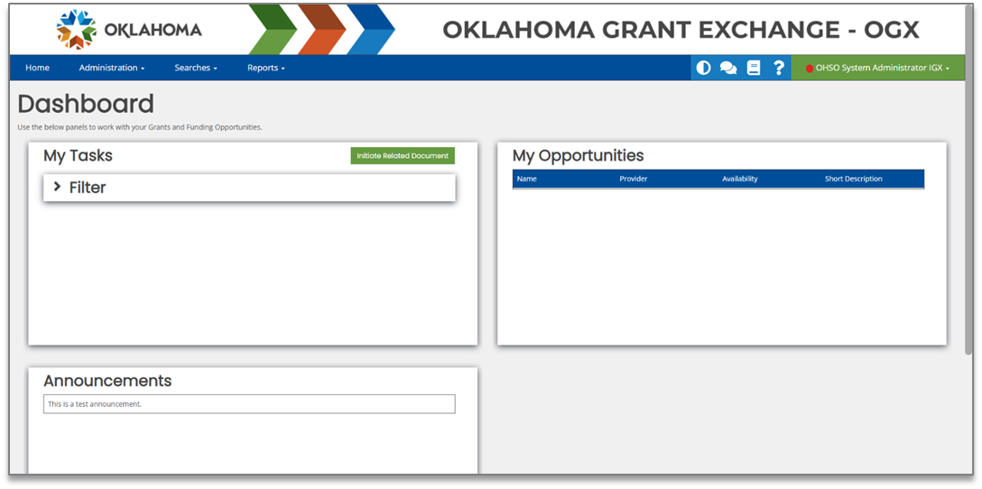

Tabs

Home
This is a navigation link that will return the user to the Home page from anywhere in the system.

Searches
This is a navigation link that will allow the user to conduct document searches for that organization. The user can access this link from anywhere in the system.

Menu Options
- Applications
- Financials
- Programmatic Reports

Icons

 | Theme Setting | This button switches the theme visible from black and white to color and vice versa.
 | Training Materials | Clicking this button allows the user to view available training materials
 | Help | Clicking this button allows general help tips to display about the current item selected.
Name |  | Clicking on the user’s name allows the user to access the Profile, Messages, Edit Dashboard, and Logout links.

Dashboard

My Tasks
The My Tasks area is an area that defines the tasks assigned to the user. It also gives the user a way to initiate a related document (like a report or requisition). This area can be filtered using the Filter function.

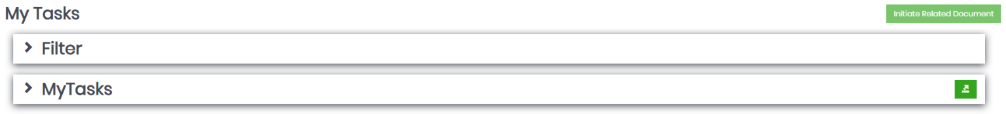

Using the My Tasks Filter
To use the My Tasks Filter to on a list of tasks assigned to the user, please follow these instructions:
- Click on the > sign next to the Filter header.
- Enter data into any of the fields and/or select an option from the Type drop-down.
- Click the Search button.

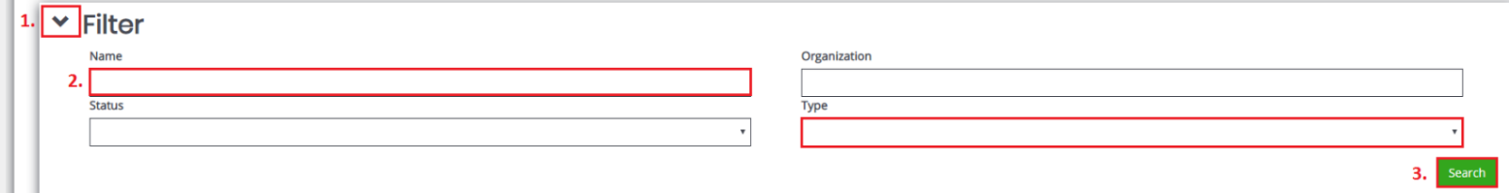

Announcements
The Announcements area is an area that allows the user access to announcements from the portal designers. These announcements can include (but are not limited to) training dates, news updates, or web site links.

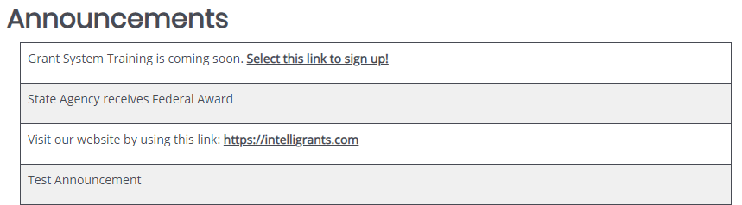

My Opportunities
The My Opportunities area allows the user to start grant opportunity documents (usually applications).

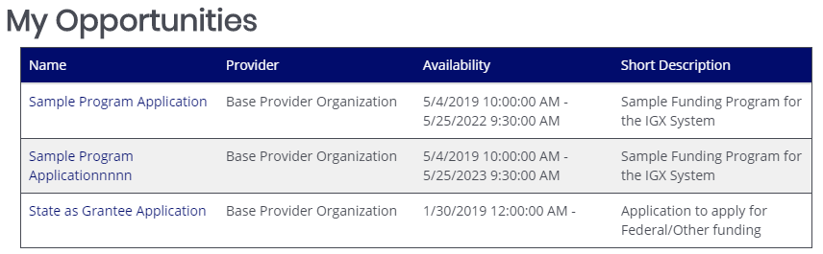

Grant Opportunities

Starting a Grant Opportunity
To start a grant opportunity, please follow these instructions:
            - Click on the grant opportunity name in the Name column. This brings up a menu with more information and the Agree or Decline buttons.

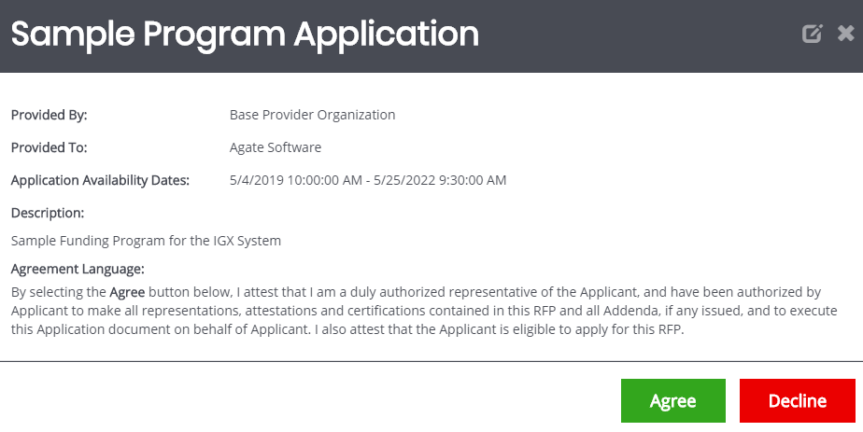

            - Click on the Agree button.

Working on a Grant Opportunity
Start the grant opportunity using the instructions in the previous section.
NOTE: The default page for the application is the Document Landing Page.

The Document Landing Page
The Document Landing Page contains several sections and the New Note button.

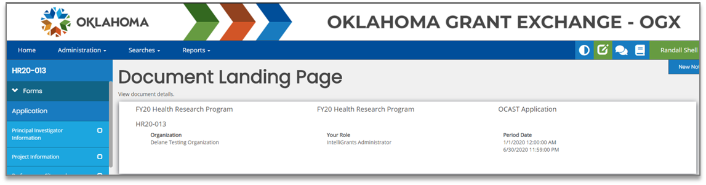

Application Link
The number listed above the Forms header is the application number. It also functions as a link to bring the user back to the Document Landing Page.

Forms Menu
The Forms Menu is divided into sections containing individual forms for the user(s) to fill in. There are drop-down arrows next to the Forms header that allow the forms to be hidden and other sections uncovered.

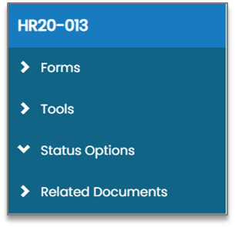

Legend
Forms – the list of forms. Usually forms without sections are listed first, then the form list is broken in to sections.
Tools – a list of tools available to the user.
Status Options – a list of possible status options to apply to the application. This list will vary from user to user, depending on which role the user is logged in as and current status of the application.

Related Documents – a list of related documents (primarily reports) associated with the application.

Document Details
The Document Details section provides visual data including the grant opportunity status, future statuses, the name of the organization, the role of the user currently logged in, and both the Period Date and Due Date.

New Note Button
The New Note button allows a user to leave a note for other users.

Grant Opportunity Forms

Forms
The list of forms is usually divided into sections, with the first section visible being the default form location.

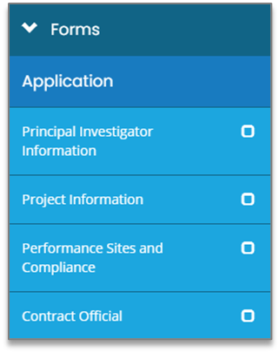

Clicking on a form link in any section will bring up that form for the user to fill in.

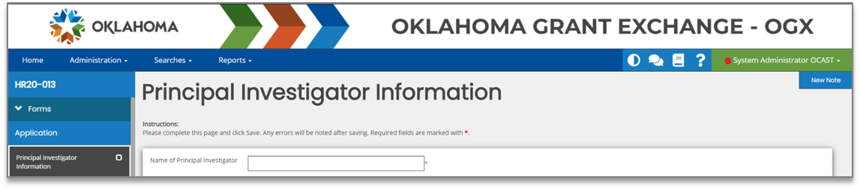

Form Options
There are additional tools in the purple banner on the right side of the screen.

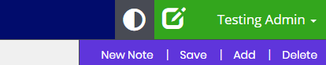

Legend
New Note – allows the user to create a new note for other users.
NOTE: For more information, please see the Notes section in the Tools area.

Save – allows the user to save the form.
Add – allows the user to create an additional instance of the form. It is the digital equivalent to being handed an extra piece of paper of a specific form to staple to an existing packet of forms.

Delete – allows the user to delete the instance of the form that is visible to the user. Clicking on the Delete button will clear out the fields on the form (including any uploaded attachments).

Tools
The Tools section contains a list of customized tools available to the user depending on the role assigned to the user.

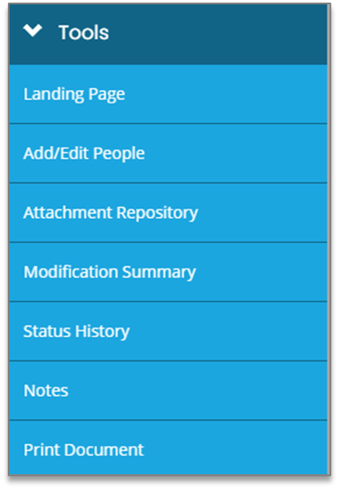

Legend Summary
Landing Page – the default application page.
Add/Edit People – allows the user to add/edit people associated with a specific document.
Attachment Repository – allows the user to access a list of stored attachments.
Modification Summary – allows the user to access a summary of modifications for a specific document.
Status History – allows the user to access a history of the status(s) of a specific document.
Notes – allows the user to create/view/edit notes for a specific document.
Print Document – allows the user to create a PDF of the document.

Landing Page
Clicking on this link returns the user to the Document Landing Page.

Document Add/Edit People
This tool allows authorized users to add/edit people assigned to the document.

Adding/Assigning People to the Document
To add/assign a person to the specific document, please follow these instructions:
- Click on the Plus Sign button on the People Assigned to this Document row.
- Select the Person and Role options from the drop-down menus.
- Click the Save button.
NOTE: This will automatically assign today’s date. If a past active date is required, please use the menu in the Active Date field to select the date.

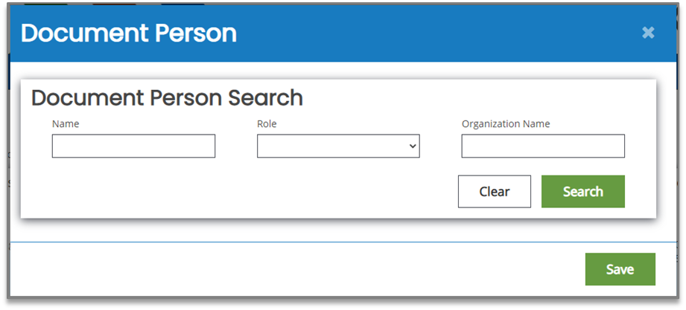

Editing People Assigned to the Document
To edit the role of a user assigned to the specific document, please follow these instructions:
- Click on the Pen button on the right side.
- Select a role from the Role drop-down list.
Optional: Update the Active Date field.

- Click the Save button.

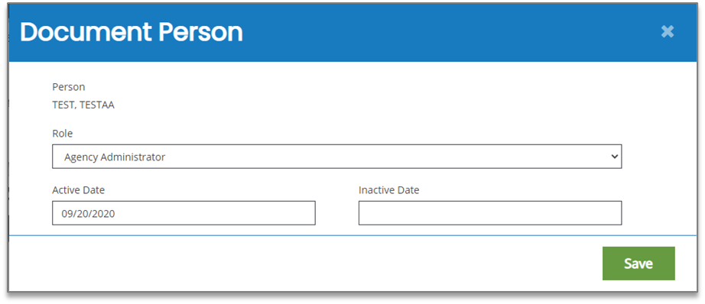

Attachment Repository
This tool allows the user to view files that have been added as attachments throughout the document.

Document Modification Summary
This tool allows the user to view and/or download the modification summary.

Status History
This tool allows the user to view the status of the document – including the Status name, Date/Time the document had that status, and the name of the Person who changed the status of that document. There is also a field for status notes.

Notes
This tool allows the user to add/edit notes.

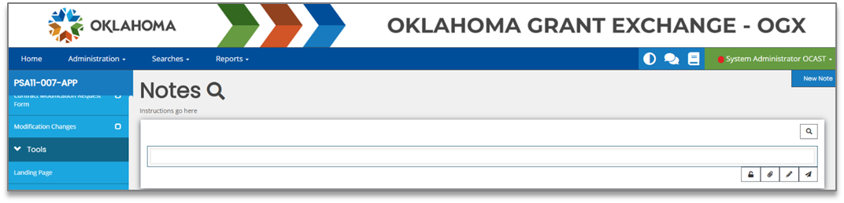

Adding a New Note
Please use these instructions to create a note.

- Click on the New Note button.
- Fill in the field.
- Click on the Paperclip icon to add an attachment (optional).
- Click on the Paper Airplane icon to SAVE the note.

Additional Fields
Icon | Name | Description
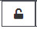 | Internal Note | This tool locks this note into the form as an internal note. The internal notes are only visible to members within the same organization.
 | Attachment(s) | This tool allows the user to add attachments to the note.
 | Editor | This tool allows the user to edit a note.
 | Save Note | This tool allows the user to save the note.

Locating a Note
Once a note is created, it ends up in the Notes area of the Tools menu.
To access the note, please follow these instructions:

- Click in the Forms section to minimize that section.
- Click on the Notes link in the Tools section.

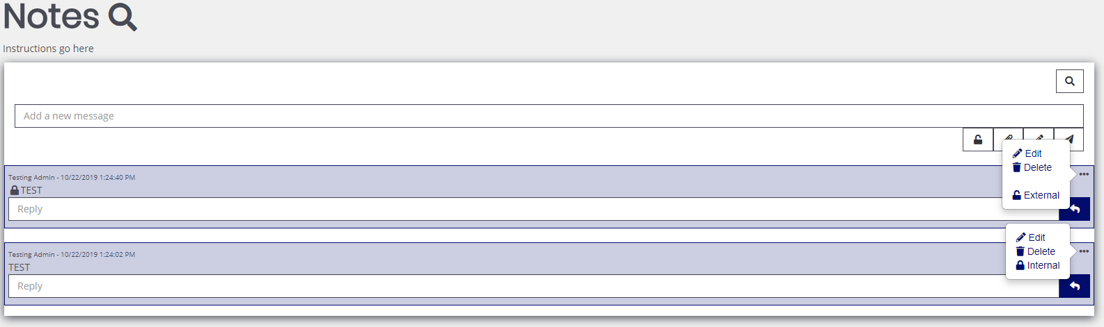

Updating a Note
- Click in the Forms section to minimize that section.
- Click on the Notes link in the Tools section.
- Click on the … icon. This brings up the Edit, Delete and External/Internal tool buttons.

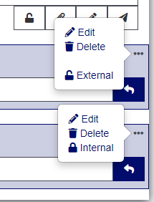

- Click on the Edit tool to edit the text field.

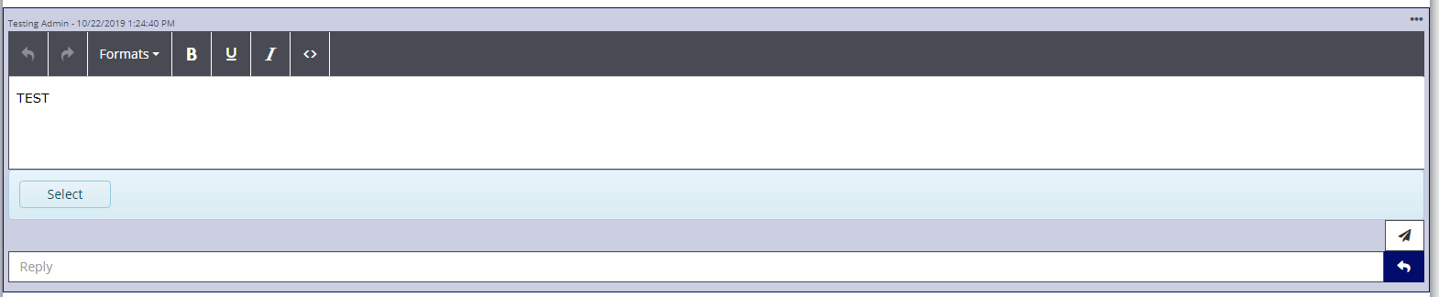

- Click in the text field to adjust the formatting and/or the contents of the note.
- Click the paper airplane icon to save the updates to the note.

Deleting a Note
- Click in the Forms section to minimize that section.
- Click on the Notes link in the Tools section.
- Click on the … icon. This brings up the Edit, Delete and External/Internal tool buttons.

- Click on the Delete button to delete the note.

Replying to a Note
- Click in the Forms section to minimize that section.
- Click on the Notes link in the Tools section.
- Add a response to the Reply section and click on the airplane icon.

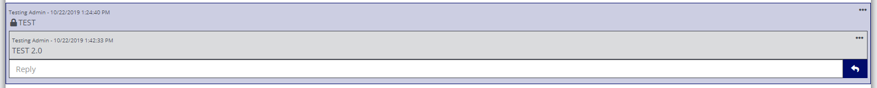

Print Document
This tool allows the user to create a PDF version of the document to save onto the user’s computer and/or print out. Each form has the option of being included in the printout (with both questions and answers), excluded in the printout, or including a blank version of that form.

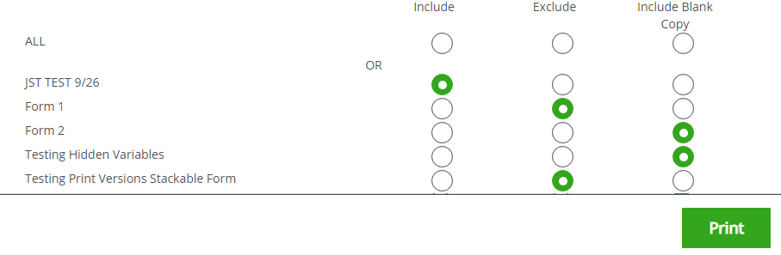

Status Options
The Status Change area allows the user to change the status of a document. This is normally useful for submitting applications, signing contracts, or requesting grant modifications.

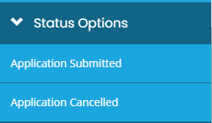

Related Documents
The Related Documents section is where the user can access documents (such as reports) that are related to the application/contract.

Accessing a related Document
To access a report, please follow these instructions:
- Navigate to the grant.
- Close the Forms, Tools, and Status Options sections.
- Click on the report link in the Related Documents section.
- Click on the report link in the 2nd column. This will bring up the Document Landing Page for the report.

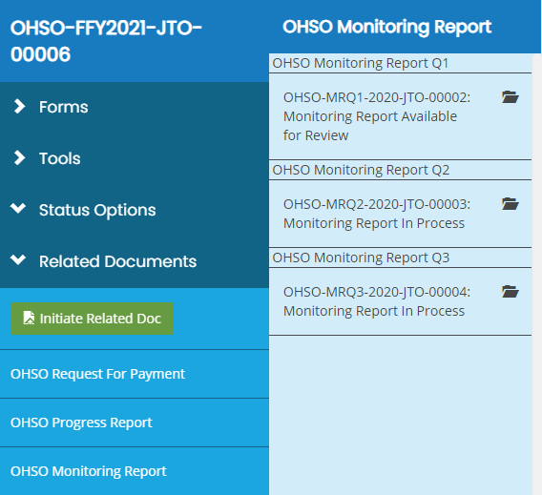

Starting a Related Doc
Click on the Initiate Related Doc button (either in the Related Documents section or in the My Tasks area of the Dashboard).

Searches

The Searches tab is used to quickly locate specific documents. Different types of searches have their own search sections set up. The sections below explain how to use these search sections.

Applications
To use this search tab, please follow these instructions:
- Go to Searches Application/Grant.
- OPTIONAL: Enter in search parameters. Click the Clear button to clear out search parameters.
- Click the Search button.
- Click on the name of a specific document in the Name column.

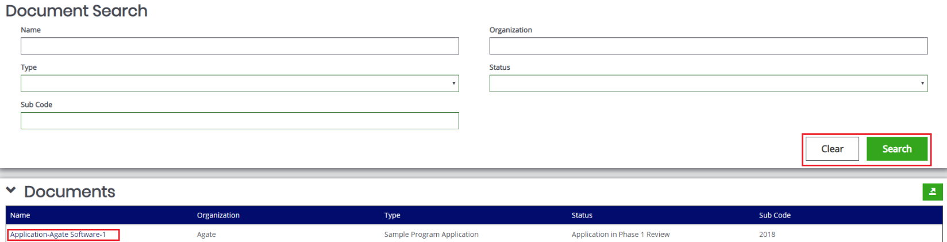

Legend
Name – A text field for the name of the document.
Organization – A text field for the name of the organization that created the document.
Type – A drop-down list to select the type of document from.
Status – A drop-down list to select a specific document status from.
Sub Code – A text field to enter the sub code of the document in.

Financials
To use this search tab, please follow these instructions:
- Go to Searches Financials.
- OPTIONAL: Enter in search parameters. Click the Clear button to clear out search parameters.
- Click the Search button.
- Click on the name of a specific document in the Name column.

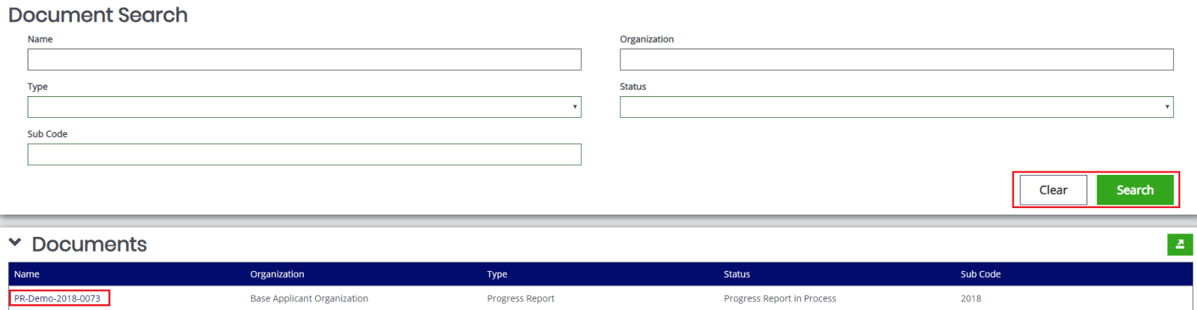

Programmatic Reports
To use this search tab, please follow these instructions:
- Go to Searches Programmatic Reports.
- OPTIONAL: Enter in search parameters. Click the Clear button to clear out search parameters.
- Click the Search button.
- Click on the name of a specific document in the Name column.

