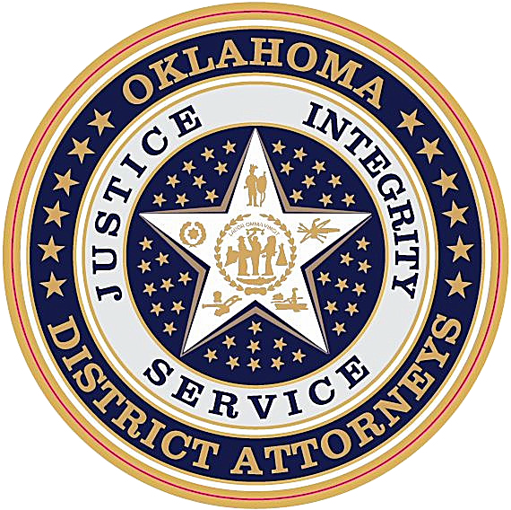
KATHRYN B. BREWER
Executive Coordinator

RYAN STEPHENSON
Assistant Executive Coordinator
STATE OF OKLAHOMA
DISTRICT ATTORNEYS COUNCIL
421 NW 13th Street, Suite 290 | OKC, OK, 73103
Federal Grants Division
Ph: 405-264-5008

Statement of Audit Arrangements: Form A-10

Subgrantee Name and Address:
Lone Grove Police Department
____________________________________________________________________________________
Subgrant Number: _24P001_
Telephone Number: _________________________
Fiscal Year Ends: __________________________

Does your organization receive:

Under $1,000,000 in total federal funds?
Stop, sign and return this form.


Over $1,000,000 in total federal funds?
Complete the remainder of the form.

Organizations Receiving More Than $1,000,000 in Total Federal Funds
Name of CPA (or State Auditor) and address:
_______________________________________________________________________________________
_______________________________________________________________________________________
_______________________________________________________________________________________
Contact person in CPA’s Office: _________________________________
Telephone: ___________________________________________
Anticipated date A-133 audit report will be sent to District Attorneys Council: _____________________
Provide date for financial statements: _____________________________
Provide date for letter report on financial and compliance audit of subgrant: __________________________
Typed Name of Authorized Official

Signature of Authorized Official
Title

Date

The Authorized Official is the person with official signature authority to make financial and programmatic commitments on behalf of the applicant agency. The Authorized Official must be a state agency head, mayor, city manager, chairperson of the County Commission, an authorized tribal leader, Chairperson of the Board of Directors, or District Attorney.

