Sandwich Making - Revised 8/19/2019
Sandwich Making, an individual event*, allows the participant to demonstrate the ability to prepare a sandwich and display it on a plate and garnished in a specified amount of time.
ELIGIBILITY
- A chapter may submit three secondary and three post-secondary entries in this event.
- Open to active SkillsUSA members enrolled in career and technical programs with entry-level job skills as the occupational objective. A letter from the appropriate school official on school letterhead stating that the contestant is classified under the provisions of Public Law 105-17, Individuals with Disabilities Education Act, 1997 is required for participation. State/school associations having restrictions on the release of this information may submit a letter on school letterhead of eligibility which simply states: ‘I certify that (student name) meets the eligibility requirements for the SkillsUSA Championships Sandwich Making contest. Signed (school official).” The eligibility letter is to be presented to the contest chair at the contest orientation meeting.
- Each participant must submit a personal resume during sign-in.
CRITERIA FOR EVALUATION
Participants will be evaluated on:
- Ability to prepare one sub sandwiches to be displayed on a plate and garnished
- Proper handwashing techniques
- Personal appearance (professional attire and grooming)
- Proper use of tools and equipment
- Taking proper safety precautions
- Appearance of finished product
- Merchandising skills in plate presentation
- Leaving work area clean for next participant
- Response to oral questions

PROCEDURES AND TIME REQUIREMENTS
- Participants must attend the event orientation session where they will:
- Receive a nametag and contestant number.
- Be given an overview of the event and the participant’s responsibilities.
- Participants will remain in the holding area until the assigned time.
- Participants must be dressed in a professional attire which consists of an uniform top or apron, long pants, hair cover (a cap or hair net), and close-toe shoes.
- There will be a tour of the kitchen to acquaint the participants with the equipment and preparation area.
- Each participant will have 10 minutes to complete the entrée and garnish.
- Each participant will then clean-up work station.
- When participants have completed their assigned tasks, they will answer an oral question and leave the event area.
- All judges’ decisions are final.

SAMPLE ORAL QUESTIONS
- What is a garnish?
A garnish is something that adds color and flavor and makes a plate look more decorative and attractive. It is used to “decorate” a plate.
- Can you name some garnishes?
Pickles, olives, lettuce, tomatoes, carrot sticks, celery sticks, radish roses, parsley
- Why is it important to wear gloves while making sandwiches?
To avoid the spread of germs. Also, state law requires that ready-to-eat food be prepared and served without bare hand contact. One way to do this is by using gloves.
- Why it is policy at most deli’s to wash hands and put on a new pair of gloves before each customer order?
For safety and sanitation purposes. Also, it is important for the customer to feel that their order is being prepared safely from any germs or bacteria.
*Students who communicate through an interpreter may use their interpreter during the skills demonstration. Students who require reading assistance may request to have any written tests read to them.
Sandwich Making Information Sheet
Each participant will have 10 minutes to complete set-up, assembly, and cleanup.
Ingredients
1 6” sub rolls
Sliced turkey
Sliced ham
Sliced cheese
Sliced tomatoes
Lettuce
Garnishes

Equipment
Serrated knife
Cutting board
Plate
Toothpicks

Set-Up and Assembly
- Wash hands thoroughly and put on gloves
- Set up assembly line as shown on page 5
- Place the one sub sandwich roll on the cutting board, opened and face up
- Fold two slices of turkey in half and place on bottom section of roll
- Fold two slices of ham in half and place on top of the turkey
- Place two halves of cheese on top of ham
- Top sub sandwich with lettuce
- Top lettuce with two tomato slices
- Place roll top section on top
- Cut sub sandwich in half (you may use toothpick to keep sandwich halves together)
- Place sandwich on a plate and garnish
Cleanup
- Collect the cutting board and serrated knife and take it to the sink
- Wipe off workstation with sanitizer towel

Set-Up Diagram
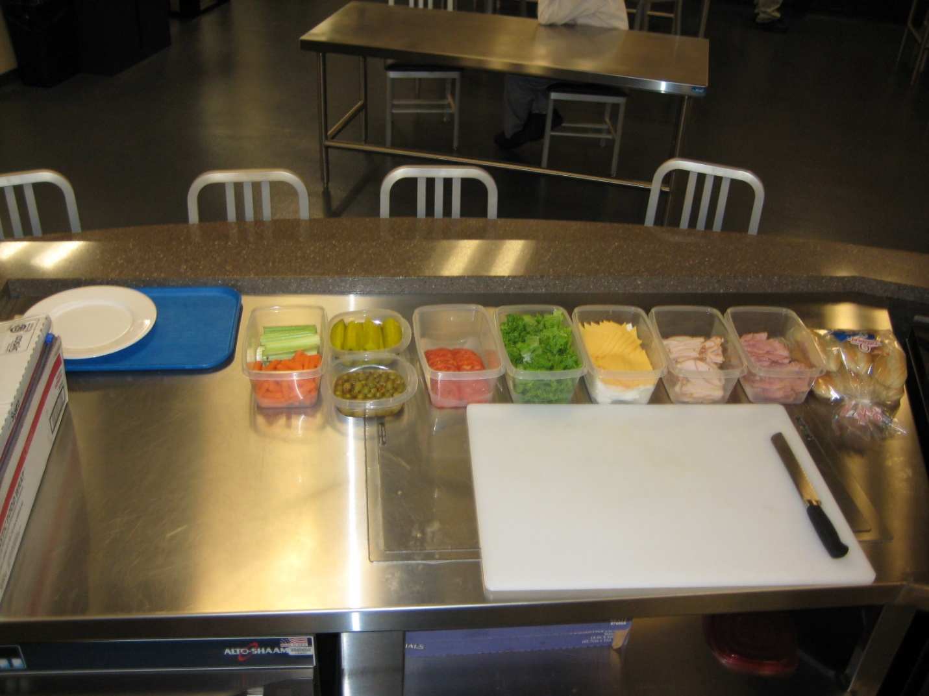

Ingredients
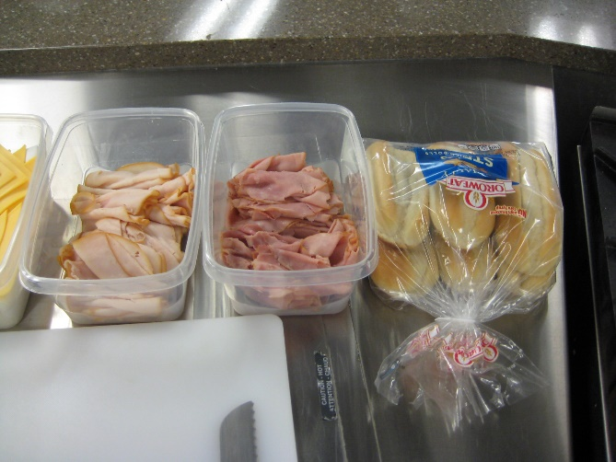 | 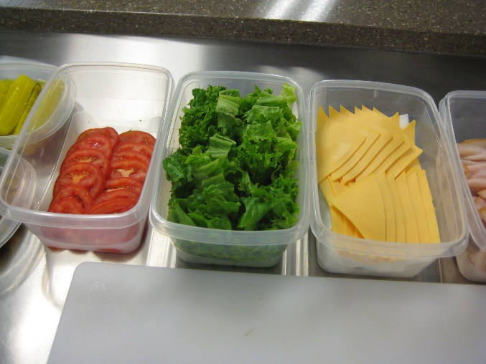
Garnishes | Cutting Board, Serrated Knife
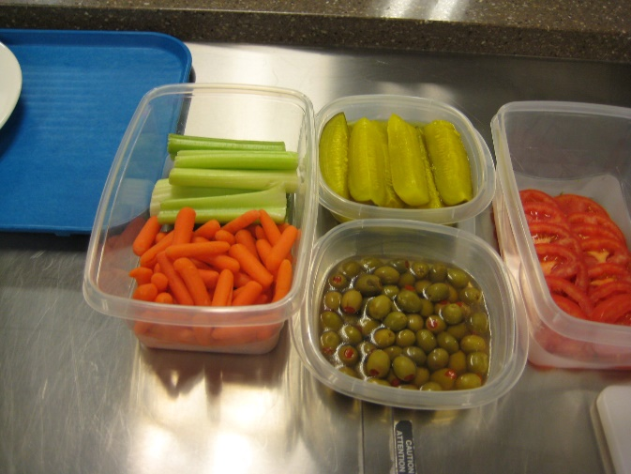 | 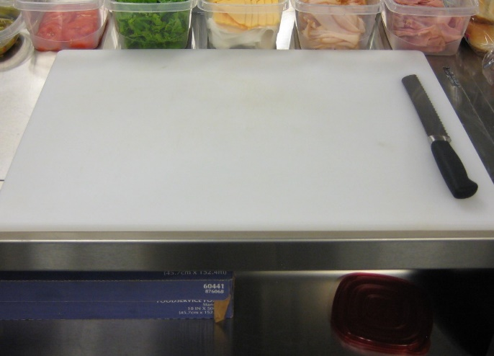

Sandwich Making Rubric

Participant Number: ________
Safety and Appearance |  |  |  | Points
Clothing and Appearance  0-5 points | 0-2  Non-professional appearance, attire and/or grooming | 3-4  Neat appearance, attire and grooming with minor modifications needed | 5  Proper appearance, attire, and grooming
Safety  0-10 points | 0-4  Disregard of safety creating unsafe situations during preparation | 5-8  Shows minimal safety concerns | 9-10  Follows and demonstrates all safety practices
Sanitation  0-10 points | 0-1  No visible hand washing, frequent touching of face, hair | 2-8  Shows minimal sanitation concerns during preparation | 9-10  Follows and demonstrates all sanitation practices
Food Production
Equipment, Tools, and Techniques  0-10 points | 0-1  Lacks understanding of equipment and/or improper use of tools | 2-8  Minimal use of safety and appropriate industry techniques and equipment | 9-10  Uses all equipment correctly and safely
Time Management and Sequence  0-10 points | 0-4  Lacks efficient use of time and/or organization/planning | 5-8  Poor use of time and lack of organization/planning | 9-10  Effective use of time and organization/planning skills
Plating and Presentation
Product Appearance  0-10 points | 0-4  Presentation needs improvement, large amount of waste | 5-8  Presentation is acceptable but lacks professional qualities. | 9-10  Presentation is attractively displayed and shows creativity
Garnish  0-5 points | 0-2  Inappropriate selection of garnish, no garnish, too much garnish | 3-4  Adequate but not outstanding, lacks creativity | 5  Appropriate for food items, exhibits creativity

Cleanup
Station Cleaning  0-10 points | 0-4  Inspection shows no cleaning of equipment, utensils or surfaces |  | 5-8  Inspection shows adequate cleaning of equipment, utensils and some disorganization |  |  | 9-10  Inspection shows clean equipment, utensils, and surfaces
Oral Questions
Responses to Judges’ Questions  0-5 points | 0-1  Questions not answered properly | 2  Few questions answered properly |  | 3  Some questions answered properly | 4  Most questions answered properly |  | 5  All questions answered properly
Time: ___________ |  |  | (75 points possible) TOTAL

Judge’s initials: ___________
Contest Chairperson’s initials: ___________

Judge’s comments:

