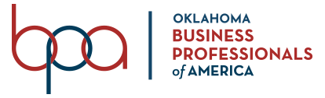

BPA Monthly Meeting January 24, 2022
9:00 AM | Professional Dress
Location: Stillwater, OK

Meeting Agenda
Call to Order - Makayla, President
Role Call & Determination of Quorum - Maggie, Secretary
Inspiration - Natalie
Membership Update - Thomas
Social Media Update - Madalynn
Photo Session - Group & Individual
SLC Planning - All
- Oklahoma Recognition Awards
- Conference agenda and expectations
- Questions
CTSO Day at the Capitol
New Business
Adjourn

