Completing a Student

Manage Program Enrollments

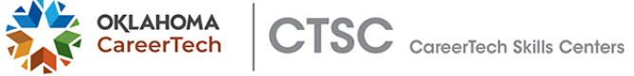
- Click Search to pull up the grid view of your roster
- Click the little blue man to go in and edit your student
- Change the Program Enroll Status to Completed Program
- Change Program Completion Status to Program Completed
- Add/update Program Completion Date
- Last Date Student Attended
- Save Changes

