Discharging a Student to Move Them to the Follow-up List.

Go into Manage Student Records.
- Search for the student (Searching by DOC # is the easiest and quickest way)
*You do not need to change any of the check-marked options, we have preset them for you*
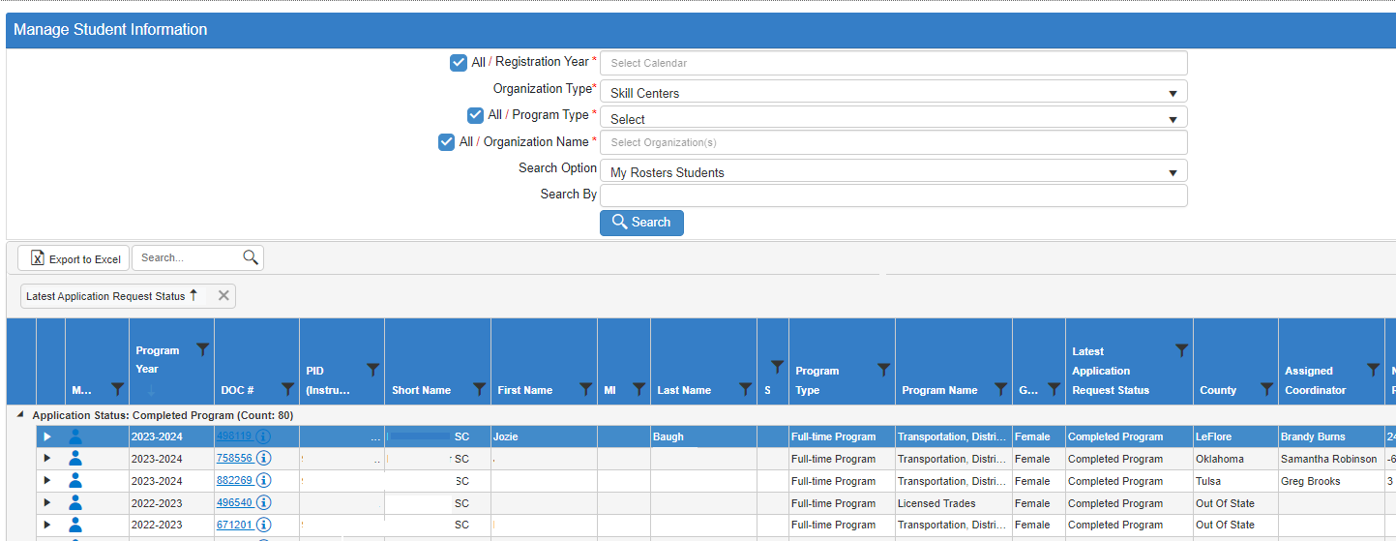
- Go into the student’s record by clicking the little blue man.
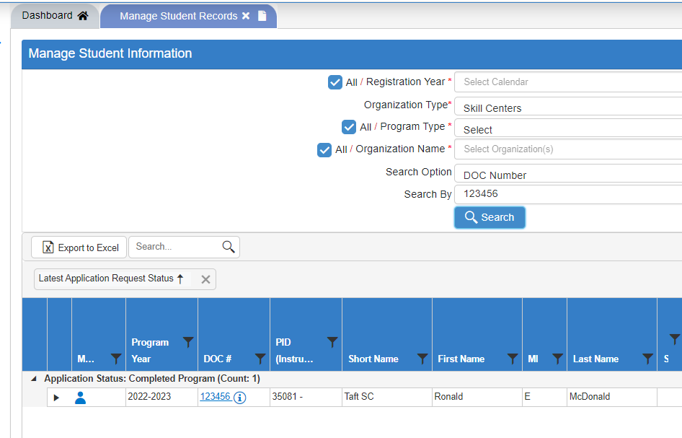

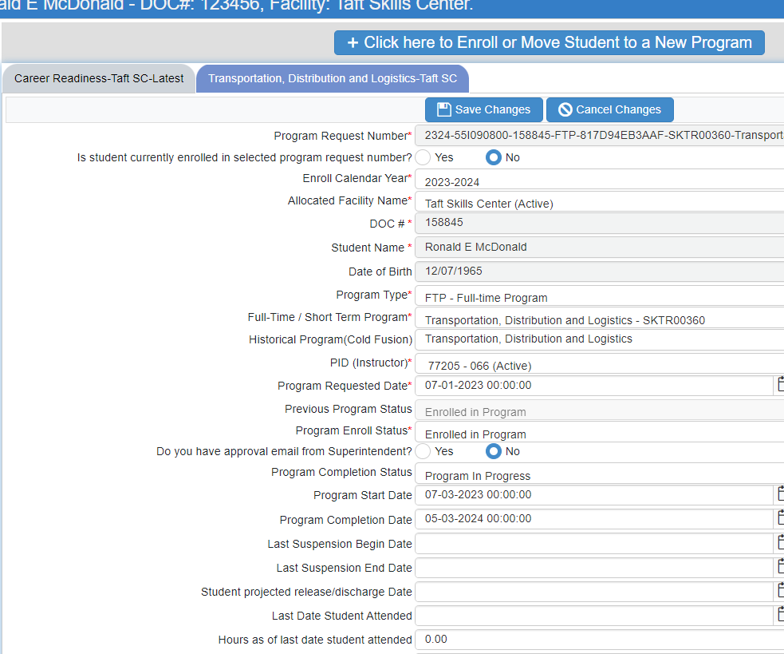
- Go to the grey Release-Discharge-Transfer tab
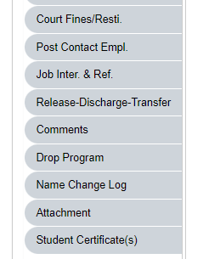

Complete the Grid View if there are blanks
- Click the +New Exit or Release or Transfer button.
- Fill out the Discharge information at the top of the page. DO NOT hit the Save Changes button yet.
- If there are blank cell, missing the dates in the grid view,
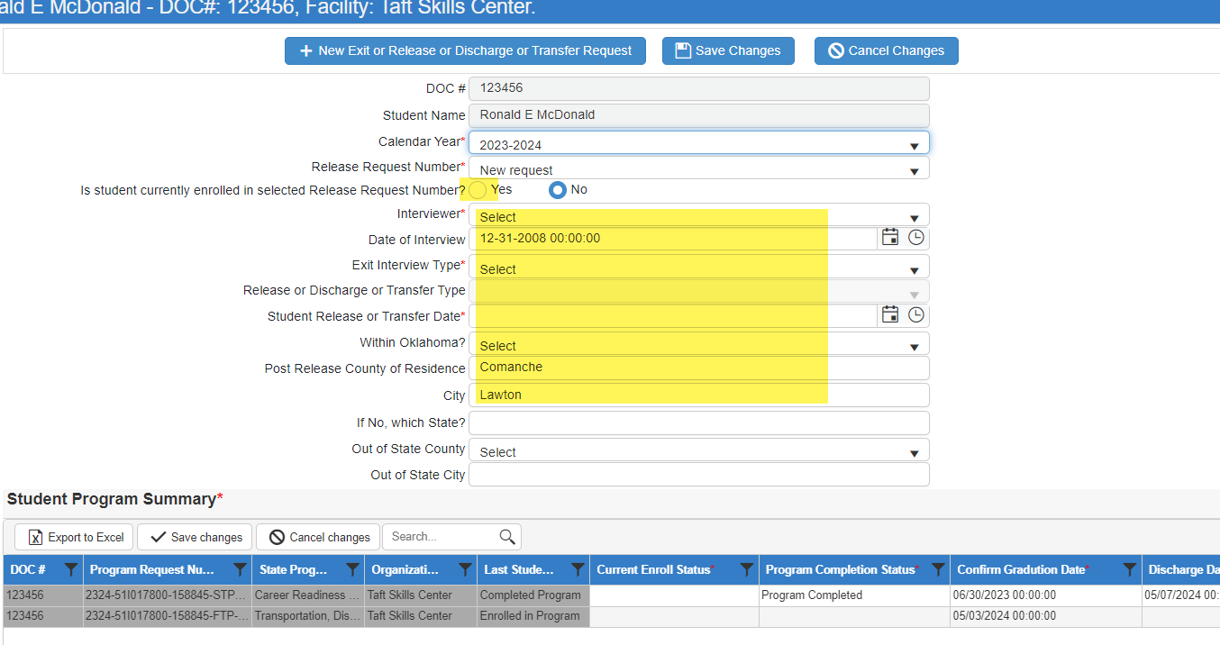
- Change the option in the drop box under Current Enroll Status to Released for all programs in the grid view.
- Add the missing dates.
- Once you add the information to the grid, hit the Save Changes button under the Student Program Summary.
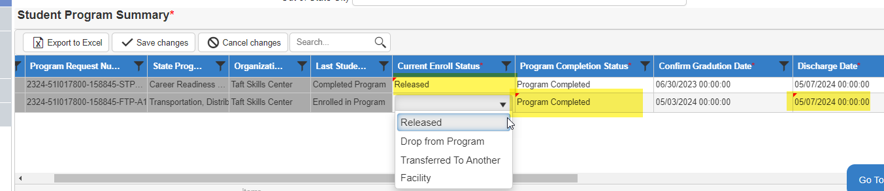

- Click the Save Changes on the top of the screen.
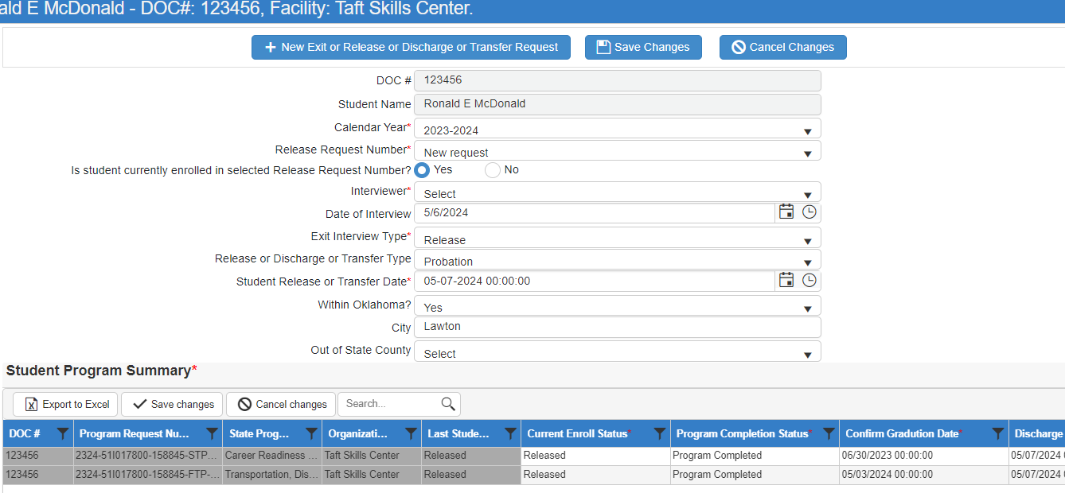
- If the student’s Life Success Plan is not complete, you will get an error with a list of what is missing.
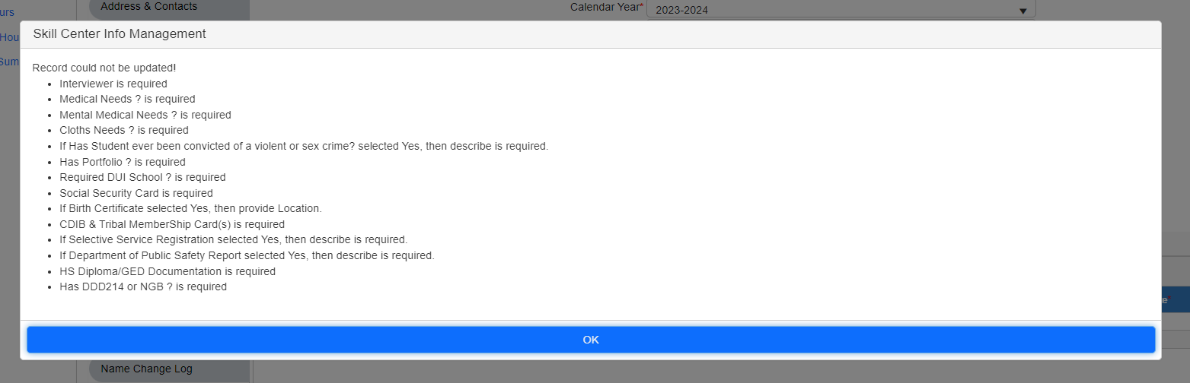
- Click OK, then scroll down and complete the Life Success Plan and Save Changes.
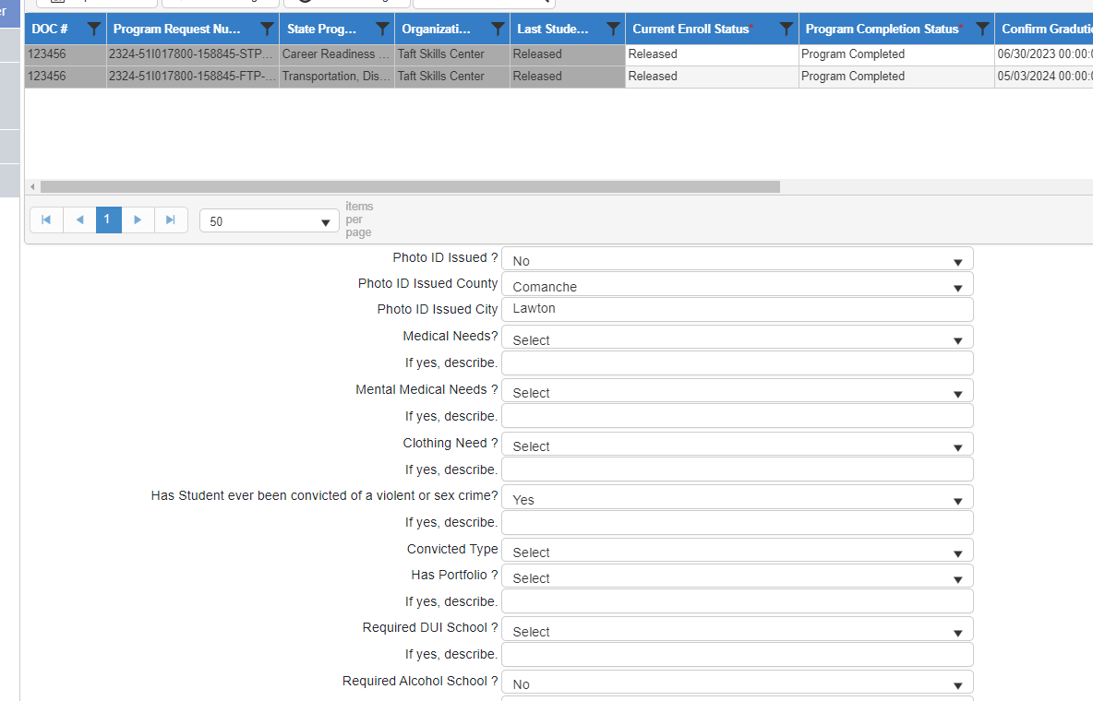
- You can now see the student in the Manage Post Release – Follow-up list.

