- Interest, Credit Card Debt, Online Commerce
- Identity Theft
- Renting vs. Buying a Home
- Insurance
- Gambling
- Bankruptcy
- Charitable Giving
- Earning an Income
- State and Federal Taxes
- Banking and Financial Services
- Managing Financial Accounts
- Savings and Investing
- Planning for Retirement
- Borrowing Money
OKMM supports students and educators by providing targeted modules aligned with all 14 mandated personal financial literacy standards, complete with quizzes that are designed to help students meet this graduation requirement efficiently. Find them at OklahomaMoneyMatters.org.
PERSONAL Financial Literacy (PFL) Standards

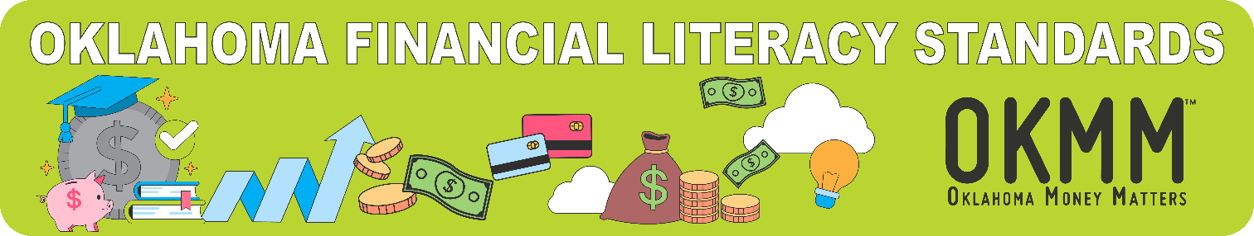

Resources
OKMM offers a variety of helpful online resources to
support your students and their families.
- Financial Friday Newsletter
- High School – Your Money Matters Guide
- College – Your Money Matters Guide
- Adult – Your Money Matters Guide
- Borrow Smart from the Start
- Low Resource Guide and Flyers
- Personal Budgeting Tool
- Student Loan FAQs
- Financial Aid 101
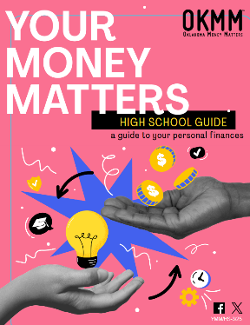

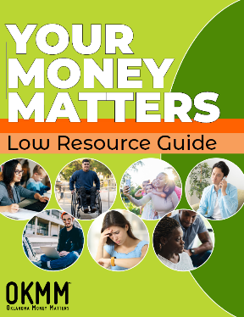
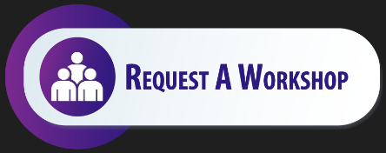
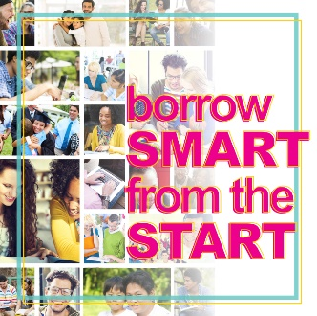
Ann Thaxton Brittney Morgan
OKMM Financial Education Specialist OKMM Financial Education Specialist
athaxton@ocap.org bmorgan@ocap.org
405.234.4415 405.234.4488

Email: OklahomaMoneyMatters@ocap.org
Toll Free: 800.970.OKMM (6566)
Contact Us

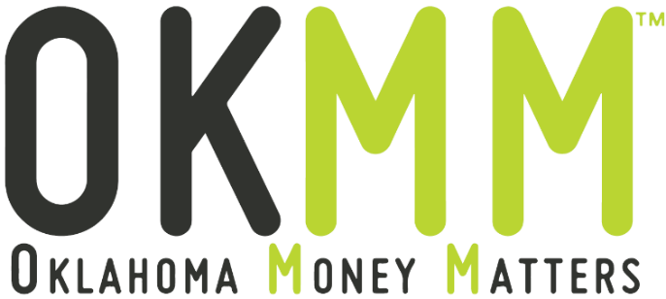
Oklahoma Money Matters (OKMM) is a financial education initiative dedicated to helping Oklahomans make informed, confident money decisions. We partner with K-12 schools, colleges and universities, businesses, and community organizations to create or enhance programs that promote financial literacy.
As a program of the Oklahoma College Assistance Program (OCAP) and the Oklahoma State Regents for Higher Education, OKMM provides free trainings, practical resources, and informative publications designed to help students, families, and adults manage personal finances. Our topics include budgeting, saving, credit and debt management, student loan repayment and more.
What can OKMM do for you? We offer a wide range of free services and tools to support your financial education efforts. Explore more at OklahomaMoneyMatters.org.

- Short, Mid and Long-Term Savings Goals

OKMM offers a comprehensive selection of resources, publications, and services designed to support you, your students, their families, adults, and community partners, including:
- Financial Friday Newsletter
- OKMM Outlook Newsletter
- Your Money Matters Guides for all ages
- Free Presentations
- New Student Orientation Programs
- Financial Literacy Modules
- Personal Budgeting Tool
- Comprehensive Website Information for:
- Students
- High School
- College
- Adult
- Parents
- Student Loan Borrowers
- K-12 Educators
- Campus Professionals

SERVICES
OklahomaMoneyMatters.org
ReadySetRepay.org

