August 18, 2021

To Whom It May Concern:

We are allowing 412 program assistance money that is sent to the comprehensive high schools to be used to pay for the Agricultural Education program’s affiliated membership fees. The affiliated fees include access to the Agricultural Experience Tracker—an online system that students will use in developing, implementing, and recording individualized Supervised Agricultural Experiences and journaling hours spent in career exploration and community service. In addition, membership fees include access to AgExplorer.ffa.org which is a robust, comprehensive career resource that students may use to explore the broad range of careers available in the industry of agriculture. Teachers also have access to resources and lesson plans through both the Agricultural Experience Tracker and National FFA. Because of the educational value and content, the expenditure falls under the section of instructional delivery embedded in CareerTech rules. Included is the CareerTech Rule of reference:

780:10-5-4. Instructional funding
(2) Program assistance monies. All approved CareerTech programs shall receive the
program assistance monies annually. Pending availability of funds. These monies shall be used to support the additional costs of the CareerTech program limited to the purchase of equipment,
instructional delivery and supplies, and staff development.

Respectfully,
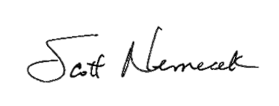
Scott Nemecek
State Program Manager, Agricultural Education
State FFA Advisor

